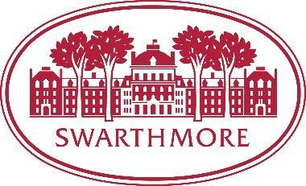
Performance Assessment Conversation: A Quick Guide for Staff Members
Goal: To foster an environment of open communication at Swarthmore College, regular and periodic conversations with staff members and supervisors regarding job performance are encouraged.

Clear and open dialogues throughout the year allow an opportunity to recognize work well done, and to address concerns as they arise. Yearly conversations reinforce desired performance outcomes and provide opportunities for immediate improvement, development, and redirection. In addition, staff members are encouraged to proactively seek feedback and communicate any concerns with their supervisors. At the end of the year, supervisors must provide a written assessment of each staff member's job performance and summarize their work.

The following suggestions will aid you in conversations throughout the year.

Plan and Prepare

- Be sure to have immediate access to the performance assessment documents on the Performance Assessment & Coaching site.
  - Review and fill out the Performance Assessment Template. Staff members are asked to complete the template first, then, send an electronic copy to their supervisor for their written and verbal feedback.
- Document your job responsibilities, goals, and priorities.
- Document progress against each goal and supply examples, such as emails/feedback or input from fellow colleagues or team members.
  - Remember, the performance assessment is meant to summarize and evaluate performance over the past performance year, which for us was approximately July 2019 to June 2020. That means approximately two thirds of the review year took place before COVID-19 and the shift to work-from-home, and approximately one third took place during COVID-19. An option is to consider goals, responsibilities, and priorities for the time before COVID and during COVID as two distinct parts of the year.
  - Ratings are not documented for the 2019-20 year.
- Think about what has helped you achieve goals and what things might be getting in the way.
- What is preventing you from achieving your goals?
- What kinds of professional development may be of interest to you?

Conversation with the Supervisor

- The supervisor will provide performance assessment copies that include your and the supervisor’s feedback.
- Be prepared to share your overall assessment of your performance in 2019-2020.
  - What went well?
  - What roadblocks did you encounter?
  - What would you have done differently, if anything?
  - Describe how you measure your success.
- Be sure to point out areas of accomplishment by reviewing each goal. Be direct, specific, and concise.
- Have readily available any documentation that will support the conversation [emails, metrics, data, feedback, project documents, etc.].
- Share professional development interests and needs.
- Share how you plan to keep your supervisor apprised of your progress and success.
- Think of any questions you would like to address with the supervisor.

Reflection

- What did you learn?
- What surprised you in the conversation?
- What were the benefits of having the conversation?
- What aspects were challenging?
- What will you do or say differently in future performance assessment conversations?
- How will you maximize the possibilities that resulted from the conversation? How will you hold yourself accountable to achieve your goals and seek continual professional development?

