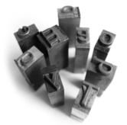

**Swarthmore College Writing Center**

**writing.swarthmore.edu**

**610.328.8659**

Stumped? Questions to Ask When Constructing a Thesis

From David Rosenwasser, Jill Stephen, and Doug Babington, *Writing Analytically*, Toronto: Thomson Nelson, 2006.

ted from *They Say, I Say: The Moves that Matter in Academic Writing* by Gerald Graff and Cathy Birkstein (2006).

1. What kinds of patterns or implications emerge when I look closely at my evidence?
2. What kind of evidence and support do I need to support my tentative thesis?
3. What kind of evidence cannot be adequately accounted for by my tentative thesis?
4. How can I explain the mismatches between my thesis statement and my selected evidence?
5. How can I rewrite my thesis statement in order to accommodate the evidence that doesn't fit?