ROBERT WEINBERG

Isaac H. Clothier Professor of History and International Relations
Department of History
500 College Avenue
Swarthmore College
Swarthmore, Pennsylvania 19081-l397

Office (610) 328-8133
Cell (610) 308-3816
rweinbe1@swarthmore.edu

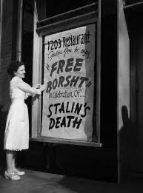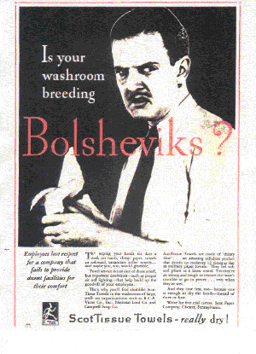

Explore a Collection of Soviet Posters From the 1920s and 1930s Housed at Swarthmore College

Watch a Video of Boney-M Performing “Rasputin, Russia’s Greatest Love Machine”

ACADEMIC DEGREES
Ph.D. in History: University of California, Berkeley (1985)
M.A. in History: Indiana University (1978)
B.S. in Industrial and Labor Relations: Cornell University (1976)

ACADEMIC EMPLOYMENT
Swarthmore College. Assistant Professor: 1988-1994
Associate Professor: 1994-2002
Professor: 2002-Present
Department Chair: 1996-2000, 2008-2009, 2011- 2012, 2015-2016, 2019-2022

BOOKS

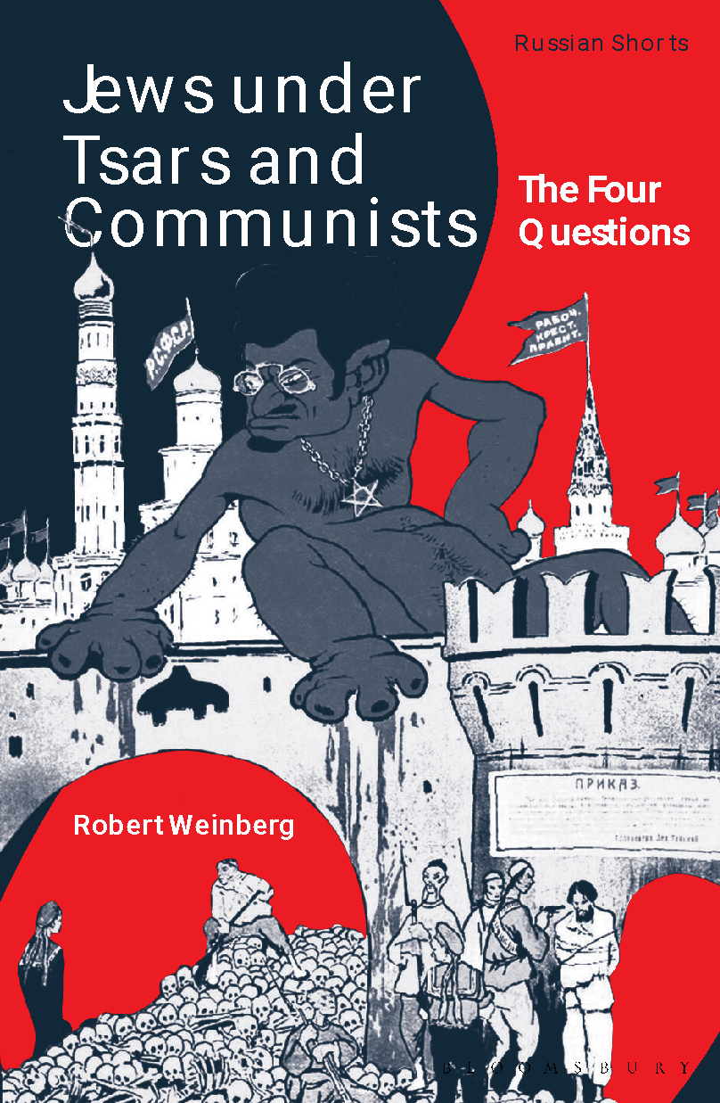
The Four Questions: Jews Under Tsars and Communists (Bloomsbury Press, 2024)

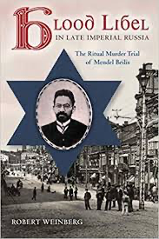
Ritual Murder in Late Imperial Russia: The Trial of Mendel Beilis (Indiana University Press, 2013)
Published in Russian as Kровавый навет в последние дни Российской
Империи: процесс над Менделем Бейлисом по обвинению в ритуальном убийстве
(Academic Studies Press, 2019).
Interview with Professor Joan Neuberger (University of Texas, Austin) about Mendel Beilis and the Blood Libel

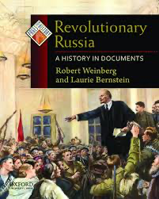
Revolutionary Russia: A History in Documents (Oxford University Press, 2010). Joint authorship with Laurie Bernstein

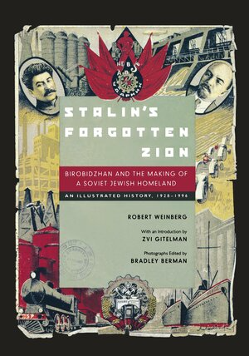
Stalin’s Forgotten Zion: Birobidzhan and the Making of a Soviet Jewish Homeland (University of California Press, 1998). Published in French as Le Birobidjan, 1928-1996 (Paris: Edition Autrement, 2000) and German as Birobidshan: Stalins vergessenes Zion (Frankfurt: Verlag Neue Kritik, 2003). Also served as curator for traveling exhibition about the history of Birobidzhan. Organized by the Judah Magnes Museum of Berkeley, California, with venues in Berkeley, Miami Beach, and Chicago. 1998-1999.

Explore My Museum Exhibition on Birobidzhan

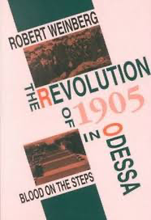
The Revolution of 1905 in Odessa: Blood on the Steps (Indiana University Press and Studies of the Harriman Institute, 1993).

EDITED VOLUMES
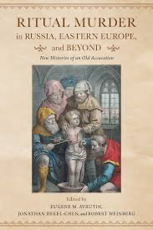
Ritual Murder in Russia, Eastern Europe, and Beyond: New Histories of An Old Accusation. Edited by Robert Weinberg, Eugene Avrutin, and Jonathan Dekel-Chen (Indiana University Press, 2017)

Special Issue of Jewish History, 26: 3-4 (2012).
Solicited articles on the blood libel in Eastern Europe and wrote introductory essay.

“Red and White: Conversations with Moritz Mebel.” The Carl Beck Papers in Russian and East European Studies, No. 1805 (2007).

Special Issue of Russian Studies in History, 43:1 and 2 (2004). Selected recent articles by Russian historians on Russian-Jewish
history and wrote introductory essay.

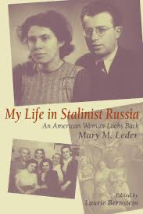
Mary Leder, My Life in Stalinist Russia: An American Woman Looks Back
Edited by Laurie Bernstein and Robert Weinberg (Indiana University Press, 2001).

Special Issue of Russian History/Histoire Russe, 23:1-4 (1996). Festschrift for Reginal E. Zelnik. Co-editor with Gerald Surh.

ARTICLES AND CHAPTERS IN BOOKS

“Ethnic Violence in a Cosmopolitan City: The October 1905 Pogrom in Odessa.” Mirja Lecke and Efraim Sicher, eds., Odessa, Cosmopolitanism, Modernism (Boston: Academic Studies Press, 2023), 118-138.

"Representing Jewish in the Red Zion The Jewish Autonomous Region in the 1930s"“ Valerie Kivelson, Sergei Kozlov, and Joan Neuberger, eds. Picturing the Russian Empire (New York: Oxford University Press, 2023), 373-380.

“Reflections on the Blood Libel in Late Imperial Russia.” Antisemitism Studies 5 (2) (2021): 358-369 (Scholars Forum on Magda Teter, Blood Libel: On the Trail of An Antisemitic Myth).

“Russia’s Encounter with Revolution and Pogroms: Odessa, 1905.” Eugene Avrutin and Elissa Bemporad, eds. Pogroms: A Documentary History (New York: Oxford University Press, 2021), 85-107.

“The Red Zion: Birobidzhan and Soviet Jewry.” Simon Mraz, ed., Birobidzhan: An Artistic Study of the Russian Federation’s Jewish Autonomous Oblast’ in The Russian Revolution and Village Life (Austrian Cultural Forum, 2018), 547-558.

“The Bolshevik Revolution and Jews.” Choi Chatterjee, Steven Marks, Mary Neuberger, and Steven Sabol, eds., The Global Impacts of Russia’s Great War and Revolution. Book 2: The Wider Arc of Revolution, Part 1 (Slavica Press, 2018), 105-124.

“Connecting the Dots: Jewish Mysticism, Ritual Murder, and the Trial of Mendel Beilis.” Daniel Kaiser, Valerie Kivelson, and Maria di Salvo, eds. Word and Image in Russian History: Essays in Honor of Gary Marker (Academic Studies Press, 2015), 238-252.

“The Trial of Mendel Beilis: The Sources of the `Blood Libel’ in Late Imperial Russia.” Michael Melancon and Donald Raleigh, eds., Russia’s Century of Revolutions: Parties, People, and Places (Slavica Press, 2012), 17-35.

“Look! Up There in the Sky: It’s a Vulture, It’s a Bat … It’s a Jew:
“Reflections on Antisemitism in Late Imperial Russia, 1906-1914.” Eugene Avrutin and Harriet Murav, eds., Jews in the East European Borderlands: Daily Life, Violence, and Memory (Academic Studies Press, 2012), 167-186.

“Antisemitism and Anti-Jewish Violence in Late Imperial Russia.” Andrew Murphy, ed., A Companion to Religion and Violence (Blackwell Publishing, 2011), 451-460.

“Demonizing Judaism in the Soviet Union during the 1920s.” Slavic Review 67:1 (2008), 120-153.

“Soviet Images of Jehovah in the 1920s.” Joan Neuberger and Valerie Kivelson, eds., Picturing Russia: Explorations in Visual Culture (Yale University Press, 2018), 153-156.

“The Russian Right Responds to Revolution: Visual Depictions of Jews in the Black Hundred Press in Post-1905 Russia.” Ezra Mendelsohn, ed., The Revolution of 1905 and Russia’s Jews: Essays in Honor of Jonathan Frankel (University of Pennsylvania Press, 2008), 55-69.

“Biology and the Jewish Question After the Revolution: One Soviet Approach to the Productivization of Jewish Labor.” Jewish History 21: 4 (2007), 413-428.

“Antisemitism.” Tatiana Smorodinskaya, Karen Evans-Romaine, and Helena Goscilo, eds., The Routledge Encyclopedia of Contemporary Russian Culture (Routledge, 2007), 18-19.

“Jewish Bund.” John Merriman and Jay Winter, eds., Europe, 1789-1914: Encyclopedia of the Age of Industry and Empire (Charles Scribner’s Sons, 2006), 313-315.

“The Politics of Remembering: The Treatment of the Holocaust in the Soviet Union.” Dagmar Herzog, ed., The Holocaust in International Perspective (Northwestern University Press, 2006), 314-329.

“Birobidzhan” and “Arkady Raikin.” James Millar, ed., Encyclopedia of Russian History (Macmillan Reference USA, 2004).

“Beyond the Pale: Reflections on Research in Birobidzhan and Odessa.” Samuel Baron and Cathy Frierson, eds., Adventures in Russian Historical Research (M.E. Sharpe, 2003), 191-203.

“Birobidzhan After the Second World War.” Jews in Eastern Europe No. 3 (49) (2002), 31-46.

“Visualizing Pogroms in Russian History.” Jewish History 12:2 (1998), 71-92.

“Jewish Revival in Birobidzhan in the Mirror of Birobidzhanskaia zvezda.” East European Jewish Affairs 26:1 (1996), 35-53.
“Anti-Jewish Violence and Revolution in Late Imperial Russia: Odessa, 1905.” In Paul Brass, ed, Riots and Pogroms. (Macmillan Press Ltd, 1996), 56-88.
"Birobidzhan and Solving the 'Jewish Question': The Making of a Jewish Peasantry." In Yaacov Ro'i, ed., Jews and Jewish Life in Russia and the Soviet Union (Frank Cass and Co., 1995), 87-102.

“Jews.” Peter Stearns, ed., Encyclopedia of Social History (Garland Pubishing Company, 1994), 489-491.

“Purge and Politics in the Periphery: Birobidzhan in 1937.” Slavic Review 52:1 (1993), 13-27.

“Stalin’s Forgotten Homeland: Birobidzhan Experiences Jewish Cultural Renaissance.” East European Jewish Affairs 22:2 (1992), 39-45.

“The 1905 Pogrom in Odessa: A Case Study.” In John Klier and Shlomo Lambroza, eds., Pogroms: Anti-Jewish Violence in Modern Russian History (Cambridge University Press, 1992), 248-289.

“The Politicization of Labor in 1905: The Case of Odessa Salesclerks.” Slavic Review 49:3 (1990), 427-445.

“Workers, Pogroms and the 1905 Revolution in Odessa.” The Russian Review 46: 1 (1987), 53-75.

“Social Democracy and Workers in Odessa: Ethnic and Political Considerations.” The Carl Beck Papers in Russian and East European Studies, No. 504 (July 1986).

PROFESSIONAL SERVICE
Program Chair for the 2023 Association for Slavic, East European, and Eurasian Studies Conference
Cohen-Tucker Dissertation Fellowship Selection Committee of Association for Slavic,
East European, and Eurasian Studies, 2022-2024
Nominating Committee of Association for Slavic, East European, and Eurasian Studies, 2018-2019
Chair of American Historical Association Committee on Travel Grants for Graduate Students, 2017
Assessment of College Board’s AP European History Curriculum and Test, June and October 2016
Mentor for Advanced Graduate Students in Slavic Studies. 2015-2017 and 2020-2021
Program Committee for Association for Slavic, East European, and Eurasian Studies in
Philadelphia, November 2015
Nominating Committee for Senior Scholar Award of the Southern Conference on Slavic Studies, February 2015
Selection Committee for Central Eurasian Studies Society Conference in Astana, Kazakhstan, May 2014
Reginald Zelnik Book Prize in History. Sponsored by the ASEEES. 2012-2013.
Representative of American Historical Association to the Association for Slavic, East European and Eurasion Studies 2011-2013
Editorial Board of Book Series Imperial Encounters in Russian History (Academic Studies Press) 2009—Present
Editorial Board of journal On the Jewish Street 2009—Present
Secretary of Modern European History Section of American Historical Association. 2001-Present
Editorial Board of Journal of Modern History. 2006-2009
Led two-day workshop on Soviet Jewish history for Jewish Studies and Russian and Slavic Studies students. Oberlin College. March 2008.
AAASS Committee on Travel Grants for Graduate Students (2007-2009)
NEH Fellowship for College Teachers and Independent Scholars (2005)
ACLS Fellowship Committee (2003-2004)
NEH Collaborative Research Program Committee (2003-2004)
National Screening Committee for Fulbrights to Russia and Ukraine (2000-2002)
Shulman Committee of the AAASS (Selection of best book about the international relations of a country of the former Soviet Union, 2002-2004)

CONFERENCE PAPERS AND TALKS
“Ethnic Violence, Politics, and Revolution: The Odessa Pogrom in 1905.” Conference on Odessa, Cosmopolitanism, Modernism. Hebrew University of Jerusalem. June 2021.
“Documenting the Communist Experience: Swarthmoreans Visit the Soviet Union.” Conference on the Photography of Frank Fetter. Museum of Applied Art of the Republic of Tatarstan. Kazan. November 2020.
“The 1905 Pogrom in Odessa.” Workshop on Odessa and Cosmopolitanism. Israel Institute for Advanced Studies. June 2020.
“Visualizing Soviet Jewry in Birobidzhan.” Conference on Picturing the Russian Empire. University of Tyumen. June 2019.
“The Role of Rumor in the Trial of Mendel Beilis.” Third National Conference of
Historians of the Nineteenth Century. University of Warsaw. June 2019.
“The 1905 Pogrom in Odessa.” YIVO Institute for Jewish Research. May 2019
“The Pogrom Phenomenon in Late Imperial Russia.” Stanford University. May 2019
“Jewish Autonomy in the Soviet Union.” Annual Convention of the Association for Slavic, East European, and Eurasian Studies. Boston, December 2018.
“Visions of Transformation in Russian and Soviet Literature.” Washington, D.C. Alumni Book Group. October 2018.
“The Politics of Seekers of Happiness.” Pears Institute for the Study of Antisemitism, University College London. February 2018.
Co-organizer of Symposium “Global Impact of the Russian Revolution. University of Delaware, November 2017.
“Land, Language, and Labor: Birobidzhan and Radical Jewish Politics.” Symposium on Radical Jewish Politics. University of California, Santa Cruz. May 2017.

“From Beilis to Pussy Riot: Ritualism and the Existential Threat to Russia, 1911-2012.” Annual Convention of the Association for Slavic, East European, and Eurasian Studies. Washington, DC, November 2016.
“Maxim Gorky and the `Jewish Question’ During the Great War.” Annual Convention of the Association for Slavic, East European, and Eurasian Studies. San Antonio, November 2014.
“Religion, Antisemitism, and the Beilis Affair.” Researching New York Conference. SUNY-Albany. November 2013.
“Reflecting on the Beilis Trial.” YIVO Institute for Jewish Research. November 2013.
“Official and Popular Antisemitism and the Trial of Mendel Beilis.” International Conference on Antisemitism. Kiev. October 2013.
“Connecting the Dots: Jewish Mysticism, Ritual Murder, and the Trial of Mendel Beilis.”
Conference on Religion and Mass Politics in the Late Russian Empire. NYU. October 2013.
“The Beilis Trial at 100.” Conference on the Blood Libel in History, Politics, Theology, and Literature on the Centenary of the Trial of Mendel Beilis.” Dartmouth College. July 2013.
“Conspiracy in Russian History: The Trial of Mendel Beilis.” Roundtable. Annual Convention of the Association for Slavic, East European, and Eurasian Studies.
New Orleans. November 2012.
“Ritual Murder and the Occult in Late Imperial Russia.” Annual Convention of the Association for Slavic, East European, and Eurasian Studies. Washingtong, DC. November 2011.
Participant in Book Panel on Charles King, Odessa: Genius and Death in a City of Dreams. Annual Convention of the Association for the Study of Nationalities. New York. April 2011.
Comment on “Family and Community in the Jewish Pale during the Russian Crisis, 1890-1914.” Annual Convention of the Association for Slavic, East European, and Eurasian Studies. Los Angeles. November 2010.
“Productivization and the Jewish Question: Visual Depictions of Jews in Early Twentieth-Century Russia.” Annual Convention of the American Association for the Advancement of Slavic Studies. Boston. November 2009.
“Look! Up There in the Sky: It’s a Vulture, It’s a Bat … It’s a Jew: Reflections on Antisemitism in Late Imperial Russia, 1906-1914.” Conference on Jews in the East European Borderlands. University of Illinois, Urbana-Champaign. April 2009
Comment on “Counter-Revolution in the 1905 Era: Anti-Jewish Violence in Thought and Action.” Annual Convention of the American Association for the Advancement of Slavic Studies. Philadelphia. November 2008
“Reflections on Antisemitism in Late Imperial Russia.” Andrew Lees Seminar. Rutgers University, Camden. September 2008
Comment on “Odessa and Jewish Culture.” Annual Convention of the American Association for the Advancement of Slavic Studies. New Orleans. November 2007
“Biology and the Jewish Question After the Revolution: One Soviet Approach to the Productivization of Jewish Labor.” Conference on 200 Years of Jewish Agricultural Settlement. Tel Aviv. June 2005.
“The Russian Right Responds to Revolution: Visual Depictions of Jews in the Black Hundred Press in Post-1905 Russia.” Conference on the Russian Revolution of 1905. Hebrew University, Jerusalem. May 2004.
Comment for Symposium on the Holocaust in the Soviet Union. Center for Advanced Studies of the United States Holocaust Memorial Museum. November 2003.
“The Devil Among Us: The Kremlin’s Campaign Against Judaism in the 1920s.” Pacific Coast Branch of the AHA. August 2003.
“Beyond the Pale: Conducting Research in Odessa and Birobidzhan.” Annual Conference of the Southern Conference of the American Association for the Advancement of Slavic Studies. March 2003.
“Soviet Historians and the Holocaust.” Seventh Lessons and Legacies Conference of the Holocaust Educational Foundation. University of Minnesota.November 2002.
“Stalin’s Anti-Jewish Purges after World War II.” Symposium on the Jewish Anti-Fascist Committee and the Holocuast. Center for Advanced Holocaust Studies of the United States Holocaust Memorial Museum. December 2001.
Comment for “Publishing and the Press.” Conference on Yiddish Language and Culture in Twentieth-Century Eastern Europe. Indiana University. October 2001.
“Radical Politics in Odessa on the Eve of Revolution.” Conference on Ukrainian Politics in the Twentieth Century. Yale University. April 2000.
Comment for “Jewish Culture and the Cold War.” Annual Convention of the American Association for the Advancement of Slavic Studies. November 1999.
“Visualizing Pogroms in Russian History: The 1871 Pogrom in Odessa.” Fourth International Congress of Ukrainian Studies. Odessa. August 1999.
Panel discussant on Soviet-Jewish film at the Eighth Annual New York Jewish Film Festival. The Jewish Museum. New York. January 1999.
“Stalin’s Forgotten Zion: Birobidzhan and the Making of a Soviet Jewish Homeland.” Symposium on Birobidzhan. Center for Slavic and East European Studies. University of California, Berkeley. May 1998.
Comment for “Holocaust Studies in Post-Communist Societies.” Fourth Lessons and Legacies Conference of the Holocaust Educational Foundation. University of Notre Dame. November 1996.
Comment for “New Perspectives on Russian Jewry: Religion, Gender and Economics.” Annual Convention of the American Association for the Advancement of Slavic Studies. November 1996.
Comment for "Two Russian Revolutionary Parties: The Jewish Bund and the Russian Socialist Revolutionary Party in Conflict with the RSDWP."Annual Convention of the American Association for the Advancement of Slavic Studies. November 1994.
Comment for "Labor Politics and Culture: Trade Unionism in NEP Russia." Annual Convention of the American Association for the Advancement of Slavic Studies. November 1994.
Comment for "State, Society, and Revolution in the Twentieth Century: Regional Perspectives." Mid-Atlantic Slavic Conference. March 1994.
"Jews into Peasants?: The Agrarianization of Soviet Jewry and Solving the Jewish Question in Birobidzhan." Conference on Siberia, the Russian Far East and the Northeast Asian Region: Past and Present. Princeton University. December 1993.
"Birobidzhan and Solving the Jewish Question." Conference on Jews and Jewish Life in Russia and the Soviet Union. Moscow. April 1993.
Comment for "Law and Society in Late Imperial Russia." Mid-Atlantic Slavic Conference. March 1993.
“Purge and Politics in the Periphery: Birobidzhan in the 1930s.” Annual Convention of the American Historical Association. December 1992.
“Anti-Jewish Pogroms and the Russian Revolution of 1905.” Program for
Comparative Studies in Ethnicity and Nationality in the Henry Jackson School of International Studies. April 1991.
“Salesclerks and the 1905 Revolution in Odessa.” Delaware Valley Seminar on Russian History. December 1990.
“The 1905 Revolution in Odessa: Comparisons with Other Provincial Cities.” Annual Convention of the American Association for the Advancement of Slavic Studies. November 1989.
“The 1905 Pogrom in Odessa.” Annual Convention of the American Association for the Advancement of Slavic Studies. November 1987.
“The Psychological Origins of the Stalin Cult.” Conference on Stalin and Stalinism Stanford University. April 1987.
“Social Democratic Tactics and Working-Class Politics in Odessa: The Ethnic Dimension.” Annual Convention of the American Association for the Advancement of Slavic Studies. November 1984.

PUBLIC LECTURES AND INTERVIEWS
“The Mystery of the One-Eyed Jehovah: The Soviet Campaign AgainstJudaism in the 1920s.” Faculty Lunch. December 2003
“The Inhuman Jew: The Soviet Campaign Against Judaism in the 1920s.” Keynote Speaker for the Judaic Studies Lecture Series. University of Kentucky. October 2003.
“Soviet Posters in the Peace Collection.” Faculty Lunch. January 2003.
“L’Chayim, Comrade Stalin.” Radio Interview on The Morning Edition. NPR. February 2003.
“Birobidzhan and the Making of Seekers of Happiness.” Museum of Jewish Heritage. New York. October 1999.
“New Challenges in Russia.” Normandy Farms, Blue Bell, PA. September 1999.
“The Holocaust in the Soviet Union.” The Jewish Federation of Utica. April 1999.
Symposium on Seekers of Happiness. The Eighth Annual New York Jewish Film Festival. January 1999.
“New Challenges in Russia.” Kate Furness Library, Wallingford, PA. January 1999.
“Stalin’s Forgotten Zion: Birobidzhan and the Making of a Soviet Jewish
Homeland.” Sanford L. Ziff Jewish Museum of Florida, Miami Beach. October 1998.
“Stalin’s Forgotten Zion: Birobidzhan and the Making of a Soviet Jewish Homeland.” Radio Interview on All Things Considered. NPR. April 1998
“The Holocaust and the Issue of Bystanders.” Congregation Ohev Shalom. Wallingford, Pennsylvania. November 1997.
“Why Jews Don’t Farm: Soviet Policy toward the Jews.” Faculty Lunch. September 1997.
“Birobidzhan and Solving the Jewish Question.” Dartmouth College. October 1996.
“The Soviet Experience.” Jewish Community Center of Southern NewJersey. March-April 1996.
“Jewish Revival in Birobidzhan after World War II.” University of California at Berkeley. Slavic Studies Center. January 1996.
“Birobidzhan and Soviet Policy toward the Jews.” West Chester University. History Department Seminar. March 1995.
“Russia During a Period of Transition.” Wallingford-Swarthmore Community School. Organized lecture series. March-April 1995.
"Russian Jewry Today." Temple Beth Hillel. Media, Pennsylvania. June 1994.
“What Aren’t We Noticing on Our Way to the Second Millennium?” Alumni College.
June 1994.
"Holocaust Denial and Historians." Philadelphia Anti-Defamation League. February 1994.
"Birobidzhan: Solving the Jewish Question in the Early Soviet Period." University of Pittsburgh. Russian and East European Institute. September 1993.
"The Jewish Question in Contemporary Russia." Wallingford-Swarthmore Community School. March 1993.
“Education and History in Contemporary Russia.” Organized alumni weekend retreat with Tom Bradley. March 1993.
“Stalin’s Forgotten Homeland: Contemporary Developments in Birobidzhan.” Drew University. April 1992.
Interview with editors of Birobidzhaner shtern. March 1992.
“Contemporary Issues and Problems in the Soviet Union.” Organized Alumni College. June 1991.
Organized and led alumni tour to Soviet Central Asia with Stephen Bensch. May 1991.
“Impressions of Soviet Life.” Jewish Community Centers of Greater Philadelphia. January 1990.
“The Soviet Union Today: The Nationality Issue.” Jewish Community Centers of Greater Philadelphia. October 1989.
“Democracy in the U.S.S.R.” Swarthmore Presbyterian Church. April 1989.
“Birobidzhan and the Jewish Question in the Soviet Union.” Swarthmore College. November 1989.

