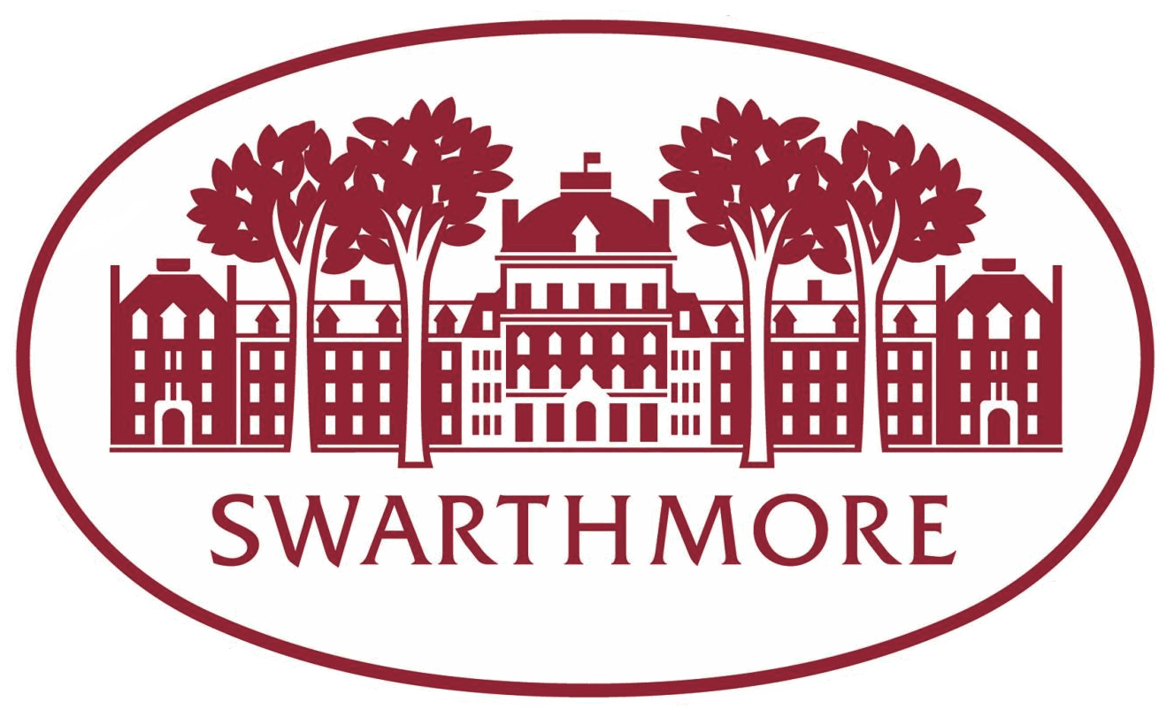

STUDENT ACADEMIC MENTORING PROGRAM
Application for 2024-25 Academic Year

As a critical part of your application to the SAM program, please answer all of the questions below and upload this document onto the JobX platform. For any questions regarding JobX, please contact Meg Wherrity, Director of Student Employment at mwherri1@swarthmore.edu.

Please save this questionnaire as a .pdf before uploading. Complete instructions on the application process are further below. Thank you for your interest in the SAM program!

Name: Class Year:

Major(s)/Minors(s) or Academic Areas of Interest (if undeclared):

- Why do you want to be a SAM? (300-word limit)

- What qualities and skills would you bring to the SAM position? Please provide examples from past experience. (300-word limit)

- Please respond to Scenario 1: During Orientation a First Year student seeks out your advice when choosing their first college courses. What kind of advice would give this student? (300 word limit)

- Please respond to Scenario 2: A student is struggling to manage their classes and extra-curricular activities. Their workload is affecting their ability to perform academically. What approach would you take to work with this student? (300 word limit).

- Describe a time when you’ve worked collaboratively or in a team setting. How would you work collaboratively as a SAM? What people, offices, resources etc. would you want to draw upon in your collaborations? (300 word limit)

- SAMs hold periodic study breaks and programs in the residence halls and across campus. Share a few ideas for study breaks and programs you would like to coordinate if you were a SAM. (300 word limit)

Name of your recommender:

Application Instructions and Process

All applications must be completed through the Swarthmore JobX site:

https://swarthmore.studentemployment.ngwebsolutions.com/

The deadline for completing the application through JobX is 12:00 pm on March 25, 2024. As part of the online application, you must upload: 1) this question form saved as a PDF; 2) your resume; 3) a copy of your unofficial transcript.

The deadline for a letter of recommendation (preferably from a faculty member) is also 12:00 pm on March 25, 2024. The letter must be emailed to mmandos1@swarthmore.edu. The recommender should discuss what skills and character traits you possess that would make you a good SAM.

Interviews will take place on a rolling basis. Once your application is complete, we will contact you to set up an interview.

If you have any questions about the SAM program or the application process please contact the SAM Program Director, Melissa Mandos, at mmandos1@swarthmore.edu.

