May 24, 2022

Dear Students:

If you will be participating in a varsity sport or any of the following club sports:

* Badminton (M),
* Fencing (M&W),
* Rugby (M&W), and
* Ultimate Frisbee (M&W)

during the 2022-2023 academic year, you will need to follow the instructions below:

# Returning Varsity or club student-athletes

**If you are a returning varsity OR club student-athlete, you must enter the system and update your information annually.**

Transfer and First Year student athletes or intend to participate in club sport

1. **You must request to join SportsWareOnLine, beginning on *June 15, 2022*.**
2. Visit [www.swol123.net](http://www.swol123.net/).
   1. The first time you visit the website you will need to enter your Swarthmore College email address and click Get Password.
   2. The school code for Swarthmore College is ***Swat1GoGarnet***
   3. Your request will be sent to the Athletic Trainer for review.
   4. Once your request has been accepted you will be notified within 10 days.
   5. ***Important note:*** your request will not be accepted without your Swarthmore College email address.
3. Once you have received your notification you must provide the following information:
   1. current home address;
   2. emergency contacts;
   3. insurance information including uploading an image of both sides of your insurance card;
   4. medical alert(s)
   5. complete medical history information and
   6. PHQ-9
4. Additionally, you will need to read and complete required paperwork listed under Forms. You will not be permitted to participate in any team activities until this information is completed. This information must be completed by **July 31, 2022**.

# SportsWareOnLine Instructions

## Instructions for Joining SportsWareOnLine

1. Go to [swol123.net](http://www.swol123.net/)



1. Scroll to the middle of the screen and click the **Join SportsWare**

button.

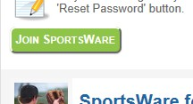

1. Enter your School ID: Swat1GoGarnet

*Important Note:* You should have received a School ID from the athletic trainer. This is required to join the correct school.

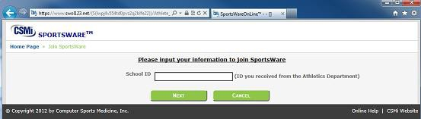

1. Enter your First Name, Last Name, Email address and click the Send button.

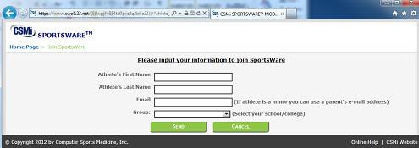

1. Your request to join SportsWare will then be sent to the Athletic Trainers for review.

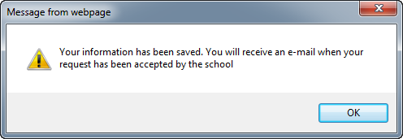

1. Once your request is accepted you will receive an e-mail with the Subject *“SportsWare request accepted”.*
2. Open the e-mail and click the [www.swol123.net](http://www.swol123.net/) link to continue to SportsWareOnLine.

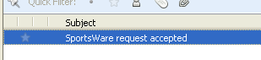

## Setting Your Password

1. Go to [swol123.net](http://swol123.net/)



1. Enter your Email Address and click the Reset Password button.



1. You will receive and e-mail with the Subject “SportsWareOnLine Password Request”.

Open the e-mail and click on the link to reset your password. Enter

your e-mail address, new password and click the Save button.

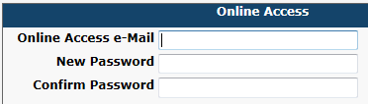

## Updating Your Information

1. Go to [swol123.net](http://swol123.net/)



1. Enter your Email Address and click the Login button.



1. At the top of the page is the Menu Bar.



* 1. My Info: Update your address, emergency contact and insurance information.
  2. Med History: Complete a Medical History questionnaire.
  3. Forms: View/complete required paperwork. ***Important Note:***

SportsWare will also display “You have “x” forms to

complete/download”.



* 1. Print: Print My Info and Medical History data.

# Important Dates

|  |  |
| --- | --- |
| **Date** | **Activity** |

|  |  |
| --- | --- |
| June 15, 2022 | Request to join SportsWareOnLine**.** |
| July 31, 2022 | Update account, complete Medical History, & COVID-19 |

Zoom Info Sessions will be held on July 6th, July 13th, and July 20th. Meeting information will be sent via email after June 15, 2022.

Please do not hesitate to call or email the Sports Medicine Office if you have any questions. Best wishes for a healthy and successful upcoming academic year.

Sincerely,

Marie Mancini, LAT, ATC, CSCS Allison Hudak, LAT, ATC [mmancin1@swarthmore.edu](mailto:mmancin1@swarthmore.edu) [ahudak1@swarthmore.edu](mailto:ahudak1@swarthmore.edu) 500 College Avenue 500 College Ave

Swarthmore, PA 19081 Swarthmore, PA 19081

Ph: 610-328-8223 Ph: 610-690-1273