**List Gallery / Swarthmore College**

***Edith: An Architectural History***

**An installation by Nora Wendl**

**January 19 – February 25, 2023**

**Thurs., January 19**

Artist's talk: 4:30 – 5:30 PM

Lang Performing Arts Center Cinema

List Gallery reception: 5:30 – 7:00 PM

Gallery hours: Tues. – Sun., 12:00 –5:00 PM

Contact: Andrea Packard: apackar@swarthmore.edu

phone: 610.328.8488

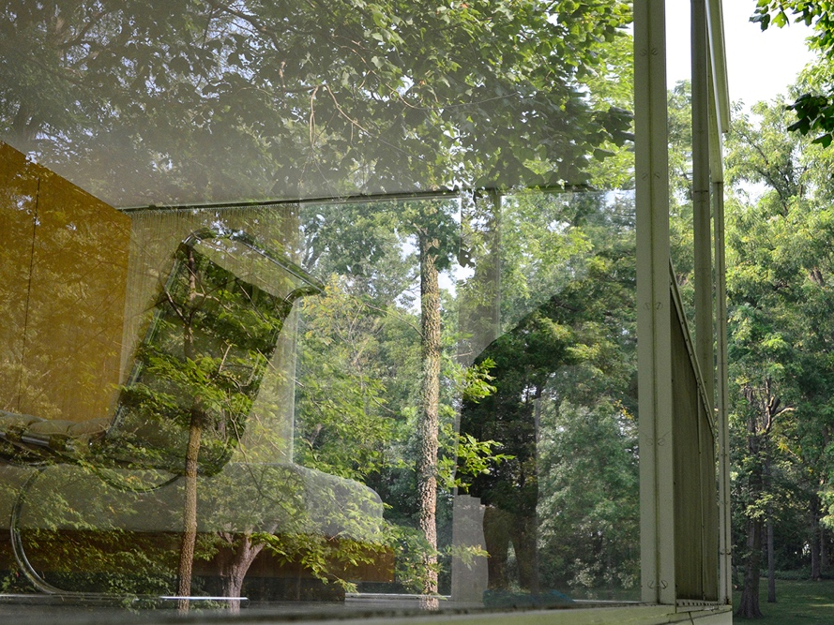

Above: Nora Wendl, *I Listened Series*, digital print, dimensions variable, 2017

Photo: Courtesy of the artist

The List Gallery, Swarthmore College is pleased to present *Edith: An Architectural History*, by Nora Wendl. Incorporating videos, printed fabric panels, and photographic installations, Wendl's List Gallery exhibition calls attention to the myths, controversies, and the redacted testimonies surrounding one of the icons of modernist architecture: The Edith Farnsworth House. Nora Wendl will give a public lecture about her work on Thursday, January 19 at 4:30 PM in the Lang Performing Arts Center Swarthmore College. The List Gallery reception will follow from 5:30 to 7:00 PM. List Gallery hours are Tuesdays through Sundays, Noon – 5:00 PM. Gallery admission and all events are free and open to the public.

Trained as an architect, Wendl researches and reinterprets architectural history through writing, photography, film, installation, and performance. Since 2003, she has focused on the life and work of Dr. Edith Farnsworth a Chicago-based physician who, in 1945, commissioned Ludwig Mies van der Rohe to design a weekend retreat on her riverfront property in Plano, Illinois. The resulting steel and glass house became an icon of 20th Century International style architecture. However, cost overruns, design flaws, and construction delays led to heated disputes and lawsuits between Farnsworth and van der Rohe—a process that interfered with the completion of the building, turned the house into a contested space, and fostered narratives that tend to mythologize van der Rohe as an artistic genius, while casting Farnsworth (without substantiation) in the role of a disappointed lover—ignoring her contributions as a patron and connoisseur, accomplished violinist, medical expert, and more.

A centerpiece of the exhibition is *I Listened*, a series of four 10-foot-long photographs showing different views of The Edith Farnsworth House. The images are printed on semi-transparent panels that hang from the ceiling, creating a space within the gallery that is simultaneously intimate and unrestricted. White plywood staircases placed next to two of the panels invite visitors to imagine themselves ascending to a pristine inner sanctum; at the same time, the steps call attention to the artificial and contingent nature of such perspectives.

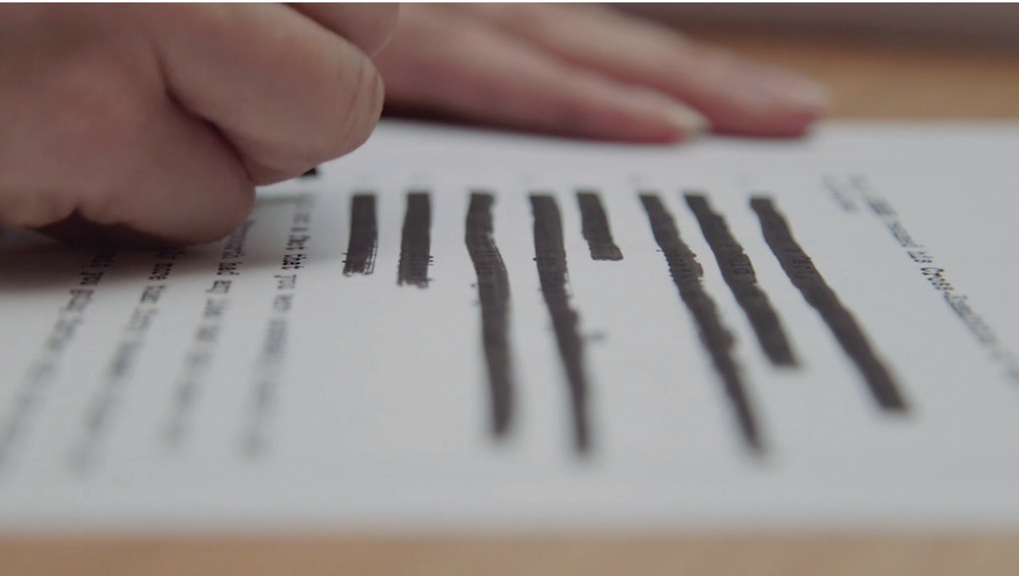 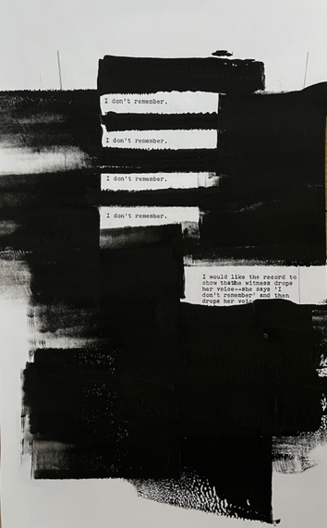

Above, left: Nora Wendl, *"Guard Everything Appropriately and All Will be Well,"* 2018.

Still image from a film produced by Melinda Frame, Albuquerque, New Mexico. At right: detail from *"I do not remember the importance of the moon,"* a wall installation comprised of 20 monoprints together with three tables piled with redacted documents.

The barriers to historical research are writ large in Wendl's two-channel video titled *"Guard Everything and All Will Be Well,"* which documents the artist redacting the trial transcript of *van der Rohe vs. Farnsworth*,a document that she was permitted to read, but not substantially quote, paraphrase, or represent.On an adjacent wall, an installation of redacted transcript pages calls attention to unequal power relationships, reputational gatekeeping, and compromises that can limit our understanding of history.

Nora Wendl is an associate professor of architecture at the University of New Mexico, where she teaches both architectural design and theory. She is also executive editor of the *Journal of Architectural Education.* She has been awarded grants and residencies by numerous organizations, including the Graham Foundation for Advanced Studies in the Fine Arts, the Santa Fe Art Institute, and the National Trust for Historic Preservation (NTHP). For NTHP, Wendl was content lead and design co-lead for the 2020-2021 exhibition *Edith Farnsworth, Reconsidered*, in which the Farnsworth House was staged as Dr. Farnsworth actually inhabited it in the early 1950s—rebutting the claim that Mies van der Rohe furnished the house*.* Wendl has also written and published widely, including poetry, fiction, creative non-fiction, and academic articles that have made their way into popular press. Her most recent publication, “Guard Everything Appropriately and All Will be Well” in *Revista Arquitectura* (2021), examines the trial transcript from *van der Rohe vs. Farnsworth* and the exhibition *Edith Farnsworth, Reconsidered* as twin artifacts—both representing the same period of time (1951 – 1954) and both institutionally redacted to “protect” the legacy of the architect.

*This exhibition is made possible by the Bruno Fine Arts Fund and the programs in Art and Art History.*