This guide will cover how to complete your Benefits Open Enrollment in Workday. Benefits Open Enrollment is typically completed through a task in My Tasks in the fall of each calendar year, where employees are prompted to review and select/make changes to their benefit options.

Key Terms
- Benefit elections: The benefit plans and coverage options you choose during enrollment.
- Benefit plan: A specific coverage option available within a benefit type, such as a medical or dental plan.
- Dependent: An eligible family member, such as a spouse/domestic partner or child, whom you can enroll in certain benefit plans.
- Beneficiary: A person or trust you designate to receive a benefit payment, such as a life insurance payment, in the event of your death.
- Waive: Choose not to enroll in a benefit plan.
- Automatic enrollment: Enrollment in a benefit without requiring you to select it. Automatically enrolled benefits cannot be waived or changed.
- Effective date: The date your benefit coverage begins.
- Open enrollment: The annual designated period when you can review and change your benefit elections for the upcoming plan year.

Detailed Instructions
- Log in to Workday and navigate to your Inbox at the top right corner of your screen to access your benefits open enrollment task. Or, it may also be on your Workday landing page, under the date as a To Do item

- Locate and click on the Enroll button for your Open Enrollment Change task in your Inbox. Click the Let’s Get Started button to begin your enrollment.

- The Enrollment screen will display all benefit plans for which you are eligible.
  - Note: Some benefits are automatically provided to you and will appear as enrolled. These benefits cannot be waived.

- Read the Enrollment Instructions in each benefit plan by clicking enroll or manage.

- Select Enroll to view the plan option(s) for each benefit.

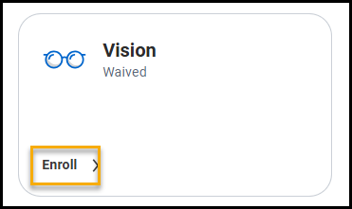

Note: Each FSA and HSA benefit type will say Waived because you must re-enroll in these benefits each year. You will need to click on Enroll for each type of benefit you want to enroll in.

For the FSA and HSA you can enter the per paycheck amount you want to contribute and then click tab and it will automatically calculate the annual amount. Or you can enter the annual amount you want to contribute and then click tab and it will automatically calculate the per paycheck amount.

For the HSA, if you do not want to make an employee contribution but still want to receive the College HSA contribution, you still need to Enroll, however, just keep the per paycheck amount and annual amount at $0.00.

- If multiple plans are available for a benefit, click Select for the plan you want to enroll in.
  - The plans you do not select will be marked as Waive.
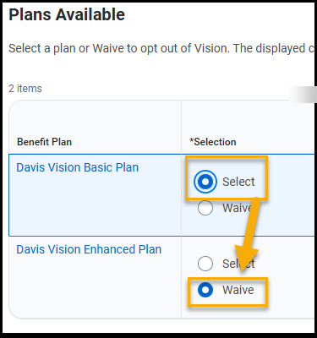
- If there is only one plan option, you can Select that plan or choose to Waive the plan.
- Once you have made a choice, click Confirm and Continue.
  - If you are waiving the benefit entirely, you will return to the main screen where you can review your selections and see the updated enrollment status.
  - If you are electing the benefit, you’ll move to the next screen to add optional dependents.
- If you already have dependents in the system, you will see them listed in a grid. If all necessary dependents are already listed, simply toggle the Select checkbox to include or exclude dependents from this plan.
- If you have dependents that are not listed on the screen, click the Add New Dependent button.
- On this new screen, enter all name and contact information.
  - Be sure to update contact information where it differs from your own address and you will be required to enter their date of birth and National ID (which should be a Social Security Number)

  - Click Save to return to the previous screen.
  - Repeat the process for additional dependents if necessary.

- Back on the main dependents screen, check the box next to the dependent(s) you want to add to your plan and click Save to complete your enrollment.
- After clicking Confirm and Continue, a pop-up will confirm that your selections have been updated but have not yet been submitted. You can review your selections and see the updated enrollment status.
- Continue updating your other benefits. Select Save for Later if you need additional time to review your options.
- You will be required to add at least one beneficiary to the Basic Life, Basic AD&D, and any Supplemental Employee Life and/or Supplemental AD&D benefits for which you enroll. You will click Manage for the Basic Life and Basic A&D benefits then click Confirm and Continue, scroll down to the + sign for Primary beneficiary. You can click the ellipsis to add an Existing beneficiary or create a new beneficiary. If you are creating a new beneficiary, you will need to have their Legal Name and Address (phone #, DOB, and SSN are also preferred but not required). You will repeat this process for each beneficiary you want to add as Primary and you will need to enter the % that you want to allocate to each person. You will follow the same process to add any Secondary beneficiaries. You can refer to the Workday Help Center, Benefits section for more detailed information on how to Manage Beneficiaries.
- Once all benefit elections are complete, select Review and Sign.
- You can then print or save a PDF of your benefit enrollment elections for your records.

Have Questions?
For questions about the content and instructions within this article, please contact benefits@swarthmore.edu.
For technical questions, please contact the Swarthmore Help Desk at support.swarthmore.edu.

