An approach to path movement in the diachronic study of sign languages: Biomechanics and nonarbitrariness

Donna Jo Napoli¹ and Nathan Sanders²

¹Swarthmore College

²University of Toronto

Sign languages seem not to be amenable to traditional historical reconstruction via the comparative method, making it difficult to replicate the successes achieved in the diachronic study of spoken languages. We propose to alleviate this difficulty with an alternative approach that draws upon nonarbitrariness and biomechanics, especially the drive for reducing articulatory effort. We offer a demonstration of this approach, which can add confirmation to known relationships between sign languages and new evidence in support of suspected relationships, helping to fill in a methodological gap in the diachronic study of sign languages.

Keywords: sign languages; historical change; articulatory effort; nonarbitrariness

1. Introduction

We demonstrate an approach to studying historical relatedness of sign languages that can help with recognizing and measuring lexical similarity across sign languages. We ask what it means to see “sameness” in movement by focusing on nonarbitrary form/meaning relationships and biomechanics. “Nonarbitrariness” here is an umbrella term for what is known in the literature as iconic, depictive, associative and mimetic. The term is chosen to help the reader keep in mind that the basic tenet of arbitrariness in investigations of spoken language histories is not assumed here. We outline a range of principles operative in sign languages that are biomechanical and pertain to the drive for ease of articulation. These principles can serve as metrics for determining similarity/sameness of movement in sign languages.
Section 2 offers a brief overview of issues that complicate the diachronic study of sign languages. Section 3 outlines characteristics of movement in signs that we will rely on. In §4, we exemplify how nonarbitrariness is important to recognizing potential cognates, and we exemplify the biomechanical principles outlined in §3 with lexical items from an old sign language (Old French Sign Language) and its modern daughters (including American, Italian, ...). Our conclusions are in §5.

2. Issues that complicate the historical study of sign languages

Despite more than forty years of research (since Frishberg 1975 and Woodward 1978; see Power 2022 for an overview of how thinking about sign languages has changed in the course of this research) and a recent blossoming of studies, fundamental questions persist in studying the historical development and relationships of sign languages. In particular, determining genetic relatedness among sign languages is not straightforward (Abner et al. 2020; Padden 2011; Wilcox & Occhino 2016; Woodward 2011).
Four facts unique to sign languages complicate investigation: one at the individual-person level, one at the societal level and two having to do with language in general. Further, data availability is an issue. And, finally, whether there is regularity of change in sign languages is debatable.

2.1 Transmission of language

Only a small percentage of deaf children are born to (deaf) signing parents; those who are not generally acquire a sign language through association with deaf people outside their families, often at an age older than the age at which hearing children in hearing households and children (deaf or hearing) in deaf households acquire language. This makes schools for the deaf crucially important to the transmission of sign languages (Fenlon & Wilkinson 2015) and opens up the possibility that this unique type of language transmission might have properties that influence historical change.

2.2 Extent of borrowing

Deaf schools themselves introduce complications regarding borrowing. The first school for the deaf in a country is often established by bringing in teachers from another country. In these settings, the language(s) used by the instructors mixes with the varieties of signing that the students bring (largely homesigning; Goldin-Meadow 2014). Because the first school then tends to serve as the parent school for the national sign language, the resultant language contact permeates the language, so much so that some sign languages have been analyzed as creoles, including American Sign Language (ASL; Fischer 1996; Woodward 1978) and British Sign Language (BSL; Edwards & Ladd 1983). This analysis is problematic, at least regarding ASL (cf. Lupton & Salmons 1996; Kegl 2008), and DeGraff (2005) further challenges whether creoles really do form an exceptional class on phylogenetic and/or typological grounds. Nevertheless, the point that sign languages and creoles have widespread language contact as a norm in their history is well-taken (Quinto-Pozos & Adam 2015).
Connected to this point is a factor not unique to sign languages, but its importance to sign languages is growing: deaf people globally are interacting with each other digitally to the point of creating social venues that have taken on the social-cohesion functions that deaf clubs used to serve in earlier decades (Valentine & Skelton 2008, 2009). Digital connectivity of this sort excessively raises the possibility of borrowing between sign languages, and thus of sign languages becoming less distinct from one another (at least regarding the lexicon), and of some sign languages being lost entirely; this happens with spoken languages when population movement occurs (Bromham et al. 2022). This raises the specter of whether horizontal transmission invalidates natural models of linguistic evolution (phylogenetic trees). While Greenhill et al. (2009) argue that this danger does not, in fact, constitute a threat to diachronic study of spoken languages, we know of no comparable studies on sign languages. And while some have suggested ways of teasing apart borrowing from genetic relationships in the area of morphology (Johanson & Robbeets 2012), we see no obvious ways of applying these methods to the range of morphological processes in sign languages.

2.3 Rate of change

Sign languages change more quickly than spoken languages (at least with respect to the rate of differentiation of core concepts; McKee & Kennedy 2000), thus one generation may sign quite differently from its predecessor (Schembri et al. 2010). This effect can be great enough to obscure historical similarities (Abner et al. 2020).

2.4 Nonarbitrariness

Sign languages tend to absorb gestures from the community of the ambient spoken language (de l’Épée 1784; Shaffer 2002; Shaw & Delaporte 2011; Wilcox 2004) as well as create gestures; both of these types of gestures can be nonarbitrary (Goldin-Meadow 2014; McNeill 2000) and subsequently get lexicalized (Janzen 2012; Xavier & Wilcox 2014). While gestures can be of many types, the development from natural gesture discourses in the early stages of a sign language into conventional signs points in this direction (Supalla 2013). Thus, the newly formed lexical items can be similar in sign languages that are not genetically related (Janzen & Shaffer 2002).
Connected to this point is a factor not unique to sign languages, but more prevalent in them: nonarbitrary form/meaning mappings. Handbooks of historical linguistics that analyze spoken languages typically start from the principle that regular sound change is associated with the arbitrariness of linguistic form, and pay little attention to nonarbitrariness. Spoken languages vary in the amount and type of nonarbitrariness in their lexicons (Dingemanse et al. 2015; Dingemanse et al. 2020; Radden 2021) and do not exploit the full range of opportunities for nonarbitrariness available to them. For example, even though the bouba/kiki effect is robust across cultures (Ćwiek et al. 2020), words having to do with the senses of audition and touch are more likely to be nonarbitrary than words having to do with the visual shape of objects (Winter et al. 2017). Lupyan and Winter (2018) attribute the lack of full exploitation of nonarbitrariness in spoken languages to semantics; iconic forms are so connected to specific contexts and sensory depictions that they inhibit easy conveyance of abstract meanings. Dautriche et al. (2017) show that, given a natural language’s phonotactic rules, its lexicon uses a smaller portion of the phonological space than what is available to it, where this phonological clustering may be due to nonarbitrariness. Still, what nonarbitrariness there is in spoken languages can be informative to diachronic studies; similarities in nonarbitrariness can uncover semantic networks that reveal motivated diachronic change (Carling & Johansson 2014).
In comparison, opportunities for nonarbitrariness in sign languages are abundant and robust (Guerra Currie et al. 2002; Lepic et al. 2016; Pietrandrea & Russo 2007; Pizzuto et al. 1995). Sign languages make generous use of encoding real-world visual information into signing (Brennan 2005), resulting in multiple strategies of nonarbitrariness and patterns of such strategies within a given sign language (Padden et al. 2013). This is not because sign languages are exotic (see Braithwaite 2020), and it cannot be exclusively because they are “young” (which many have claimed, but see Cantin & Encrevé 2022 for evidence that some sign languages go back at least to the early Middle Ages); the nonarbitrariness of sign languages is due mostly to modality differences. As Johnston (1996: 65) puts it, “…the fact that our experience, as a whole, is visual, temporal, and spatial means that language that has visual and spatial resources for representation has greater means for mapping onto those very visual and spatial qualities.” To approximate the many types of nonarbitrariness found in sign languages, spoken languages must avail themselves of co-speech gestures (Reddy 1979; McNeill 1992).
We follow Perniss et al. (2010) in viewing lexical items as nonarbitrary if they exhibit regular correspondences between form and meaning motivated by experience with the real world. Many signs originate via metaphor, metonymy, synecdoche, or movement associated with the signified entity (Adam et al. 2007; Hoiting & Slobin 2007; Malaia & Wilbur 2012; Meir 2010; Perniss & Özyürek 2008; Russo 2004; Taub 2001; Wilcox 2000) or derive from cross-modal linked mappings (Napoli 2017) or via indicating, such as pointing to a body part (Ferrara & Hodge 2018) or otherwise describing (Ferrara & Halvorsen 2017). Accordingly, unrelated languages with little or no contact might have the same or similar signs for a given meaning.
At the same time, languages that are genetically related, such as ASL and Italian Sign Language (lingua dei segni italiana; LIS), can have distinct nonarbitrary signs for the same concept. For example, tree and dance are both signed with whole-entity classifiers in ASL, but in LIS, tree is signed with an outline-perimeter classifier, while dance is signed with embodiment. Which properties of the real world are used as the base for a sign can vary so much that it can be difficult to guess at a sign or to recognize the nonarbitrary nature of a sign’s form without knowing its meaning; that is, nonarbitrariness is not to be confused with transparency (Occhino et al. 2017; Pizzuto & Volterra 2000).
Further, a sign’s nonarbitrary origins can be lost when it becomes part of an organized linguistic system (Verhoef et al. 2016), so much so that many signers do not see visual intent in their own conventionalized signs (Cuxac & Sallandre 2007; Klima & Bellugi 1979). Add to this the fact that sign language communities are subject to pressures that aim toward standardization (involving language politics, educational matters and language ownership; see Adam 2015; Eichmann 2009; Pfau & Steinbach 2006), which can also bleach nonarbitrary origins.
Therefore, not only may unrelated languages appear related due to shared nonarbitrariness, but true genetic relationships may likewise be obscured. The result is that neither the presence nor absence of shared nonarbitrariness can be relied upon solely for determining shared history. Still, with this caveat in mind, astute attention to nonarbitrariness may help us better understand sign language change (Currie et al. 2010; Greenhill et al. 2009).

2.5 Availability of data

There are two additional complicating facts that sign languages share with many spoken languages. First, sign languages have historically not been written down; there is little to no data available from periods preceding the invention of video recording and, for many sign languages, no data available until recently (Brentari 2019: 243 ff). A notable exception is French Sign Language (langue des signes française; LSF), where we have written descriptions and illustrations of signs from Old LSF provided in large part by members of the clergy (Blanchet 1850; de l’Épée 1784; Degérando 1827; Ferrand ca. 1785; Lambert 1865; Laveau 1868; Pélissier 1856; Sicard 1808). ASL is also described and sometimes illustrated in some early texts (Brown 1856; Higgins 1923; Long 1910; Michaels 1923), and original film sources (including those by George Veditz of the National Association of the Deaf) are being reformatted and made available to Deaf World (Supalla 2001, 2004; Supalla & Clarke 2015), allowing for study of a range of phenomena (Supalla et al. 2020). Ongoing longitudinal work compares films of other languages over relatively short periods of time, such as Portuguese Sign Language of the Azores (Moita et al. 2018) and Nicaraguan Sign Language (The Hearing Review 2019). For arguments that language change in progress mirrors diachronic developments, see Bailey et al. (1991) and for sign languages Frishberg (1975), Radutzky (1989) and Geraci et al. (2011).
Second, for many sign languages, we do not have contemporary data corpora to allow reliable comparative or internal reconstruction. Important initiatives are changing this, including the SIGN-HUB research project. This is a four-year project funded by the European Union’s Horizon 2020 Research and Innovation Programme. The SIGN-HUB project is collecting data from six sign languages, including from elderly signers (Quer & Boronat 2016, 2017; Geraci et al. 2019), which promises to be an important source for apparent time analysis of diachronic change in these languages. Additionally, Global Signbank (Crasborn et al. 2020) is a lexical database for sign languages administered through Radboud University. The number of languages housed there is growing, as is the amount of data on each. Lexical items are annotated for articulatory features (Börstell et al. 2020). Another ongoing initiative is the Sign Change Project, compiling and annotating data from 13 sign languages in two putative language families to develop a theoretically-informed, quantitative model of sign change and phylogenetic relations (Power et al. 2021). Added to this are initiatives for individual sign languages, more of which are being undertaken all the time, such as the lexical database FLexSign for LSF (Périn et al. 2023). Since the way one annotates or transcribes data is critical to the kinds of questions those data can be used to answer and to the possibilities for comparison between studies, various scholars have developed web-based tools for annotating articulatory features of signs in such corpora, allowing for a lexico-statistical approach based on articulatory features (Abner et al. 2020; Yu et al. 2018).

2.6 Dearth of regular phonological change

An articulatory-based approach to diachronic study in linguistics is motivated to some degree by the Neogrammarian hypothesis of regularity in sound change (Leskien 1876: xxviii; Osthoff & Brugman 1878: xiii), a powerful tool in the historical analysis of spoken languages. However, linguists have been unable to identify regular correspondences in sign languages (Moser 1990; Power 2022), and, as we argue below, for good reason. Of course, spoken languages do not change in a perfectly regular way (Labov 1981), but the difference between the modalities is stark. For example, in the development of modern English, the Middle English long high front vowel /iː/ generally diphthongized to /aɪ/ in all words as part of the Great Vowel Shift (Luick 1896; Jespersen 1909), but we do not see analogous cases of regular phonological change in a given sign language, such as the B-handshape changing to the 5-handshape in all signs, or all two-handed signs becoming one-handed, or all signs articulated on the forehead changing location to the cheek.
It is possible that there is a genuine lack of regular phonological diachronic change in sign languages (Wilbur & Petersen 1997), which could be partially due to the fact that such changes are at the sublexical level, a level where sign languages generally have few phonological rules. The list in §3.2 below contains examples of processes that occur in casual conversation, but none of them is obligatory in any context we know of. Others that truly seem obligatory include Mandel’s (1981) finding that only the selected fingers of a handshape can make contact with a location on the body and can move (secondary movement), and Brentari and Poizner’s (1994) finding that the timing of handshape change within a lexical item is linked to the duration of path (primary) movement. There are also arguments for sublexical phonological rules based on syllable constraints (Brentari 1998; Uyechi 1996) and reduplication in iterative aspect (Sandler 2017). Feature spreading at the sublexical level can happen between a manual parameter and a nonmanual parameter (Loos & Napoli 2021; Woll & Sieratzki 1998). However, most proposed phonological rules are at a higher level; they involve compound formation (Brentari 2019: especially §8.3; Liddell & Johnson 1986; Sandler 1989, 1993) or spreading of features between roots and affixes (Sandler et al. 2011) or from one lexical item to another within a syntactic phrase (where it’s often a nonmanual parameter that spreads: Bank et al. 2015: 45; Neidle et al. 2000; but sometimes a weak hand spreading to the next sign: Brentari & Crossley 2002; Sandler 1999). With few sublexical phonological rules to start with and a tighter link between form and meaning than that found in spoken languages, regular phonological change would be unlikely for sign languages.
An alternative account is that there is, in fact, regular phonological historical change in sign languages, but it is difficult to discern. Along this line, Napoli and Ferrara (2021) argue that relationships between phonological parameters at the sublexical level are obscured without consideration of nonarbitrariness. It could be, then, that regular phonological historical change does take place for some appropriate phonological unit yet to be acknowledged.
Accordingly, ferreting out genetic relationships between sign languages solely on the basis of segmental phonology should be difficult. We expect diachronic change in sign languages to be affected by the drive for ease of articulation – as happens in spoken language – but also, due to nonarbitrariness, to be open to changes influenced by meaning. Since semantic change is largely sporadic rather than regular (Lehrer 1985: 283; Hock 2003: 456), this sporadic characteristic may be transmitted to the phonology via the tight link between phonetics and meaning in sign languages, so that the inherent resistance of regular change in the semantics is shared with the phonology (Taub 2001: 229). This supposition is supported by the way in which phonological change in spoken languages similarly resists regularity when there is a tight link of the articulatory form to the semantics, as with onomatopoeia and other expressive or mimetic lexical items (Jespersen 1922: 288, 406; Joseph 1987; Mithun 1982). We propose that this same link inhibits change in sign languages, but to a greater degree due to the more extensive nature of nonarbitrariness.

3 Movement in sign languages

It is generally assumed that the appropriate degree of similarity one must demonstrate in order to argue that two sign languages are historically related involves comparison of the distinctive manual phonological parameters/categories: handshape, location, orientation and movement. McKee and Kennedy (2000: 48) propose that two signs count as related only if they differ by at most one parameter.
Here we seek to contribute to the discussion on how similarity measures are to be interpreted with respect to movement.

3.1 Movement

The movement parameter has been reported by signers to be the most salient parameter for recognizing signs, either alone for non-native signers or in combination with other parameters for native signers (Corina & Hildebrandt 2002; Corina & Knapp 2006; Dye & Shih 2006; Orfanidou et al. 2009). Thus, understanding how movement changes is critical to historical study. The movement parameter is complex, at minimum involving direction of movement, shape of path, iteration, size of path, dynamics and speed. For our purposes, iteration involves repeated movement in the same direction; thus, moving forward and then backward along the same path is not iteration, just a return movement, but moving forward, then backward, and then forward again is iteration (Wilbur 2005).
There are two types of movement based on joint articulation: primary and secondary. Primary movement involves articulation of the shoulder and/or elbow joint, causing the entire hand to trace a route through space or on the body. Primary movement is often called path movement; the route it traces is a path. Secondary movement involves the other joints of the manual limb (radioulnar, wrist, base knuckles, interphalangeal knuckles) and does not cause the entire hand to trace a path. Nevertheless, secondary movement can cause most of the hand to trace a route through space. For example, in the ASL sign bounce, articulated with a 5-handshape and wrist flexion and extension, the fingers and palm (but not the wrist) trace a visually salient up-down line through space. The important distinction between the two types of movement is that primary movement always involves the entire hand, including the wrist, moving along a path, while secondary movement always keeps at least the wrist in a fixed location (though it might rotate in place due to radioulnar articulation).

3.2 Motivated possible historical changes to the movement parameter

A number of processes that occur in conversational signing affect the articulatory shape of sign languages with respect to movement (Napoli et al. 2014), most often for articulatory ease by reducing mass, acceleration, or distance traveled. In the list below, we catalogue some of those processes as a list of motivated possible types of changes, which, when “undone” can reveal “sameness” of movement and, thus, be used to recognize historical relatedness.

(1) Iteration Loss: Repeated movement along a path in a given direction is reduced to a single movement in that direction, reducing distance traveled and acceleration forces from direction changes, as found in lexicalization of compounds (Corina & Sandler 1993; Liddell & Johnson 1986; Wilbur 2017).

(2) Weak Drop: A two-handed sign with reflexively symmetric movement across the midsagittal plane changes to a one-handed sign by not using the nondominant hand at all (Frishberg 1975; Padden & Perlmutter 1987; Zimmer 2000), halving the total amount of moving mass.

(3) Weak Freeze: A two-handed sign with reflexively symmetric movement changes to a two-handed sign with only one hand moving by keeping the nondominant hand static in a fixed position (Mak & Tang 2011; Padden & Perlmutter 1987), reducing the total amount of moving mass.

(4) Joint Freeze: One or more joints are subtracted from the articulation of a sign via freezing of joint(s), reducing the total amount of moving mass, with the shoulder and elbow being particularly prone to freezing (Meier et al. 2008; Napoli et al. 2014).

(5) Joint Graft: One or more joints are added to the articulation of a sign, usually the radioulnar or (most commonly) the wrist, in conjunction with Joint Freeze of a more proximal joint, maintaining the overall visual shape of the path (Crasborn & Kooij 2003; Frishberg 1975; Meier et al. 2008; Napoli et al. 2014; Radutzky 1989).

(6) Torque Reduction: Movement changes to avoid incidental torso twisting or rocking, reducing the reactive effort needed to maintain a stable torso, with twisting being more unstable than rocking (Sanders & Napoli 2016a, b).

(7) Lowering: The location at which a sign is articulated is lowered, reducing the lift needed in raising the hands to a higher location (Tyrone & Mauk 2010).

(8) Location Undershoot: Movement to a target location is cut short, reducing the distance traveled (Brentari & Poizner 1994; Mauk 2003; Poizner et al. 2000).

(9) Midsagittal Symmetry: Other types of symmetry give way to reflexive symmetry across the midsagittal plane, reducing cognitive effort of muscle coordination (Frishberg 1975; Napoli & Wu 2003) and facilitating perception (Ferrara & Napoli 2019; Mechsner et al. 2001).

These types of changes are based on the biomechanical drive for ease of articulation. For instance, a common kind of Joint Graft is called “distalization” (Mirus et al. 2001) or “joint migration” (Poizner et al. 2000), where a more proximal joint freezes and a more distal joint is grafted, thus reducing effort. Napoli et al. (2014), find that joint freezing occurs in 97% of the conversational variants of signs in their data set, while joint grafting occurs in only 29%. Hence, we have chosen to list Joint Freeze separately from Joint Graft.

3.3 Utility

The processes in §3.2 are optional, and none is without qualification. Consider perhaps the most obvious example of effort reduction: Weak Drop. Frishberg (1975) found for ASL that signs articulated on the face tend to become one-handed, while signs made below the neck tend to become two-handed; Radutzky (1989) found the same for LIS. This tendency is predicted from Siple’s (1978) observation that signs made outside the foveal (i.e., central) vision of the addressee require help in being visually perceived – thus they should be larger with both hands moving, whereas signs on the face can be smaller with one hand doing the job by employing a wide range of handshapes. Consistent with this finding, Caselli et al. (2022) show for ASL that high-frequency signs are articulated closer to the face than low-frequency signs and that high-frequency signs with rare handshapes occur closer to the signer’s face than those with common handshapes. Battison (1974) and Brentari (1998) found that signs in which both hands move symmetrically and simultaneously can undergo Weak Drop, but signs with out-of-phase (alternating) symmetrical movement do not. Tkachman et al. (2018) correlate this to the fact that in-phase symmetrical movement is usually not repeated, while out-of-phase movement is (which they attribute to vestigial locomotor central pattern generators in the brain). Brentari (1998) notes for ASL that Weak Drop is inhibited if the two hands have continuous contact during the movement, but Kooij (2001) finds no such inhibition in Sign Language of the Netherlands. Siedlecki and Bonvillian (1993) find that among children, Weak Drop is more likely if both hands are in contact with the body.
Weak Drop clearly has a range of potential inhibiting factors, most of which just might lend themselves to a unified account. In order to see this, consider first Sanders and Napoli (2016a), who look at 24 languages and find that all exhibit a drive to reduce the effort needed to resist torque, as evidenced in the shape of their lexicons. In particular, twisting signs occur less frequently than rocking signs, which occur less frequently than signs that induce neither twisting nor rocking. This uniformity of lexical distribution of different types of signs holds across sign languages (which vary from being very young to centuries old) and suggests that sign languages have a drive to maintain a somewhat stable proportion of different types of torque-inducing movement in signs over time. Keeping this in mind, we also note that there are many signs in many languages that have lexical iteration (cf. Iteration Lost), use two moving hands (cf. Weak Drop and Weak Freeze), move the shoulder and/or elbow joint (cf. the combination of Joint Freeze and Joint Graft), are made high in signing space (cf. Lowering) and call for a relatively long movement path at least in their citation form (cf. Location Undershoot).
We suggest that sign languages tend to exhibit a somewhat stable proportion of all types of allowable movement in signs over time: stability protects utility. Gibson et al. (2019) offer a review of recent work on spoken languages that addresses how languages achieve utility – that is, a balance between efficiency and complexity. The notion of communication relevant to their review is the information-theoretic view:

First, an information source selects a message to be transmitted. Next, the message is encoded into a signal, and that signal is sent to a receiver through some medium called a channel. The receiver then decodes the signal to recover the intended message. Successful communication takes place when the message recovered at the destination is equal to the message selected at the source, or diverges from it only slightly. (Gibson et al. 2019: 391)

Efficiency for them means that the message is accurately interpreted, regardless of its context, with minimal effort on the part of the interlocutors, quantified via the length of messages: short messages are most efficient. Complexity for them is about learnability, where languages must be infinitely expressive but still learnable; simpler systems are more easily learned. Languages achieve utility largely through being compositional, where, to a great degree, the meaning of novel expressions is a predictable function of its parts. However, as Gibson et al. (2019: 400) note, iconicity and systematicity are also important players in utility; children may bootstrap their way into learning a language via nonarbitrariness. Kirby et al. (2014) argue that compositionality plus iterated learning can overcome the poverty-of-the-stimulus problem and can allow a framework for language emergence. Similarly, Dingemanse et al. (2015) consider experimental results in iterated learning that suggest the importance of the role of repeated cultural transmission in creating and maintaining systematicity. Koplenig et al. (2022) conducted a large-scale quantitative cross-linguistic study of written language, concluding that the trade-off is (at least partially) shaped by the social environment in which languages are used.
Sign languages also develop means toward efficiency based on nonarbitrariness. Nonarbitrariness aids children in acquisition of sign languages (Caselli & Pyers 2017, 2020; Ortega et al. 2017; Thompson et al. 2012; Vinson et al. 2008), and deaf parents are aware of this: they often modify nonarbitrary signs in ways that highlight the shared features between the sign and its meaning (Perniss et al. 2018). Thompson et al. (2010) show how nonarbitrariness speeds response time and improves accuracy in a picture and sign matching test. Slonimska et al. (2023) examine experimental evidence from earlier studies (Slominska et al. 2020, 2021, 2022) that show how simultaneous and nonarbitrary constructions in LIS evolve and are used for communicative efficiency.
Maintaining a wide range of different movements in sign languages allows for different nonarbitrary associations. If the loss of a biomechanical feature will lead to unrecognizability of the nonarbitrary part of the sign, the utility of a language is decreased by that loss; thus, effort-reduction processes in sign languages should be curtailed by the need to maintain recognizability (Napoli & Liapis 2019). The loss of any particular type of movement could reduce the communicative potential of the language. For Weak Drop in particular, maintaining two hands allows for different nonarbitrary relationships between the hands, where those relationships can carry a wide variety of meanings (Börstell et al. 2016; Crasborn 2011; Lepic et al. 2016; Kooij 2002). Hence, utility might demand that no movement type should be entirely abandoned in a sign language.
Certainly, attributing a given historical (lack of) change to the trade-off between efficiency and complexity is not straightforward; other factors may come into play in both spoken languages (Levshina 2020) and sign languages. Nevertheless, given the richness of nonarbitrariness in sign languages, we believe the trade-off needs to be considered. Hence, we plow forth.

4 Examples of this dual approach to analyzing the movement parameter

We here exemplify how considering nonarbitrariness and biomechanics grants insight into whether the movement of two signs is similar enough that they might possibly be cognates.

4.1 Data set

Our examples come from the STS database, run by the European Sign Language Centre in Örebro, Sweden. The lexical entries are presented in whichever language the user has selected for reading the website (we selected American English, the default setting), and the database can be searched by main entry and filtered by category, which may be syntactic (Nouns, Verbs, Sentences, etc.) or semantic (Architecture, Military & Weaponry, At the hair salon, etc.). These main entries do not reflect well-defined lexemes, a problem with most sign language databases (Johnston & Schembri 1999). For example, Fenlon et al. (2015: 176) point out that the STS main entries excited and enthusiastic would be grouped into the same lexeme in a properly lemmatized dictionary of BSL, but in STS, they are separate entries containing different videos depicting different signers, with no indication that the two signers are in fact signing the same lexeme. It seems unlikely that this lexicographical shortcoming would systematically skew in favor of or against any particular one of the processes (1–9) listed in §3.2, let alone all of them. Additionally, STS rarely points out contemporary variants of a sign, which might serve as better candidates for cognates than the lexical items in the database. Since our goal, as we have stated, is to demonstrate possible historical processes at work (not to argue for a particular genetic relationship), we take the STS database to be adequate for this purpose, with the understanding that properly lemmatized dictionaries which list more variants would yield more reliable results and should be used when available.
For a detailed quantitative phonetic study, the ideal would be to use high quality, multi-camera video data, recorded using a motion-sensing input device (such as Kinect) and its accompanying software (Puupponen et al. 2014). The videos we analyze, instead, are available on the Internet and were not collected for exacting linguistic study. Further, we used eyeballing to make judgments of joint movements. Still, we believe our analysis is adequate to the task of demonstrating the approach we propose, since the cameras always catch the full movement of the manual articulators and whether a joint in the manual articulators moves is relatively apparent to bare vision.
We restrict our examples to confirmed or hypothesized members of the Old LSF family because much of the work in this area is available to us. Discussion of the origins of Old LSF are found in Cagle (2010) and Lane (1980). For description of the spreading of Old LSF via teachers from the initial school fanning out to establish schools in other countries, see Berthier (1852). The Old LSF family is large: Wittmann (1991) lists a total of 30 languages that at least potentially belong to it (and see earlier editions of Ethnologue: Simons & Fennig 2019).
Beyond documents about the history of deaf education in various countries, a variety of linguistic studies contribute to our knowledge of sign language families, including the Old LSF family. Anderson and Peterson (1980) applied the comparative method to European sign languages. We do not have access to that work; however, Power et al. (2020) report them as finding evidence for two families: South-West European (consisting of three main branches: French-, Polish- and Spanish lineages) and North-West European (consisting of British-, German- and Swedish lineages).

Napoli et al. (2011) examined direction of path movement in the sign languages of the United States, France, Italy, Australia and the United Kingdom to try to use phonetic information to confirm deaf-education evidence that the first three are in one family and the other two in another. Their corpora were entire dictionaries, and their findings confirmed the memberships of the two families. They then applied their method to studying a sixth language proposed to be in the Old LSF family, for which the historical evidence regarding deaf education was more controversial: Nicaraguan Sign Language. Their results cast doubt on that proposal.

Power et al. (2020) compared manual alphabets across many sign languages using a neighbor-net based on simple (Hamming) pairwise distances calculated from the standard-coded CogID binary matrix to arrive at a set of members in what they call the French group, with important differences from Wittmann (1991) and Anderson and Peterson (1980). First, they find a Spanish group distinct from the French group. Second, they argue that, while an Austrian-origin group of sign languages have manual alphabets that initially make them appear to be in the French-origin group (with the exception of Iceland), that fact is due to early but minimal contact. Thus, the Austrian group is not a member of the French group. Third, their net includes two more languages in STS – Greek SL and Finnish SL – as well as others not in STS. They offer extensive discussion of both the dispersal of Old LSF from the late sixteenth to the late nineteenth century in support of their findings.

4.2 Nonarbitrariness

When comparing lexical items, one must first check for nonarbitrariness. Languages belonging to the same family might well choose different nonarbitrary ways to present meanings, and thus confound the issue of finding cognates. We first show an instance in which nonarbitrariness shows sign are not cognates. We temper that with another instance in which movement is similar, but, in light of nonarbitrariness, we conclude the signs are most likely not cognates, which we then confirm by checking with an Old LSF dictionary.
First, consider cook in ASL, LIS and LSF (Figure 1). Though the development of ASL is complex (Tabak 2006), it is clear that ASL and LSF share a common ancestor. Shaw and Delaporte (2011, 2015) demonstrate how individual lexical items in ASL came from Old LSF. For the history of LIS as influenced by LSF, see Radutzky (1992), Corazza (1994), Pinna et al. (1994). The initial school for the deaf in Rome emphasized lip-reading, which spoken Italian lends itself to readily (Volterra & Bates 1989) and which may account for the prevalence of mouthing today (Ajello et al 1997; Roccaforte 2018), although mouthing is not a core component of the grammar (Giustolisi et al. 2017).

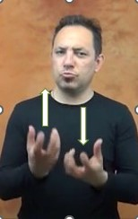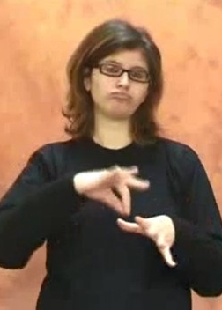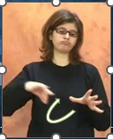

ASL LIS LSF
Figure 1: cook in three potential members of the Old LSF family

In ASL, the nondominant hand in cook is a classifier for a flat object (unmoving), while the dominant hand is like a spatula, flipping one way then the other (via radioulnar articulation) – as in cooking a steak or pancakes. In LIS, the hands move out-of-phase in vertical lines, like bubbles rising in a pot of boiling water – as in cooking pasta. In LSF, the nondominant hand behaves as though it is holding the side of a bowl (unmoving) while the dominant hand is like a spoon or whisk, moving in a circle above the (unseen) bowl – as in whipping up egg whites or cream. These movements cannot be derived from the same source.
On the other hand, sometimes movements can be similar, but nonarbitrariness indicates different sources. Here we compare an LSF example to an example of Pakistani Sign Language. The Indo-Pakistani Sign Language of India (IPSL-I; notated on STS as both “English (India)” and “Hindi”) and of Pakistan (IPSL-P; notated on STS as “Urdu”) might belong to the Old LSF family (Desai 1930; Stevens 1923; Woodward 1993), although the evidence for this is weaker than the evidence for ASL and LIS. Though Zeshan (2003: 157) states that “IPSL is not known to be related to other sign languages of either Asia or Europe”, we consider the possibility that the IPSL dialects may belong to both the Old LSF and Old BSL families, via a connection between Old IPSL and Irish Sign Language (ISL), which itself was originally influenced by BSL (via teachers of the deaf) and later by LSF (via nuns from Dublin visiting Paris to learn how to teach deaf students) (Adam 2012; Burns 1998; Woll et al. 2001). Early writings show pockets of deaf people in India had been using sign languages for centuries (Dennis 2005). In the deaf school in Bombay, a number of Irish nuns and brothers were instructors, and they were accustomed to teaching in ISL. Thus, ISL likely mixed with the varieties of indigenous sign languages that the students brought to the Indian schools (McBurney 2012), and due to ISL’s mixed history, we therefore have a potential second-generation link connecting the dialects of IPSL to both Old LSF and Old BSL.
Given this suggestive evidence of relatedness, consider attention in ISPL-P and LSF (Figure 2). The sign we are calling IPSL-P₂ is no longer available on STS, but it remains available on the Internet.

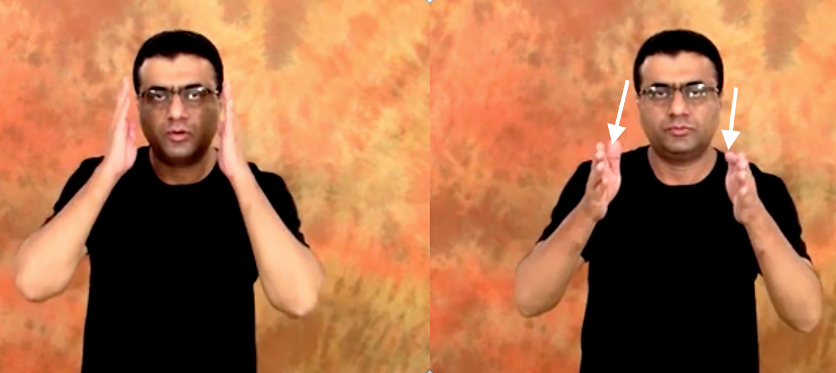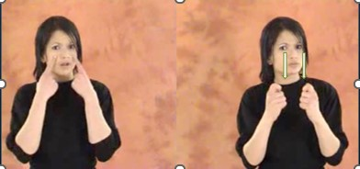

IPSL-P₂ LSF

Figure 2: attention in two potential members of the Old LSF family

The starting point in IPSL-P₂ is the outer sides of the eyes, and in LSF, below the eyes. In both, the movement path is straight and ends at a point in front of the very upper part of the signer’s chest. Primary movement involves extension of the elbow and, possibly, a very slight rotation of the shoulder joint. The LSF sign, however, also involves an extremely short iteration of the path at the very end (we refer the reader to STS, rather than trying to represent this in the image), as though the hands bounce after they hit the end point of the movement path.
Setting aside their near identity of primary movement, these signs seem to be built on different approaches to the sense of attention. The handshapes are telling. The flat-B-handshapes at the sides of the eyes in IPSL-P₂ rely on the iconicity of hands as blinders, restricting eye gaze to straight ahead. Since the hands do block out visually peripheral information, this iconic source is concrete. Other potential members of the Old LSF family use the “blinder iconicity” for attention (such as ASL and LIS), as do many other sign languages not in the Old LSF family, including those of Great Britain, Germany and China (the Chinese sign is a compound, the second element of which is the relevant part). Additionally, we note that in the sign language of Brazil (língua brasileira de sinais; Libras), concentrate uses this blinder iconicity; Libras’ history is well studied (Campos de Abreu 1994; Noberto et al. 2014; Quadros & Campello 2010; Ramsey & Quinto-Pozos 2010; Xavier & Agrella 2015). Campello (2011) studied the first dictionary of Libras, Gama’s (1875) collection of lithographs (Sofiato 2011), and found that LSF was integrated into an already existing indigenous sign language of Brazil. Thus, it appears this iconic source was widely available within the Old LSF family and outside it.
However, the blinder iconicity is not apparent for the LSF sign attention. Again, handshape is telling. Upward-pointing 1-handshapes initially face towards the speaker, indicating eye (as seen in eye in LSF), and then slightly rotate to face almost contralaterally while both interphalangeal joints bend, curling the fingers. This handshape change is not an orientation change (Wilbur 1979; finger orientation is the direction in which the hand-internal finger bones, i.e., the metacarpals, point), which remains up throughout. The final location is emphasized via the bounce.
While the handshape change from 1 to (super)bent-1 is legitimate at the sublexical level (that is, the selected finger is the one that undergoes change; Brentari 2011), it’s hard to imagine an iconic or articulatory motivation within the blinder iconicity. Further, the final bounce is decidedly odd. There is a difference between repetition of movement inherent to the lexical item – iteration – and morphologically motivated repetition – often called reduplication. Certainly, iteration in conversation is often inexact, repeating only a part of the path, and reduction happens even in morphological reduplication (MacLaughlin et al. 2000). Still, the citation form of a sign (as in STS) usually shows full iteration; plus, in conversation, even if a sign’s path is reduced, iteration generally consists of more than a bounce unless the sign occurs in final position in a phrase, where iteration can be lost entirely (Nespor & Sandler 1999). The iteration in the LSF sign occurs only on the bent-1-handshape, so it belongs only to the part of the sign after the handshape change. This behavior is not typical of simple signs; it looks suspiciously like that of a compound that has not been lexicalized (Liddell & Johnson 1986) or reduced (Lepic 2016). We propose the iconicity is a metaphor on taking the eyes (in the first part of the sign) and putting them in a particular place (in the second part of the sign): the “put-eyes-here” metaphor. In the sign language of Mexico (lengua de señas mexicana; LSM), which has also been argued to be in the Old LSF family (Guerra Currie 1999; Guerra Currie et al. 2002; Hendriks & Dufoe 2014; Jullian Móntañes 2001; Quinto-Pozos 2006, 2008; Ramsey & Quinto-Pozos 2010) attention also seems to use the “put-eyes-here” metaphor.
Despite the strong similarity in the movement parameters of attention in IPSL-P₂ and LSF, these signs are not cognates. We support that with information from two Old LSF dictionaries.
Lambert’s dictionary of Old LSF was published in 1865. The year in which LSF instructors were involved in the establishment of schools for the deaf in India and Pakistan was 1895 (via ISL, for which no date is given for the Irish nuns’ visit to Paris, but which is presumably not much before they brought it to India and Pakistan). Thus, Lambert’s (1865) dictionary (which includes descriptions and drawings) offers an appropriate check for our speculation.

Delaporte (2007) is a dictionary of Old LSF, in which the author gives examples from a textbook written by the deaf poet Pélissier (1856, unavailable to us), who was a teacher at the Paris Deaf Institute in the mid 1800s, and who explained sign language to other teachers of the deaf (Quartararo 2008). Thus, this dictionary, also, is of great value.

Considering the blinders iconicity, we propose a source sign in Old LSF with B-handshapes focusing one’s attention by blocking out extraneous visual information. We find no such sign in the Lambert dictionary, nor in the Delaporte dictionary. But there are signs in the Delaporte dictionary that suggest that using the B-handshape as a blinder was an iconic base in Old LSF. parler en cachette ‘speak in secret’ (Delaporte 2007: 112; attributed to International Visual Theater (IVT) 1990) puts the B-handshape on one side of the mouth, then moves it to the other side of the mouth, blocking visual access to the lips. The sign changer d’avis ‘change opinion’ (p. 126; attributed to IVT 1986) has the B-handshape beside the eye change direction via radioulnar articulation, as though what one could see has now changed (changer ‘change’ alone is a B-handshape in neutral space with the same radioulnar articulation; p. 125). The sign classe ‘class (as in school)’ (p. 139) has the B-handshape beside the eye move down to hit the weak hand, as though directing the gaze toward a particular point (Delacorte relates this sign to learning). Hence, we stand firm beside the proposal that Old LSF recognized the blinders iconicity of the B-handshape beside the eye. Perhaps it was so widely prevalent that it was considered more gesture than sign and thus overlooked by these scholars.

Considering the “put-eyes-here” metaphor, we note Lambert’s (1865: 73) Old LSF sign prudent in Figure 3, where prudent and attention in LSF are identical. It is unclear from Lambert’s drawing whether the second element of this compound is iterated, but the dotted lines appear to indicate that the axis of movement is away, i.e., toward the body.

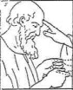
Figure 3: prudent in Old LSF (Lambert 1865: 73)

Delaporte (2007: 71) gives three signs under the entry attention (Figure 4). The first he attributes to Pélissier (1856) with the gloss prudent. He offers the iconicity of managing or controlling via reins (and this is the sign on STS for manage in LSF, ASL and LIS, with out-of-phase movement). The second and third he attributes to IVT (1986) with the gloss attention. He offers the explanation that these two forms for attention are compounds made of pointing to the eyes then controlling via reins, in one case, and taking care, in the other case.

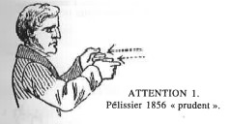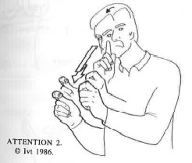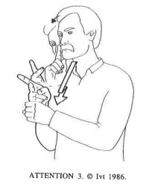

Figure 4: prudent and two variants of attention in Old LSF (Delaporte 2007: 71)

Perhaps the sign in Figure 3 and the middle sign in Figure 4 were variants of each other. Either could be the source sign(s) for the “put-eyes-here” signs in the modern languages. It seems the original metaphor was not “put-eyes-here”, but “eyes-control” in Old LSF.
There are two major takeaways from this demonstration. First, consideration of nonarbitrariness must go hand-in-hand with consideration of biomechanics. Second, semantic shift is part of the historical puzzle in sign languages just as in spoken languages (Deo 2015; Traugott 2012). A one-to-one approach to meaning based on an English (or any other language) translation of each sign is unlikely to consistently yield the true set of cognates that must be considered.

4.3 Biomechanics

Here we offer two examples from members of the Old LSF family for each of the biomechanical processes listed in §3.2. When one looks in STS at the sign languages for which membership in the Old LSF family has been proposed, there are many potential examples for these processes, however, most lack entries in the Old LSF dictionaries that we have access to.

4.3.1 Iteration loss

Consider know (Figure 5). In Old LSF, connaître has iteration (Delaporte 2007: 155). Today know has iteration in IPSL-I, but not in LSF. It appears Iteration Loss has applied in LSF.

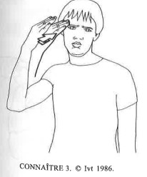

Old LSF (iteration)

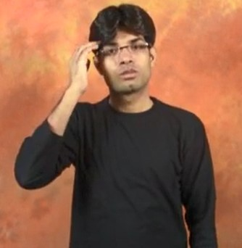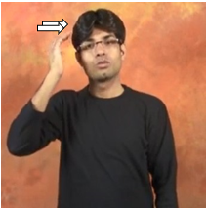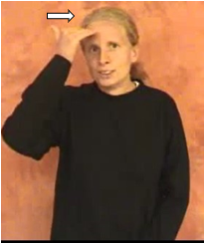

IPSL-I (iteration) LSF (no iteration)

Figure 5: know in Old LSF, IPSL-I and LSF

Another example is the two-handed sign name in Old LSF (nom, Delaporte 2007: 412) and LSF versus the one-handed sign in Spanish Sign Language (lengua de signos española, LSE). It is possible that LSE was influenced by LIS, as the Jesuit scholar Lorenzo Hervás y Panduro visited the school for the deaf in Rome before helping found the first public school for the deaf in Spain in Barcelona in 1800 with Joan Albert i Martí (Quer et al. 2010).

4.3.2 Weak Drop

Consider milk (Figure 6). In Old LSF lait, two hands move vertically out of phase with iteration (Delaport 2007: 339). In IPSL-I, two hands make the same movement, but Libras has only one hand, with a shorter movement path, maintaining iteration. It appears Weak Drop has applied in Libras.

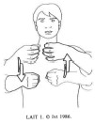
Old LSF (two hands)

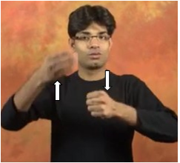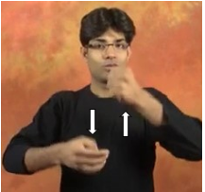
IPSL-I (two hands) Libras (one hand)

Figure 6: milk in Old LSF, IPSL-I and Libras

Another example is two-handed biology in Old LSF (biologie, Delaporte 2007: 96) and LSF versus the one-handed sign in Libras.

4.3.3. Weak Freeze

Consider sentence (Figure 7). In Old LSF phrase (Delaporte 2007: 340), the hands move away from each other, with out-of-phase secondary radioulnar movement. The sign sentence in LSF likewise has two moving hands, but only the strong hand moves in ASL. It appears Weak Freeze has applied in ASL.

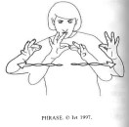

Old LSF (both hands move)

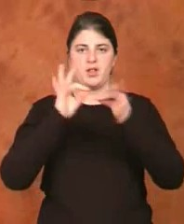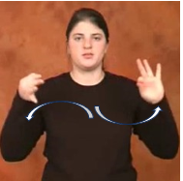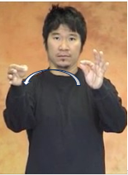

LSF (both hands move) ASL only one hand moves

Figure 7: sentence SENTENCE in Old LSF, LSF and ASL

Another example is interpret. In Old LSF (dechirer, Delaporte 2007: 282) and IPSL-I, two hands move. But in ASL, the weak hand is frozen.

4.3.4 Joint Freeze

Consider already (Figure 8). In Old LSF déjà (Delaporte 2007: 185), the elbow, the radioulnar and the wrist articulate. In LIS, the elbow and radioulnar articulate. And in ASL, only the radioulnar articulates. It appears Joint Freeze has applied once in LIS and twice in ASL.

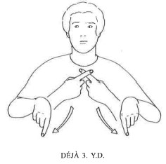

Old LFS

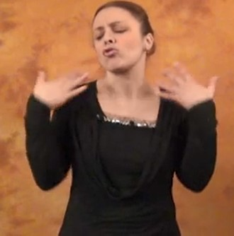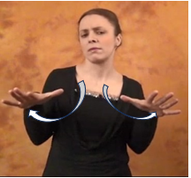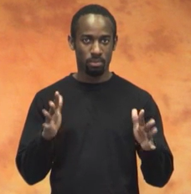

LIS ASL

Figure 8: already in Old LSF, LIS and ASL

Another example is finish. In Old LSF (fini, Delaporte 2007: 185) and in LSF, the elbow, radioulnar and wrist articulate, versus in Libras, where only elbow and wrist articulate. It appears Joint Freeze applied in Libras.

4.3.5 Joint Graft (as part of Distalization)

Consider color(s) (Figure 9). In Old LSF couleurs (Delaporte 2007: 186), the hand moves in front of the lips, from one side to the other, with the fingers trilling; the shoulder joint and the base knuckles of the hand articulate. In IPSL-I, the same joints articulate, however the starting position is with the elbow lifted and the palm oriented downward, and the handshape is different, where only the selected fingers trill. In Libras, the internal hand movement is the same as in Old LSF, but the direction of movement is from the mouth forward, which happens via elbow articulation. It appears that Distalization applied in Libras.

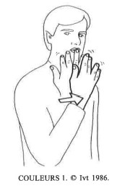

Old LSF

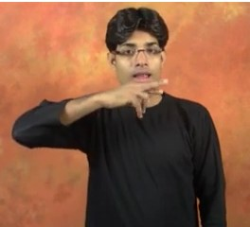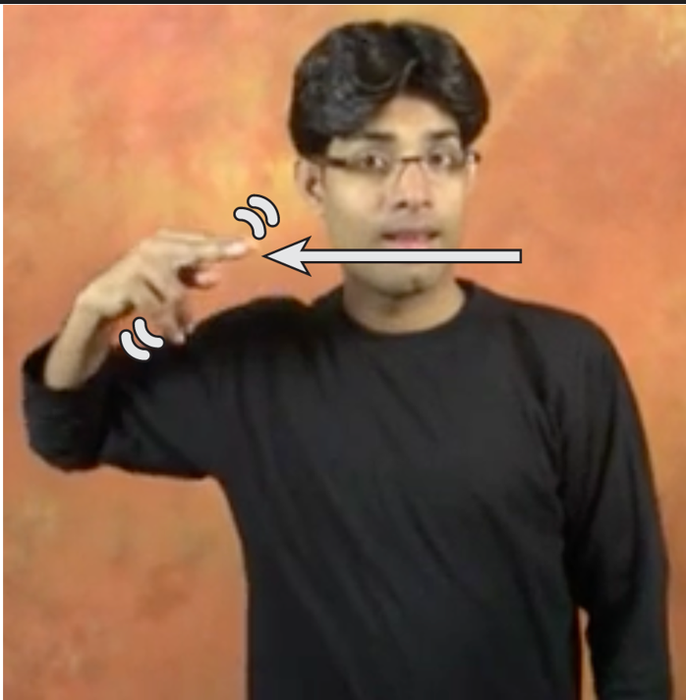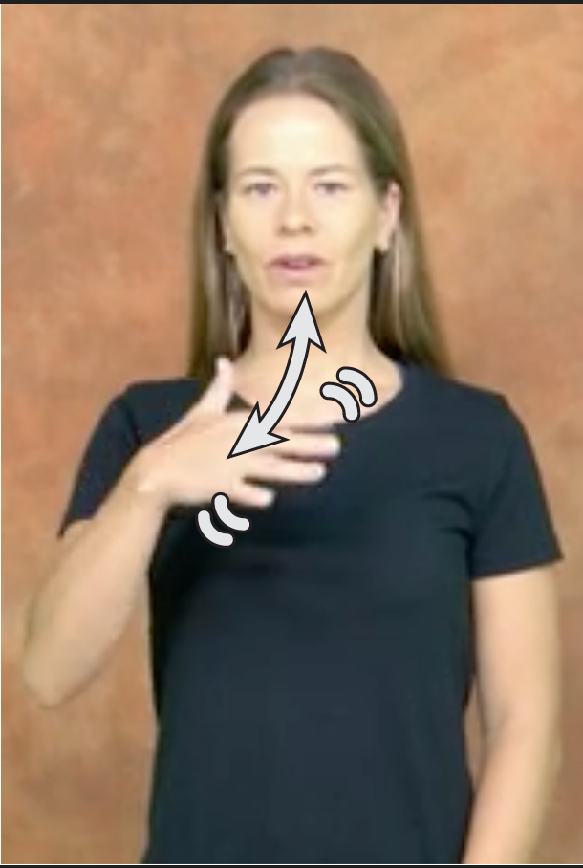

IPSL-I Libras

Figure 9: COLOR(S) in Old LSF, IPSL-I and Libras

Another example is steal. In Old LSF voler (Delaporte 2007: 626), the shoulder, elbow and radioulnar articulate (shoulder movement is necessary to bring about a curve in the path). In ASL, the shoulder articulates (in this video), so it appears Joint Freeze applied twice. In LSF, the radioulnar and wrist articulate, so it appears Distalization applied.

4.3.6 Torque Reduction

Consider snow (Figure 10). In Old LSF neige (Delaporte 2007: 409), the movement is a translation symmetry, where both hands move in a diagonal from high to low, with a bit of a zig-zag in the middle of the movement. In LSF, the movement path is straight (it has no zig-zag), but still diagonal. In LIS, the movement path is straight and vertical (symmetrical across the midsagittal plane). It appears Torque Reduction has applied in LIS.

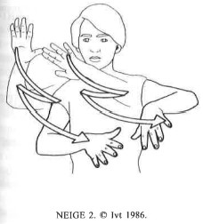

Old LSF

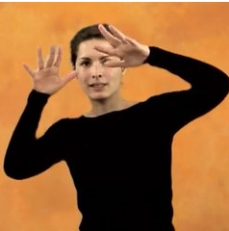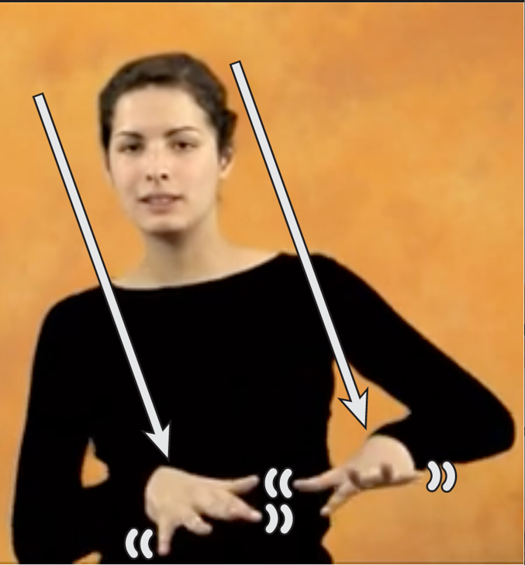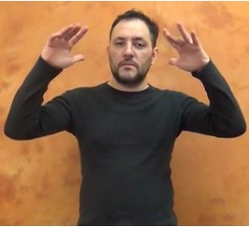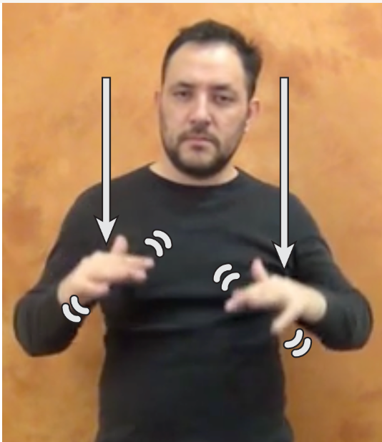

LSF LIS

Figure 10: snow in Old LSF, LSF and LIS

Another example is server. In Old LSF serveur (Delaporte 2007: 1986), both hands move horizontally in the same direction with iteration. In ASL the movement is the same, but without iteration (see the first half of the compound on STS). In LSF, the sign is one handed and the direction of movement is forward – away from the signer – with a slight zig-zag pattern and no iteration (see the second half of the compound on STS). It appears Torque Reduction and then Weak Drop have applied in LSF.

4.3.7 Lowering

Consider white (Figure 11). In Old LSF for blanc (Delaporte 2007: 98), movement starts at the side of the neck and moves forward diagonally. The sign white in LSF today is the same, but in LIS the starting point is the center of the chest. It appears Lowering has applied in LIS.

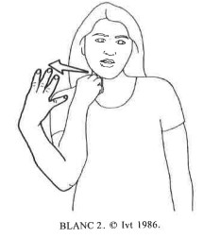

Old LSF

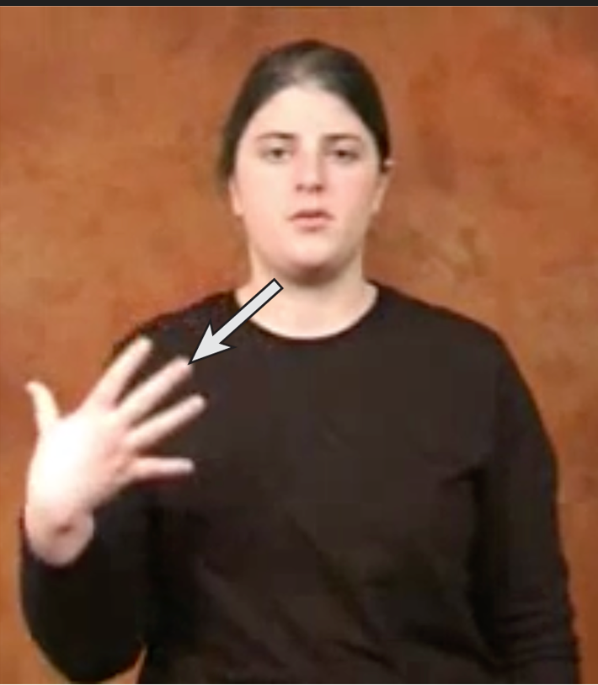 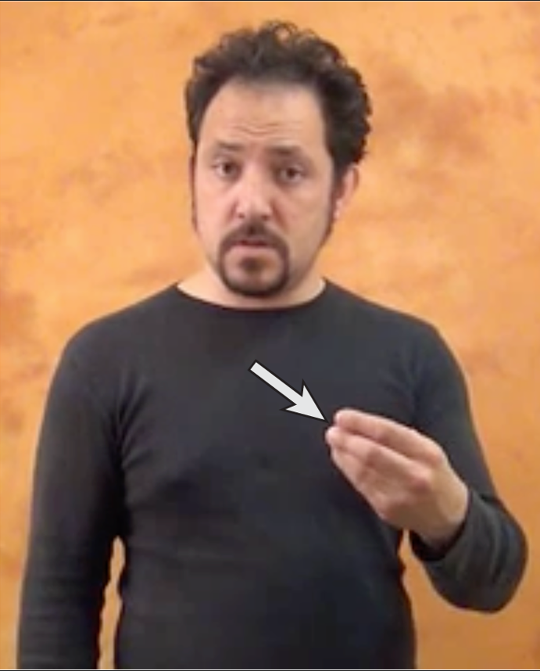
LSF LIS

Figure 11: white in Old LSF, LSF and LIS

Another example is curious. In Old LSF curieux (Delaporte 2007: 173), the C-handshape moves in a circle in front of the forehead. In LSF and LSM, that movement is in front of the nose and mouth. It appears Lowering has applied in LSF and LSM.

4.3.8 Location Undershoot

Location Undershoot usually involves the endpoint of the movement. However, if a movement has a clear starting and ending point, one could look at either location, since the point regarding effort reduction is the shortening of the movement path. Consider deaf, which is a sign that in some sign languages can have movement go in either direction via metathesis (Sandler 1986). In Old LSF sourd, sourd-muet (Lambert 1865: 77), the 1-handshape moves between the ear and the mouth. In LSF, deaf shows the same endpoints for the movement. In ASL, however, one endpoint is below the ear (and we note from our own knowledge that it often starts on the cheek) and the other is on the side of the chin. It appears Location Undershoot has applied in ASL. We also include the sign in Cuban Sign Language (lengua de señas cubana, LSC(u)) because the end points are so easy to see: not quite at the ear and not quite at the mouth. The history of LSC(u) is understudied; however, it might be influenced by Old LSF via LSE since a Spanish teacher introduced the manual alphabet around 1924 (Calderón Verde et al. 2018).

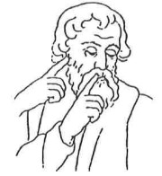

Old LSF

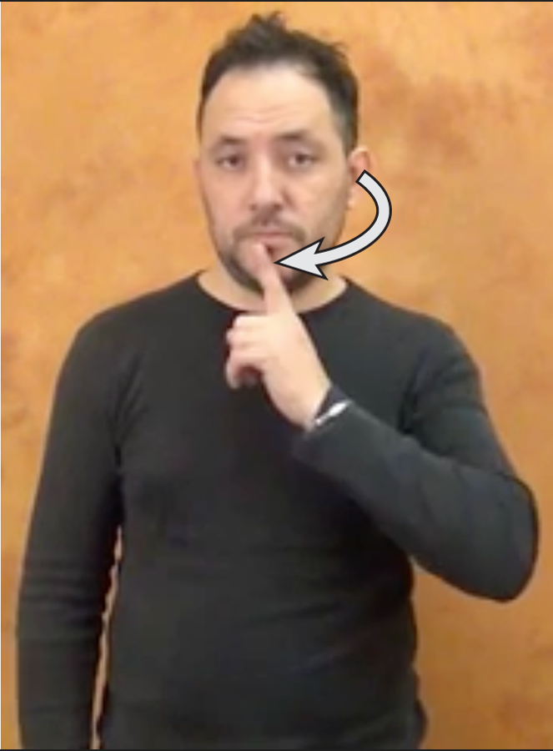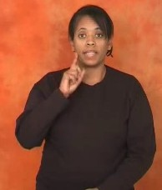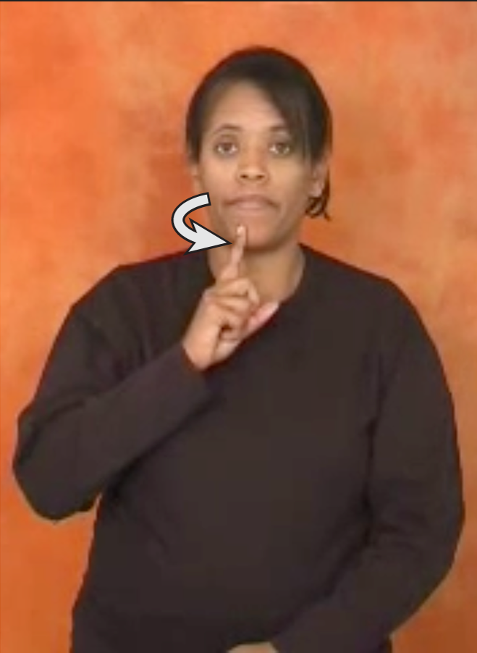

LIS ASL

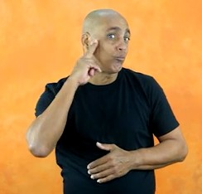

LSC(u)

Figure 12: deaf in Old LSF, LIS, ASL and LSC(u)

Another example is fork. In Old LSF (fourchette, Lambert 1865: 78) and ASL, the hand moves from the palm of the nondominant hand to the mouth. In LSM, the hand scoops off the nondominant palm and moves upward only to the level of below the throat. It appears Location Undershoot has applied in LSM.

4.3.9 Midsagittal Symmetry

Consider tournament (Figure 13). In Old LSF tournoi (Delaporte 2007: 592), the hands draw circles in out-of-phase symmetry across a horizontal plane in front of the speaker. LSF maintains that plane of symmetry, but ASL has symmetry across the midsagittal plane. It appears that Midsagittal Symmetry has applied in ASL.

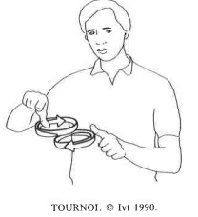

Old LSF

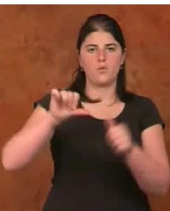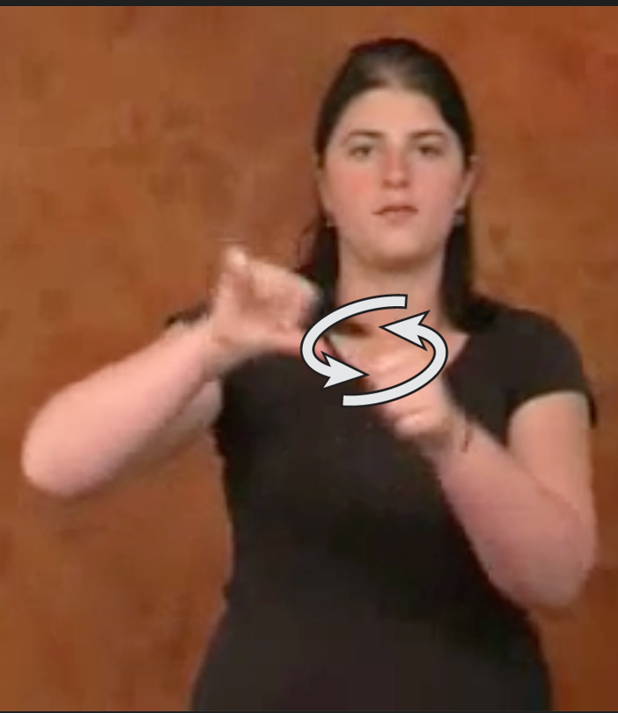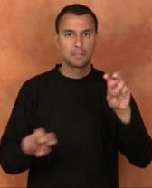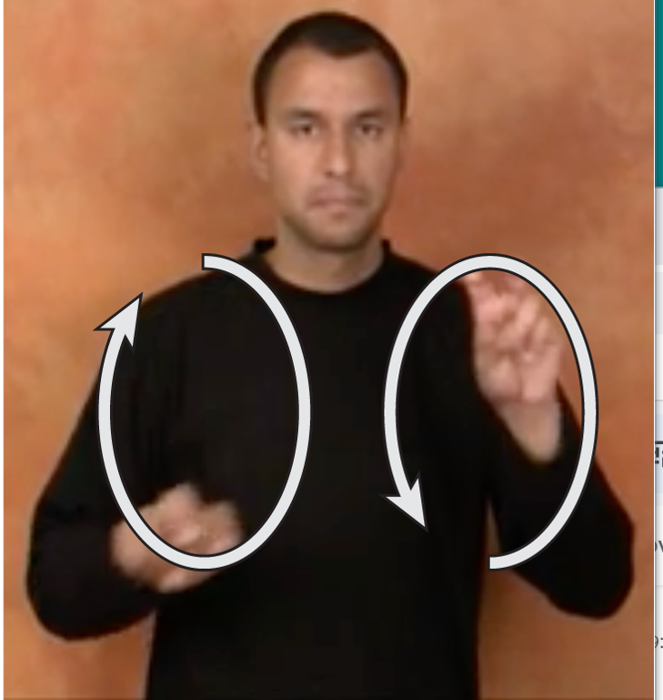

LSF ASL

Figure 13: tournament in Old LSF, LSF, and ASL

Another example is protest. In Old LSF protester (Delaporte 2007: 499), one hand moves forward and the other moves diagonally upward, with iteration. This is a translation symmetry but not one that would produce much torque. In LSF, the hands move forward as a unit (one on top of the other) without iteration; since they are touching, they are as close to symmetrical across the midsagittal plane as they can be. In IPSL-P, both hands move diagonally upward, with reflexive symmetry across the midsagittal plane. It appears Midsagittal Symmetry has applied in both LSF and IPSL-P.

5 Discussion

Recognizing iconicity is critical to diachronic studies of sign languages. Without such recognition, signs that have similar meanings and movements, but, perhaps other seemingly inexplicable differences, would appear to be cognates. Further, biomechanical processes that reduce effort appear to have applied in various daughters in the Old LSF family.
We suggest that earlier forms of signs tend to be more transparently nonarbitrary and use more articulatory effort (perhaps in order to make nonarbitrariness transparent), while later forms tend to be more arbitrary and use less articulatory effort (as generations of signers introduce natural fluidity and efficiency). This general trend toward reduction of articulatory effort shows up most prominently in the movement parameter (especially path movement due to the larger masses being moved by shoulder and elbow articulation). Changes in the handshape parameter may also be driven by articulatory effort reduction, but the articulatory savings will be much smaller, so perceptual concerns may weigh more heavily. Thus, as a starting point for considering biomechanics, the movement parameter is an obvious choice.
Nonarbitrariness itself may be an explanation for why sign languages do not immediately appear to be subject to Neogrammarian regularity. The inherent resistance to regular change in semantics can spread to phonetics/phonology for sign languages, where nonarbitrariness is pervasive. We do not suggest that arbitrary signs may be subject to regular change, however. This would be difficult to test, as it is hard to establish that a given sign did not originate from a nonarbitrary one, given the many sources of nonarbitrariness. Even if nonarbitrary signs could be neatly categorized separately from arbitrary signs, their numbers may be so small that there would be no meaningful difference between regular change and sporadic change.
As we explored the Old French dictionaries (Lambert 1865; Delaporte 2007), we were struck by how often an LSF sign was close to the source Old LSF sign. Napoli et al. (2011) looked at direction of movement in signs, finding that LSF appeared to be more conservative with regard to diachronic change in direction of movement when compared to ASL and LIS, as was BSL when compared to Auslan (Australian Sign Language). They suggested that, within sign languages, daughters that were origin-bound (i.e., remaining in the home country) were more conservative than daughters in the diaspora. Such a proposal is anathema to studies on spoken languages (Lehmann 1962; Crowley 1992; Joseph & Janda 2004), but that need not negate it. As pointed out in §2, indigenous sign languages (which usually contain a mix of gestures and homesign, as well as community-originated signs) are extensively affected by the sign language brought into a deaf school from an outside source (in these cases, from Old LSF) and, importantly, vice-versa. While two spoken languages might be very different and thus affect one another in only a limited/inhibited way in an immigration situation, sign languages often have many lexical similarities (due to nonarbitrariness) and, perhaps universally, many syntactic and semantic similarities (Wilbur 2008; Napoli & Sutton-Spence 2014; Napoli et al. 2017) – thus influences of one sign language on another might feel less foreign. Accordingly, diaspora sign languages might well change more rapidly and drastically than origin-bound sign languages.
Many questions remain. We list a few, first regarding arbitrariness, then biomechanics.
There is variation within sign languages across the lexicon and components of the grammar, correlating with many of the same demographic factors that speech variation correlates to (age, socioeconomic class, gender, race, ethnic background, region, sexual orientation), but also due to factors particular to sign language communities that we have already discussed, including the highly variable nature of sign language acquisition and the ways in which they are transmitted (Fenlon et al. 2013; Kusters & Lucas 2022; Lucas et al. 2009; McCaskill et al. 2011; McKee & McKee 2011; Schembri et al. 2009, 2018; Siu 2016; Stamp 2015). Given the centrality of nonarbitrariness to our approach, variation in signing raises thorny questions regarding data. While signers recognize nonarbitrariness in many signs (Sehyr et al. 2019), signers can and do disagree about the nonarbitrary motivation for a sign, where nonarbitrariness may be more transparent for signs with concrete meanings (e.g., chicken) than for those with an abstract meaning (Fitch et al. 2021). Folk etymologies offering accounts of perceived nonarbitrariness can arise in sign languages and exhibit a kind of collective reality, like they do in spoken languages (Rundblad & Kronenfeld 2000). Such folk etymologies can lead to changes in articulation responsive to that folk etymology (e.g., lesbian, see discussion in Mirus et al. 2020). These facts lead us to two imposing questions:
First, how do signs whose nonarbitrary motivation is not recognized fit into our picture, given that the need for recognizability that Napoli & Liapis (2019) pose might not be operative in the same way?
Second, how do signs whose nonarbitrary motivation is variably perceived fit into our picture, particularly if they undergo articulatory change responsive to the different perceptions?
Turning now to biomechanics, many questions arise.
First, to what extent is diachronic change inhibited by the need for recognizability? Are there particular kinds of rules that are inhibited or are all?
Second, can languages be characterized by use of a particular biomechanical process? Russell et al. (2011) look at variation in ASL and argue that Lowering is a kind of Undershooting in variants of signs canonically formed at the face, head or neck. Lowering is also analyzed as a change in progress in ASL (Lucas et al. 2002), Auslan (Schembri et al. 2009, who relate it to historical patterns identified in BSL) and Hong Kong Sign Language (Siu 2016). Perhaps this synchronic variation repeats a diachronic tendency across many languages.
Third, what are the proper primitives to use in the description of the movement parameter? In our research, we have isolated joint articulation, axes/planes of movement and iteration. Might there be others?
Fourth, sometimes more than one biomechanical process could reduce effort for a given sign. For example, if the hands move in some symmetry other than across the midsagittal plane, one could change the plane of symmetry to the midsagittal plane (thereby reducing cognitive effort) or one could apply Weak Drop. Is there a preferential ranking of one effort-reduction strategy over the other? If so, is that ranking language specific or universal?
Fifth, what other kinds of biomechanical processes that reduce energy might lead to diachronic change? For example, we found that signs with circular paths in Old LSF often had daughters with straight paths. Depending on starting and ending point and whether or not iteration is involved, such a change might reduce energy.
Finally, does the limitation/inhibition of biomechanical processes of reducing effort shed light on sign languages in other ways? For example, is it an additional explanation for why signers of one language often catch on to another sign language more quickly than speakers of one language catch on to another spoken language (Zeshan 2015; Napoli 2017)? Are signers accustomed to applying biomechanical principles to reduce effort in daily conversation, and given the higher degree of nonarbitrariness in sign languages than in spoken languages, are they then able to mentally undo that effort reduction to recognize underlying nonarbitrary sources?

Acknowledgements
We thank Thomas Lydell-Olsen for information about Spreadthesign. We also thank Matt Dye, Ronice Quadros de Muller, and Rachel Sutton-Spence for information about various sign languages, and Michela Ippolito and Guillaume Thomas for help with Italian and French sources. We thank audiences for feedback on versions of this work presented at the Deafness, Cognition and Language Research Centre at University College London; the University of California, Berkeley; the University of Chicago; and the University of Toronto’s Language Variation and Change research group. We thank our anonymous reviewers and the editors of this series for their generosity in offering suggestions and criticisms, and for their unfailing kindness throughout.

Abbreviations

ASL American Sign Language
Auslan Australian Sign Language
BSL British Sign Language
IPSL(-I/P) Indo-Pakistani Sign Language (of India/Pakistan)
ISL Irish Sign Language
Libras Brazilian Sign Language (Língua Brasileira de Sinais)
LIS Italian Sign Language (lingua dei segni italiana)
LSC Cuban Sign Language (lengua de señas cubana)
LSE Spanish Sign Language (lengua de signos española)
LSF French Sign Language (langue de signes français)
LSM Mexican Sign Language (lengua de señas mexicana)
MVSL Martha’s Vineyard Sign Language
STS Spreadthesign (database)

References
Abner, Natasha, Carlo Geraci, Shi Yu, Jessica Lettieri, Justine Mertz & Anah Salgat. 2020. Getting the upper hand on sign language families: Historical analysis and annotation methods. FEAST 3. 17–29.
Adam, Meike, Wiebke Iversen, Erin Wilkinson & Jill P. Morford. 2007. Meaning on the one and on the other hand: Iconicity in native vs. foreign signed languages. In Elżbieta Tabakowska, Christina Ljungberg & Olga Fischer (eds.), Insistent images, 211–227. Amsterdam: John Benjamins.
Adam, Robert. 2012. Language contact and borrowing. In Roland Pfau, Markus Steinbach & Bencie Woll (eds.), Sign language: An international handbook, 841–861. Berlin: De Gruyter Mouton.
Adam, Robert. 2015. Standardization of sign languages. Sign Language Studies 15(4). 432–445.
Ajello, Roberto, Laura Mazzoni & Florida Nicolai. 1997. Gesti linguistici: La labializzazione in LIS [English translation]. Quaderni della Sezione di Glottologia e Linguistica – Dipartimento di Studu Medivali e Moderni – Università degli Studi «G. D’Annunzio» di Chieti 9. 5–45.
Anderson, Lloyd & David Peterson. 1980. A comparison of some American, British, Australian and Swedish signs: Evidence on historical changes in signs and some family relationships of sign languages. In Brita Bergman & Inger Ahlgren (eds.), Papers from the First International Symposium on Sign Language Research, Stockholm, Sweden, June 10–16, 1979. Leksand, Sweden: Swedish National Association of the Deaf.
Bailey, Guy, Tom Wikle, Jan Tillery & Lori Sand. 1991. The apparent time construct. Language Variation and Change 3(3). 241–264.
Bank, Richard, Onno Crasborn & Roeland van Hout. 2015. Alignment of two languages: The spreading of mouthings in Sign Language of the Netherlands. International Journal of Bilingualism 19(1). 40–55.
Battison, Robbin. 1974. Phonological deletion in American Sign Language. Sign Language Studies 5(1). 1–9.
Berthier, Ferdinand. 1852. L’Abbé de l’Épée: Sa vie, son apostolat, ses travaux, sa lutte et ses succès. Paris: Michel Lévy Frères.
Blanchet, Alexandre. 1850. La surdi-mutité: Traité philosophique et médical suivi d’un petit dictionnaire usuel de mimique et de dactylologie à l’usage des médecins et des gens du monde. Paris: Labé.
Blything, Liam, Robert Davies & Kate Cain. 2015. Young children’s comprehension of temporal relations in complex sentences: The influence of memory on performance. Child Development 86(6). 1922–1934.
Börstell, Carl, Onno Crasborn & Lori Whynot. 2020. Measuring lexical similarity across sign languages in Global Signbank. In Proceedings of the LREC2020 9th Workshop on the Representation and Processing of Sign Languages: Sign Language Resources in the Service of the Language Community, Technological Challenges and Application Perspectives. 21–26.
Börstell, Carl, Ryan Lepic & Gal Belsitzman. 2016. Articulatory plurality is a property of lexical plurals in sign language. Lingvisticæ Investigationes 39(2). 391–407.
Braithwaite, Ben. 2020. Ideologies of linguistic research on small sign languages in the global South: A Caribbean perspective. Language & Communication 74. 182–194.
Brennan, Mary. 2005. Conjoining word and image in British Sign Language (BSL): An exploration of metaphorical signs in BSL. Sign Language Studies 5(3). 360–382.
Brentari, Diane. 1998. A prosodic model of sign language phonology. Cambridge, MA: MIT Press.
Brentari, Diane. 2011. Handshape in sign language phonology. In Martin van Oostendorp, Colin Ewen, Elizabeth Hume & Keren Rice (eds.), Companion to phonology, 195–222. Oxford: Wiley-Blackwell.
Brentari, Diane 2019. Sign language phonology. Cambridge: Cambridge University Press.
Brentari, Diane & Laurinda Crossley. 2002. Prosody on the hands and face: Evidence from American Sign Language. Sign Language and Linguistics 5. 105–130.
Brentari, Diane & Howard Poizner. 1994. A phonological analysis of a deaf Parkinsonian signer. Language and Cognitive Processes 9(1). 69–99.
Bromham, Lindell, Russell Dinnage, Hedvig Skirgård, Andrew Ritchie, Marcel Cardillo, Felicity Meakins, Simon Greenhill & Xia Hua. 2022. Global predictors of language endangerment and the future of linguistic diversity. Nature Ecology & Evolution 6(2). 163–173.
Brown, James. 1856. A vocabulary of mute signs. Baton Rouge, LA: Morning Comet Office.
Burns, Sarah. 1998. Irish Sign Language: Ireland’s second minority language. In Ceil Lucas, (ed.), Pinky extension and eye gaze: Language use in deaf communities, 233–273. Washington, DC: Gallaudet University Press.
Cagle, Keith. 2010. Exploring the ancestral roots of American Sign Language: Lexical borrowing from Cistercian Sign Language and French Sign Language. Albuquerque, NM: University of New Mexico dissertation.
Calderón Verde, Alicia, Donny Wilson Limonta, Gilmas Cervantes Soliño, Ariel Hernández Hernández & Elena Benedicto. 2018. Path and (a)telicity in space: Motion predicates in LSCu, Sign Language of Cuba. FEAST 2. 1–15.
Campello, Ana Regina e Souza. 2011. A constituição histórica da Língua de Sinais Brasileira: Século XVIII a XXI [English translation]. Revista Mundo & Letras 2. 8–25.
Campos de Abreu, Antonio. 1994. The deaf social life in Brazil. In Carol Erting, Robert Johnson, Dorothy Smith & Bruce Snider (eds.), The deaf way: Perspectives from the International Conference on Deaf Culture, 114–116. Washington, DC: Gallaudet University Press.
Cantin, Yann & Florence Encrevé. 2022. Perspectives: On the historicalness of sign languages. Frontiers in Communication 7. 801862.
Carling, Gerd & Niklas Johansson. 2014. Motivated language change: Processes involved in the growth and conventionalization of onomatopoeia and sound symbolism, Acta Linguistica Hafniensia 46(2). 199–217.
Caselli, Naomi & Jennie Pyers. 2017. The road to language learning is not entirely iconic: Iconicity, neighbor-hood density, and frequency facilitate acquisition of sign language. Psychological Science 28(7). 979–987. https://doi.org/10.1177/0956797617700498
Caselli, Naomi & Jennie Pyers. 2020. Degree and not type of iconicity affects sign language vocabulary acquisition. Journal of Experimental Psychology: Learning Memory and Cognition 46(1). 127–139. https://doi.org/10.1037/xlm0000713
Caselli, Naomi, Corrine Occhino, Bruno Artacho, Andreas Savakis & Matthew Dye. 2022. Perceptual optimization of language: Evidence from American Sign Language. Cognition 224. 105040.
Clark, Eve. 1971. On the acquisition of the meaning of before and after. Journal of Verbal Learning and Verbal Behavior 10(3). 266–275.
Corazza, Serena. 1994. The history of sign language in Italian education of the deaf. In Carol Erting, Robert Johnson, Dorothy Smith & Bruce Snider (eds.), The deaf way: Perspectives from the International Conference on Deaf Culture, 186–193. Washington, DC: Gallaudet University Press.
Corina, David & Ursula Hildebrandt. 2002. Psycholinguistic investigations of phonological structure in ASL. In Richard Meier, Kearsy Cormier & David Quinto-Pozos (eds.), Modality and structure in signed and spoken language, 88–111. Cambridge: Cambridge University Press.
Corina, David & Heather Knapp. 2006. Lexical retrieval in American Sign Language production. In Louis Goldstein, Douglas Whalen & Catherine Best (eds.), Laboratory Phonology 8, 213–240. Berlin & New York: Mouton de Gruyter.
Corina, David & Wendy Sandler. 1993. On the nature of phonological structure in sign language. Phonology 10(2). 165–207.
Crasborn, Onno. 2011. The other hand in sign language phonology. In Marc van Oostendorp (ed.), The Blackwell companion to phonology, 1–18. Hoboken, NJ: John Wiley & Sons.
Crasborn, Onno & Els van der Kooij. 2003. Base joint configuration in Sign Language of the Netherlands: Phonetic variation and phonological specification. In Jeroen van de Weijer, Vincent van Heuven & Harry van der Hulst (eds.), The phonological spectrum. Volume I: Segmental structure (Amsterdam Studies in the Theory and History of Linguistic Science 233), 257–287. Amsterdam: John Benjamins.
Crasborn, Onno, Inge Zwitserlood, Els van der Kooij & Richard Bank (eds.) 2020. Global Signbank, version 4. Radboud University, Nijmegen. https://signbank.cls.ru.nl/
Currie, Thomas, Simon Greenhill & Ruth Mace. 2010. Is horizontal transmission really a problem for phylogenetic comparative methods? A simulation study using continuous cultural traits. Philosophical Transactions of the Royal Society B 365. 3903–3912.
Cuxac, Cristian & Marie-Anne Sallandre. 2007. Iconicity and arbitrariness in French Sign Language: Highly iconic structures, degenerated iconicity and diagrammatic iconicity. In Elena Pizzuto, Paola Pietrandrea & Raffaele Simone (eds.), Verbal and signed languages: Comparing structure, constructs and methodologies, 13–33. Berlin: de Gruyter.
Ćwiek, Aleksandra, Susanne Fuchs, Christoph Draxler, Eva Liina Asu, Dan Dediu, Katri Hiovain, Shigeto Kawahara et al. 2022. The bouba/kiki effect is robust across cultures and writing systems, Philosophical Transactions of the Royal Society B 377(1841). 20200390.
Dautriche, Isabelle, Kyle Mahowald, Edward Gibson, Anne Christophe & Steven Piantadosi. 2017. Words cluster phonetically beyond phonotactic regularities. Cognition 163. 128–145.
de l’Épée, Charles-Michel. 1784. La véritable manière d’instruire les sourds et muets, confirmée par une longue expérience. Paris: Nyon l’aîné.
Degérando, Baron Joseph-Marie 1827. De l’éducation des sourds-muets de naissance. Paris: Méquignon.
DeGraff, Michel. 2005. Linguists’ most dangerous myth: The fallacy of Creole exceptionalism. Language in Society 34(4). 533–591.
Delaporte, Yves. 2007. Dictionnaire étymologique et historique de la langue des signes française: Origine et évolution de 1200 signes. Paris: Editions du Fox.
Dennis, Dannah. 2005. A history of the education of the deaf in India and Nepal. Baltimore, MD: University of Baltimore dissertation.
Deo, Ashwini. 2015. Diachronic semantics. Annual Review of Linguistics 1(1). 179–197.
Desai, Pranshankar Lallubhai. 1930. The deaf and dumb in India and abroad. American Annals of the Deaf 75(2). 137–145.
Dingemanse, Mark, Damián Blasi, Gary Lupyan, Morten Christiansen & Padraic Monaghan. 2015. Arbitrariness, iconicity, and systematicity in language. Trends in Cognitive Sciences 19(10) 603–615.
Dingemanse, Mark, Marcus Perlman & Pamela Perniss. 2020. Construal of iconicity: Experimental approaches to form–meaning resemblances in language. Language and Cognition 12(1). 1–14.
Dye, Matthew & Shui-I Shih. 2006. Phonological priming in British Sign Language. In Louis Goldstein, Douglas Whalen & Catherine Best (eds.), Laboratory phonology 8, 241–263. Berlin & New York: Mouton de Gruyter.
Edwards, Viv & Paddy Ladd. 1983. The linguistic status of British Sign Language. In Mark Sebba & Loreto Todd (eds.), Urban pidgins and creoles: Papers from the York Creole Conference, 24–27. Heslington, UK: Department of Language, University of York.
Eichmann, Hanna. 2009. Planning sign languages: Promoting hearing hegemony? Conceptualizing sign language standardization. Current Issues in Language Planning 10(3). 293–307.
Fenlon, Jordan, Kearsy Cormier & Adam Schembri. 2015. Building BSL SignBank: The lemma dilemma revisited. International Journal of Lexicography 28(2). 169–206.
Fenlon, Jordan & Erin Wilkinson. 2015. Sign languages in the world. In Adam Schembri & Ceil Lucas (eds.), Sociolinguistics and deaf communities, 5–28. Cambridge: Cambridge University Press.
Fenlon, Jordan, Adam Schembri, Ramas Rentelis, & Kearsy Cormier. 2013. Variation in handshape and orientation in British Sign Language: The case of the ‘1’ hand configuration. Language & Communication 33(1): 69–91.
Ferrand, Jean. 1896. Dictionnaire des sourds-muets. Manuscript, ca. 1785, ed. J. A. A. Rattel, Collection ancienne et moderne d’otologie, 7. Paris: Laval.
Ferrara, Casey & Donna Jo Napoli. 2019. Manual movement in sign languages: One hand versus two in communicating shapes. Cognitive Science 43(9). e12741.
Ferrara, Lindsey & Rolf Piene Halvorsen. 2017. Depicting and describing meanings with iconic signs in Norwegian Sign Language. Gesture 16(3). 371–395.
Ferrara, Lindsay & Gabrielle Hodge. 2018. Language as description, indication, and depiction. Frontiers in Psychology 9. 716.
Fischer, Susan D. 1996. By the numbers: Language-internal evidence for creolization. In William H. Edmondson & Ronnie B. Wilbur (eds.), International review of sign linguistics, 1–22. Mahwah, NJ: Erlbaum.
Fischer, Susan D. 2015. Sign languages in their historical context. In Claire Bowern & Bethwyn Evans (eds.), The Routledge handbook of historical linguistics, 442–465. New York: Routledge.
Fitch, Allison, Sudha Arunachalam, & Amy M. Lieberman. 2021. Mapping word to world in ASL: Evidence from a human simulation paradigm. Cognitive Science 45(12). e13061.
Frishberg, Nancy. 1975. Arbitrariness and iconicity: Historical change in American Sign Language. Language 51(3). 696–719.
Gama, Flausino José da. 1875. Iconografia dos signaes dos surdos-mudos [English translation]. Rio de Janeiro: Tipografia Universal de E. & H. Laemmert.
Geraci, Carlo, Katia Battaglia, Anna Cardinaletti, Carlo Cecchetto, Caterina Donati, Serena Giudice & Emiliano Mereghetti. 2011. The LIS corpus project: A discussion of sociolinguistic variation in the lexicon. Sign Language Studies 17. 528–574.
Geraci, Carlo, Roland Pfau, Pietro Braione, Carlo Cecchetto & Josep Quer. 2019. Hidden languages in a digital world: The case of sign language archives. Journal of the Italian Association of Speech Sciences 6. 31–47.
Gibson, Edward, Richard Futrell, Steven Piantadosi, Isabelle Dautriche, Kyle Mahowald, Leon Bergen & Roger Levy. 2019. How efficiency shapes human language. Trends in Cognitive Sciences 23(5). 389–407.
Giustolisi, Beatrice, Emiliano Mereghetti & Carlo Cechetto. 2017. Phonological blending or code mixing? Why mouthing is not a core component of sign language grammar. Natural Language & Linguistic Theory 35(2). 347–365.
Goldin-Meadow, Susan. 2014. Homesign. In Patricia Brooks & Vera Kempe (eds.), Encyclopedia of language development, 267–269. Thousand Oaks, CA: Sage Publications.
Greenhill, Simon, Thomas Currie & Russell Gray. 2009. Does horizontal transmission invalidate cultural phylogenies? Proceedings of the Royal Society B 276(1665). 2299–2306.
Groce, Nora. 1985. Everyone here spoke sign language: Hereditary deafness on Martha’s Vineyard. Cambridge, MA: Harvard University Press.
Guerra Currie, Anne-Marie Palacios. 1999. A Mexican Sign Language lexicon: Internal and cross-linguistic similarities and variation. Austin, TX: University of Texas at Austin dissertation
Guerra Currie, Anne-Marie Palacios, Richard Meier & Keith Walters. 2002. A crosslinguistic examination of the lexicons of four signed languages. In Richard Meier, Kearsy Cormier & David Quinto-Pozos (eds.), Modality and structure in signed and spoken languages, 224–236. Cambridge: Cambridge University Press.
Hendriks, Bernadet & Shelley Dufoe. 2014. Non-native or native vocabulary in Mexican Sign Language. Sign Language & Linguistics 17(1). 20–55.
Higgins, Daniel. 1923. How to talk to the deaf. Chicago: Paluch.
Hock, Hans. 2003. Analogical change. In Brian Joseph & Richard Janda (eds.), The handbook of historical linguistics, 441–460. Malden, MA: Blackwell.
Hoiting, Nini & Dan Slobin. 2007. From gestures to signs in the acquisition of sign language. In Susan Duncan, Justine Cassell & Elena Levy (eds.), Gesture and the dynamic dimension of language: Essays in honor of David McNeill, 51–65. Amsterdam: John Benjamins.
International Visual Theater (IVT). 1986. La langue des signes: Dictionnaire bilingue LSF/français. Vol. 1, 1990; vol. 2, 1997. Vincennes: Centre socioculturel des sourds.
Janzen, Terry. 2012. Lexicalization and grammaticalization. In Markus Steinbach, Roland Pfau & Bencie Woll (eds.), Handbook of sign languages, 816–840. Berlin: Mouton de Gruyter.
Janzen, Terry & Barbera Shaffer. 2002. Gesture as the substrate in the process of ASL grammaticization. In Richard Meier, David Quinto-Pozos & Kearsy Cormier (eds.), Modality and structure in signed and spoken languages, 199–223. Cambridge: Cambridge University Press.
Jespersen, Otto. 1909. A modern English grammar: On historical principles. Part I: Sounds and Spellings. Copenhagen: Munksgaard.
Jespersen, Otto. 1922. Language: Its nature, development and origin. London: George Allen & Unwin.
Johanson, Lars & Martine Robbeets (eds.). 2012. Copies versus cognates in bound morphology. Leiden/Boston: Brill.
Johnson, Robert & Scott Liddell. 2012. Toward a phonetic representation of hand configuration: The thumb. Sign Language Studies 12(2). 316–333.
Johnston, Trevor. 1996. Function and medium in the forms of linguistic expression found in a sign language. International Review of Sign Linguistics 1. 57–94.
Johnston, Trevor & Adam Schembri. 1999. On defining lexeme in a signed language. Sign Language & Linguistics 2(2). 115–185.
Joseph, Brian. 1987. On the use of iconic elements in etymological investigation: Some case studies from Greek. Diachronica 4(1–2). 1–26.
Jullian Móntañes, Christian Giorgio. 2001. Génesis de la comunidad silente de México: La Escuela Nacional de Sordomudos (1867 a 1886) [Origin of Mexico’s mute community: National School of Deaf-Mutes (1867 to 1886]. Mexico City: Universidad Nacional Autónoma de México dissertation.
Kegl, Judy. 2008. The case of signed languages in the context of pidgin and creole studies. In Silvia Kouwenberg & John Singler (eds.), The handbook of pidgin and creole studies, 491–511. Malden, MA: Wiley-Blackwell.
Kirby, Simon, Tom Griffiths & Kenny Smith. 2014. Iterated learning and the evolution of language. Current Opinion in Neurobiology 28. 108–114.
Kitzel, Mar. 2014. Chasing ancestors: Searching for the roots of American Sign Language in the Kentish Weald, 1620–1851. Falmer, UK: University of Sussex dissertation.
Klima, Edward & Ursula Bellugi. 1979. The signs of language. Cambridge, MA: Harvard University Press
Kooij, Els van der. 2001. Weak drop in Sign Language of the Netherlands. In Valery Dively, Melanie Metzger, Sarah Taub & Anne Marie Baer (ed.) Signed languages: Discoveries from international research, 27–42. Washington, DC: Gallaudet University Press
Kooij, Els van der. 2002. Phonological categories in Sign Language of the Netherlands: Phonetic implementation and iconic motivation. Leiden: Leiden University dissertation.
Koplenig, Alexander, Sascha Wolfer & Peter Meyer. 2022. Human languages trade off complexity against efficiency. Accessed 18 April 2023: https://assets.researchsquare.com/files/rs-1462001/v1_covered.pdf?c=1669292456
Kusters, Annelies & Ceil Lucas. 2022. Emergence and evolutions: Introducing sign language sociolinguistics. Journal of Sociolinguistics 26(1). 84–98.
Labov, William. 1981. Resolving the Neogrammarian controversy. Language 57(2). 267–308.
Lambert, Louis-Marie. 1865. Le langage de la physionomie et du geste mis à la portée de tous. Paris: Lecoffre.
Lane, Harlan. 1980. A chronology of the oppression of sign language in France and the United States. In Harlan Lane & François Grosjean (eds.), Recent perspectives on American Sign Language, 119–161. Hillsdale, NJ: Lawrence Erlbaum.
Laveau, François. 1868. Catéchisme des sourds-muets illettrés que l’on ne peut pas instruire au moyen de l’écriture. Orléans, France: Constant.
Lehrer, Adrienne. 1985. The influence of semantic fields on semantic change. In Jacek Fisiak (ed.), Historical semantics – Historical word-formation, 283–296. Berlin: Mouton.
Lepic, Ryan. 2016. The great ASL compound hoax. Proceedings of the High Desert Linguistics Society Conference 11. 227–250.
Lepic, Ryan, Carl Börstell, Gal Belsitzman & Wendy Sandler. 2016. Taking meaning in hand: Iconic motivations in two-handed signs. Sign Language & Linguistics 19(1). 37–81.
Leskien, August. 1876. Die Deklination im Slavisch-Litauischen und Germanischen. Leipzig: S. Hirzel.
Levshina, Natalia. 2020. Efficient trade-offs as explanations in functional linguistics: Some problems and an alternative proposal. Revista da ABRALIN 19(3). 50–78.
Liddell, Scott & Robert Johnson. 1986. American Sign Language compound formation processes, lexicalization, and phonological remnants. Natural Language & Linguistic Theory 4(4). 445–513.
Long, Joseph Schuyler. 1910. The Sign Language: A manual of signs. Being a descriptive vocabulary of signs used by the Deaf in the United States and Canada. Washington, DC: Gibson Bros.
Loos, Cornelia & Donna Jo Napoli. 2021. Expanding echo: Coordinated head articulations as nonmanual enhancements in sign language phonology. Cognitive Science 5(5). e12958.
Lucas, Ceil, Robert Bayley, Mary Rose, & Alyssa Wulf. 2002. Location variation in American Sign Language. Sign Language Studies 2(4). 407–440.
Lucas, Ceil, Robert Bayley, & Clayton Valli, in collaboration with Mary Rose, Alyssa Wulf, Paul Dudis, Susan Schatz, & Laura Sanheim. 2009. Sociolinguistic variation in American Sign Language. Washington, DC: Gallaudet University Press.
Luick, Karl. 1896. Untersuchungen zur englischen Lautgeschichte. Strassburg: Trübner.
Lupyan, Gary & Bodo Winter. 2018. Language is more abstract than you think, or, why aren’t languages more iconic?. Philosophical Transactions of the Royal Society B 373(1752). 20170137.
Lupton, Linda & Joe Salmons. 1996. A re-analysis of the creole status of American Sign Language. Sign Language Studies 90(1). 80–94.
MacLaughlin, Dawn, Carol Neidle, Ben Bahan & Robert Lee. 2000. Morphological inflections and syntactic representations of person and number in ASL. Recherches linguistiques de Vincennes 29. 73–100.
Mak, Joe & Gladys Tang. 2011. Movement types, repetition, and feature organization in Hong Kong Sign Language. In Rachel Channon & Harry van der Hulst (eds.), Formational units in sign languages, 315–338. Berlin: De Gruyter Mouton.
Malaia, Evie & Ronnie Wilbur. 2012. Kinematic signatures of telic and atelic events in ASL predicates. Language and Speech 55(3). 407– 421.
Mandel, Mark. 1981. Phonotactics and morphophonology in American Sign Language. Berkeley, CA: University of California dissertation.
Mauk, Claude. 2003. Undershoot in two modalities: Evidence from fast speech and fast signing. Austin, TX: University of Texas at Austin dissertation.
McBurney, Susan. 2012. History of sign languages and sign language linguistics. In Roland Pfau, Markus Steinbach & Bencie Woll (eds.), Sign language: An international handbook, 909–948. Berlin: De Gruyter Mouton.
McCaskill, Carolyn, Ceil Lucas, Robert Bayley, & Joseph Hill, in collaboration with Roxanne King, Pamela Baldwin, & Randall Hogue. 2011. The hidden treasure of Black ASL: Its history and structure. Washington, DC: Gallaudet University Press.
McKee, David & Graeme Kennedy. 2000. Lexical comparison of signs from American, Australian, British, and New Zealand Sign Languages. In Karen Emmorey & Harlan Lane (eds.), The signs of language revisited: An anthology to honor Ursula Bellugi and Edward Klima, 43–73. Mahwah, NJ: Lawrence Erlbaum.
McKee, Rachel & David McKee. 2011. Old signs, new signs, whose signs? Sociolinguistic variation in the NZSL lexicon. Sign Language Studies 11(4). 485–527.
McNeill, David. 1992. Hand and mind: What gestures reveal about thought. Chicago: University of Chicago Press.
McNeill, David (ed.). 2000. Language and gesture. Cambridge: Cambridge University Press.
Mechsner, Franz, Dirk Kerzel, Günther Knoblich & Wolfgang Prinz. 2001. Perceptual basis of bimanual coordination. Nature 414(6859). 69–73.
Meier, Richard, Claude Mauk, Adrianne Cheek & Christopher Moreland. 2008. The form of children’s early signs: Iconic or motoric determinants? Language Learning and Development 4(1). 63–98.
Meir, Irit. 2010. Iconicity and metaphor: Constraints on metaphorical extension of iconic forms. Language 86(4). 865–896.
Michaels, John. 1923. A handbook of the sign language of the deaf. Atlanta: Home Mission Board, Southern Baptist Convention.
Mirus, Gene, Jami Fisher, & Donna Jo Napoli. 2020. (Sub)lexical changes in iconic signs to realign with community sensibilities and experiences. Language in Society 49(2). 283–309.
Mirus, Gene, Christian Rathmann & Richard Meier. 2001. Proximalization and distalization of sign movement in adult learners. In Valerie Dively, Melanie Metzger, Sarah Taub & Anne Marie Baer (eds.), Signed languages: Discoveries from international research, 103–119. Washington, DC: Gallaudet University Press.
Mithun, Marianne. 1982. The synchronic and diachronic behavior of plops, squeaks, croaks, sighs, and moans. International Journal of American Linguistics 48(1). 49–58.
Moita, Mara, Ema Gonçalves, Conceição Medeiros & Ana Mineiro. 2018. A phonological diachronic study on Portuguese Sign Language of the Azores. Sign Language Studies 19(1). 138–162.
Moser, Margaret. 1990. The regularity hypothesis applied to ASL. In Ceil Lucas (ed.), Sign language research: Theoretical issues, 50–56. Washington, DC: Gallaudet University Press.
Münte, Thomas, Kolja Schiltz & Marta Kutas. 1998. When temporal terms belie conceptual order. Nature 395(6697). 71–73.
Napoli, Donna Jo. 2017. Iconicity chains in sign languages. In Claire Bowern, Laurence Horn & Raffaella Zanuttini (eds.), On looking into words (and beyond): Structures, relations, analyses, 517–546. Berlin: Language Science Press.
Napoli, Donna Jo & Casey Ferrara 2021. Correlations between handshape and movement in sign languages. Cognitive Science 45(5). 12944.
Napoli, Donna Jo & Stephanie Liapis. 2019. Effort reduction in articulation in sign languages and dance. Journal of Cultural Cognitive Science 3. 31–61.
Napoli, Donna Jo & Rachel Sutton-Spence. 2014. Order of the major constituents in sign languages: Implications for all language. Frontiers in Psychology 5. 376.
Napoli, Donna Jo & Rachel Sutton-Spence. 2021. Clause-initial Vs in sign languages: Scene-setters. In Vera Lee-Schoenfeld & Dennis Ott (eds.) Parameters of predicate fronting, 198–226. Oxford: Oxford University Press.
Napoli, Donna Jo, Mark Mai & Nicholas Gaw. 2011. Primary movement in sign languages: A study of six languages. Washington, DC: Gallaudet University Press.
Napoli, Donna Jo & Jeff Wu. 2003. Morpheme structure constraints on two-handed signs in American Sign Language: Notions of symmetry. Sign Language & Linguistics 6(2). 123–205.
Napoli, Donna Jo, Nathan Sanders & Rebecca Wright. 2014. On the linguistic effects of articulatory ease, with a focus on sign languages. Language 90(2). 424–456.
Napoli, Donna Jo, Rachel Sutton-Spence & Ronice Müller de Quadros. 2017. Influence of predicate sense on word order in sign languages: Intensional and extensional verbs. Language 93(3). 641–670.
Neidle, Carol, Judy Kegl, Dawn MacLaughlin, Ben Bahan & Robert Lee. 2000. The syntax of American Sign Language: Functional categories and hierarchical structure. Cambridge, MA: MIT Press.
Nespor, Marina & Wendy Sandler. 1999. Prosody in Israeli Sign Language. Language and Speech 42(2–3). 143–176.
Noberto, Mércia Creuza Lucas de Morais, Maria do Socorro Santos Pompeu, Roselita Alves Dias Felipe, Rozana Alves dos Santos Oliveira & Geilsa Medeiros Costa. 2014. Breve histórico da educação especial no Brasil no ensino regular [English translation]. Revista Brasileira de Educação e Saúde 4(1). 46–49.
Occhino, Corrine, Benjamin Anible, Erin Wilkinson & Jill Morford. 2017. Iconicity is in the eye of the beholder: How language experience affects perceived iconicity. Gesture 16(1). 100–126.
Orfanidou, Eleni, Robert Adam, James McQueen & Gary Morgan. 2009. Making sense of nonsense in British Sign Language (BSL): The contribution of different phonological parameters to sign recognition. Memory & Cognition 37(3). 302–315.
Ormel, Ellen, Onno Crasborn, Gerrit Jan Kootstra & Anne de Meijer. 2017. Coarticulation of handshape in Sign Language of the Netherlands: A corpus study. Laboratory Phonology: Journal of the Association for Laboratory Phonology 8(1). 1–21.
Ortega, Gerardo. 2017. Iconicity and sign lexical acquisition: A review. Frontiers in Psychology 8. 1280. https://doi.org/10.3389/fpsyg.2017.01280
Osthoff, Hermann & Karl Brugman. 1878. Morphologische Untersuchungen auf dem Gebiete der indogermanischen Sprachen. Leipzig: S. Hirzel.
Padden, Carol. 2011. Sign language geography. In Gaurav Mathur & Donna Jo Napoli (eds.), Deaf around the world: The impact of language, 19–37. Oxford: Oxford University Press.
Padden, Carol & David Perlmutter. 1987. American Sign Language and the architecture of phonological theory. Natural Language & Linguistic Theory 5(3). 335–375.
Padden, Carol, Irit Meir, So-One Hwang, Ryan Lepic, Sharon Seegers Tory Sampson. 2013. Patterned iconicity in sign language lexicons. Gesture 13(3). 287–308.
Pélissier, Pierre. 1856. Iconographie des signes faisant partie de l’enseignement des sourdsmuets. Paris: Dupont.
Périn, Philomène, Santiago Herrera, Frédéric Isel & Caroline Bogliotti. 2023. FLexSign: A lexical database in French Sign Language (LSF). https://feast2023.github.io/abstracts/Perin%20et%20al.pdf
Perniss, Pamela & Aslı Özyürek. 2008. Representations of action, motion, and location in sign space: A comparison of German (DGS) and Turkish (TİD) Sign Language narratives. In Josep Quer (ed.), Signs of the time: Selected papers from TISLR 8, 353–378. Hamburg: Seedorf Signum.
Perniss, Pamela, Robin Thomson & Gabriella Vigliocco. 2010. Iconicity as a general property of language: Evidence from spoken and signed languages. Frontiers in Psychology 1(227).
Perniss, Pamela, Jenny Lu, Gary Morgan, & Gabriella Vigliocco. 2018. Mapping language to the world: The role of iconicity in the sign language input. Developmental Science 21(2). e12551. https://doi.org/10.1111/desc.12551
Pfau, Roland & Markus Steinbach. 2006. Modality-independent and modality-specific aspects of grammaticalization in sign languages. In Heiner Drenhaus, Ruben van de Vijver & Ralf Vogel (eds.), Linguistics in Potsdam 24, 5–98. Potsdam: Universitatsverlag Potsdam.
Pietrandrea, Paola & Tommaso Russo. 2007. Diagrammatic and imagic hypoicons in signed and verbal languages. In Elena Pizzuto, Paola Pietrandrea & Raffaele Simone (eds.), Verbal and signed languages: Comparing structures, constructs and methodologies, 35–56. Berlin: Mouton de Gruyter.
Pinna, Paola, Laura Pagliari Rampelli, Paolo Rossini & Virginia Volterra. 1994. Written and unwritten history of a residential school for the deaf in Rome, Italy. In Carol Erting, Robert Johnson, Dorothy Smith & Bruce Snider (eds.), The Deaf way: Perspectives from the International Conference on Deaf Culture, 194–202. Washington, DC: Gallaudet University Press.
Pizzuto, Elena & Virginia Volterra. 2000. Iconicity and transparency in sign language: A cross-linguistic cross-cultural view. In Karen Emmorey & Harlan Lane (eds.), Signs of language revisited: An anthology to honor Ursula Bellugi and Edward Klima, 261–286. Mahwah, NJ: Lawrence Erlbaum.
Pizzuto, Elena, Emanuela Cameracanna, Serena Corazza & Virginia Volterra. 1995. Terms for spatio-temporal relations in Italian Sign Language. In Raffaele Simone (ed.), Iconicity in language, 237–256. Amsterdam: John Benjamins.
Poizner, Howard. 1983. Perception of movement in American Sign Language: Effects of linguistic structure and linguistic experience. Perception & Psychophysics 33. 215–231.
Poizner, Howard, Diane Brentari, Martha Tyrone & Judy Kegl. 2000. The structure of language as motor behavior: Clues from signers with Parkinson’s disease. In Karen Emmorey & Harlan Lane (eds.), The signs of language revisited: An anthology to honor Ursula Bellugi and Edward Klima, 432–452. Mahwah, NJ: Lawrence Erlbaum Associates.
Power, Justin. 2022. Historical linguistics of sign languages: Progress and problems. Frontiers in Psychology 13.
Power, Justin, Guido Grimm & Johann-Mattis List. 2020. Evolutionary dynamics in the dispersal of sign languages. Royal Society open science 7(1). 191100.
Power, Justin, David Quinto-Pozos & Danny Law. 2021. Methods and models in historical comparative research on signed languages. http://www.sfs.uni-tuebingen.de/~gjaeger/maeiqcl21/slides/poweretal.pdf
Puupponen, Anna, Tommi Jantunen, Ritva Takkinen, Tuija Wainio & Outi Pippuri. 2014. Taking non-manuality into account in collecting and analyzing Finnish Sign Language video data. In Onno Crasborn, Eleni Efthimiou, Stavroula-Evita Fotinea, Thomas Hanke, Julie Hochgesang, Jette Kristoffersen, & Johanna Mesch (eds.), Beyond the manual channel: 9th International Conference on Language Resources and Evaluation, 143–148. Paris: European Language Resources Association.
Pyykkönen, Pirita & Juhani Järvikivi. 2012. Children and situation models of multiple events. Developmental Psychology 48(2). 521–529.
Quadros, Ronice Müller de & Ana Regina e Souza Campello. 2010. Constituição política, social e cultural da Língua Brasileira de Sinais [Political, social and cultural constitution of Brazilian Sign Language]. In Lucyenne Matos da Costa Vieira-Machado and Maura Corcini Lopes (eds.), Educação de surdos: Políticas, língua de sinais, comunidade e cultura surda, 15–47. Santa Cruz do Sul, Brazil: EDUNISC.
Quartararo, Anne. 2008. The poetry of a minority community: Deaf poet Pierre Pélissier and the formation of a deaf identity in the 1850s. Sign Language Studies 8(3). 241–263.
Quer, Josep & Roc Boronat. 2016. D4.4 First SIGN-HUB Conference. https://www.unive.it/pag/fileadmin/user_upload/progetti_ricerca/sign-hub/documenti/Resources/D4.4_First_SIGN-HUB_Conference.pdf
Quer, Josep & Roc Boronat. 2017. D4.6 Second SIGN-HUB Conference. https://www.unive.it/pag/fileadmin/user_upload/progetti_ricerca/sign-hub/documenti/Resources/D4.6_Second_SIGN-HUB_Conference.pdf
Quer, Josep, Laura Mazzoni & Galini Sapountzaki. 2010. Transmission of sign languages in Mediterranean Europe. In Diane Brentari (ed.), Sign languages, 95–112. Cambridge: Cambridge University Press.
Quinto-Pozos, David. 2006. Contact between Mexican Sign Language (LSM) and American Sign Language (ASL) in two Texas border areas. Sign Language & Linguistics 7(2). 215–219.
Quinto-Pozos, David. 2008. Sign language contact and interference: ASL and LSM. Language and Society. 37. 161–189.
Quinto-Pozos, David & Robert Adam. 2015. Sign languages in contact. In Adam Schembri & Ceil Lucas (eds.), Sociolinguistics and deaf communities, 29–60. Cambridge: Cambridge University Press.
Radden, Günter. 2021. Iconicity. In Wen Xu and John R. Taylor (eds.), The Routledge handbook of cognitive linguistics, 268–296. New York: Routledge.
Radutzky, Elena. 1989. La lingua dei segni italiana: Historical change in the sign language of deaf people in Italy. PhD. dissertation, New York University.
Radutzky, Elena (ed.). 1992. Dizionario bilingue elementare della lingua italiana dei segni: Oltre 2.500 significati [Elementary bilingual dictionary of Italian Sign Language: Another 2,500 meanings]. Rome: Edizioni Kappa.
Ramsey, Claire & David Quinto-Pozos. 2010. Transmission of sign languages in Latin America. In Diane Brentari (ed.), Sign languages, 46–73. Cambridge: Cambridge University Press.
Reddy, Michael. 1979. The conduit metaphor: A case of frame conflict in our language about language. In Andrew Ortony (ed.), Metaphor and thought, 284–297. Cambridge: Cambridge University Press.
Roccaforte, Maria. 2018. Le componenti orali della lingua dei segni italiana: Analisi linguistica, indagini sperimentali e implicazioni glottodidattiche [English translation]. Rome: Sapienza Università di Roma dissertation.
Rundblad, Gabriella & David B. Kronenfeld. 2000. Folk-etymology: Haphazard perversion or shrewd analogy? In Julie Coleman & Christian J. Kay (eds.), Lexicology, semantics, and lexicography, 19–34. Amsterdam: John Benjamins.
Russell, Kevin, Erin Wilkinson & Terry Janzen. 2011. ASL sign lowering as undershoot: A corpus study. Laboratory Phonology 2(2). 403–422.
Russo, Tommaso. 2004. Iconicity and productivity in sign language discourse: An analysis of three LIS discourse registers. Sign Language Studies 4(2). 164–197.
Sanders, Nathan & Donna Jo Napoli. 2016a. A cross-linguistic preference for torso stability in the lexicon: Evidence from 24 sign languages. Sign Language & Linguistics 19(2). 197–231.
Sanders, Nathan & Donna Jo Napoli. 2016b. Reactive effort as a factor that shapes sign language lexicons. Language 92(2). 275–297.
Sandler, Wendy. 1989. Phonological representation of the sign: Linearity and nonlinearity in American Sign Language. Dordrecht: Foris.
Sandler, Wendy. 1993. A sonority cycle in American Sign Language. Phonology 10(2). 243– 279.
Sandler, Wendy. 1999. Cliticization and prosodic words in a sign language. In Alan Hall & Ursula Kleinhenz (eds.), Studies on the phonological word, 223–254. Amsterdam: John Benjamins.
Sandler, Wendy. 2017. The challenge of sign language phonology. Annual Review of Linguistics 3. 43– 63.
Sandler, Wendy, Mark Aronoff, Irit Meir & Carol Padden 2011. The gradual emergence of phonological form in a new language. Natural Language & Linguistic Theory 29(2). 503–543.
Schembri, Adam, Jordan Fenlon, Kearsy Cormier, & Trevor Johnston. 2018. Sociolinguistic typology and sign languages. Frontiers in psychology 9. 200. https://doi.org/10.3389/fpsyg.2018.00200
Schembri, Adam, Kearsy Cormier, Trevor Johnston, David McKee, Rachel McKee & Bencie Woll. 2010. Sociolinguistic variation in British, Australian and New Zealand sign languages. In Diane Brentari (ed.), Sign Languages, 476–498. Cambridge: Cambridge University Press.
Schembri, Adam, David McKee, Rachel McKee, Sara Pivac, Trevor Johnston & Della Goswell. 2009. Phonological variation and change in Australian and New Zealand Sign Languages: The location variable. Language Variation and Change 21(2). 193–231.
Sehyr, Zed Sevcikova & Karen Emmorey. 2019. The perceived mapping between form and meaning in American Sign Language depends on linguistic knowledge and task: Evidence from iconicity and transparency judgments. Language and Cognition 11(2). 208–234.
Shaffer, Barbara. 2002. CAN’T: The negation of modal notions in ASL. Sign Language Studies 3(1). 34–53.
Shaw, Emily & Yves Delaporte. 2011. New perspectives on the history of American Sign Language. Sign Language Studies 11(2). 158–204.
Shaw, Emily & Yves Delaporte. 2015. A historical and etymological dictionary of American Sign Language. Washington, DC: Gallaudet University Press.
Sicard, Roch. 1808. Théorie des signes ou introduction à l’étude des langues, où le sens des mots, au lieu d’être défini, est mis en action. 2 vols. Paris: Institution des sourds-muets.
Siedlecki, Theodore. & John Bonvillian. 1993. Phonological deletion revisited: Errors in young children’s two-handed signs. Sign Language Studies 80. 223–242.
SIGN-HUB. 2016–2019. SIGN-HUB: Preserving, researching and fostering the linguistic, historical and cultural heritage of European Deaf signing communities with an integral resource. http://www.sign-hub.eu, accessed 20 August 2018.
Simons, Gary & Charles Fennig (eds.). 2019. Ethnologue: Languages of the world. 22nd edn. Dallas, TX: SIL International. Online. https://www.ethnologue.com, accessed 15 April 2019.
Siple, Patricia. 1978. Visual constraints for sign language communication. Sign Language Studies 19. 95–110.
Siu, Wai Yan Rebecca. 2016. Sociolinguistic variation in Hong Kong sign language. Wellington, NZ: Victoria University of Wellington dissertation.
Slonimska, Anita, Aslı Özyürek & Olga Capirci. 2020. The role of iconicity and simultaneity for efficient communication: The case of Italian Sign Language (LIS). Cognition 200. 104246.
Slonimska, Anita, Aslı Özyürek & Olga Capirci. 2021. Using depiction for efficient communication in LIS (Italian Sign Language). Language and Cognition 13(3). 367–396.
Slonimska, Anita, Aslı Özyürek & Olga Capirci. 2022. Simultaneity as an emergent property of efficient communication in language: A comparison of silent gesture and sign language. Cognitive Science. 46(5). e13133.
Slonimska, Anita, Aslı Özyürek & Olga Capirci. 2023. Communicative efficiency in sign languages: The role of the visual modality-specific properties. Paper presented at the 16th International Cognitive Linguistics Conference. Available at https://hartmast.github.io/iclc16/abstracts/ICLC16_paper_325.pdf
Sofiato, Cassia Geciauskas. 2011. Do desenho à litografia: A origem da língua brasileira de sinais [English translation]. Campinas, Brazil: Universidade Estadual de Campinas dissertation.
Spreadthesign. 2006–2023. Spreadthesign. https://www.spreadthesign.com/. Accessed 13 April 2023.
Stamp, Rose. 2015. Sociolinguistic variation, language change and contact in the British Sign Language (BSL) lexicon. Sign Language & Linguistics 18(1). 158–166.
Stevens, Kelly. 1923. Young Hindu educator follows father’s example. The Silent Worker 35(6). 221.
Supalla, Ted. 2001. Making historical sign language materials accessible: A prototype database of early ASL. Sign Language & Linguistics 4(1/2). 285–297.
Supalla, Ted. 2004. The validity of the Gallaudet lecture films. Sign Language Studies 4(3). 261–292.
Supalla, Ted. 2013. The role of historical research in building a model of sign language typology, variation, and change. Historical Linguistics 2011: Selected papers from the 20th International Conference on Historical Linguistics, Osaka, 25-30 July 2011, 15–42. Amsterdam: John Benjamins Publishing.
Supalla, Ted & Patricia Clark. 2015. Sign language archaeology: Understanding the historical roots of American Sign Language. Washington, DC: Gallaudet University Press.
Supalla, Ted, Fanny Limousin & Betsy Hicks McDonald. 2020. Historical change in American Sign Language. In Richard Janda, Brian Joseph & Barbara Vance (eds.), The handbook of historical linguistics, 423–446. Hoboken, NJ: Wiley Publishing.
Tabak, John. 2006. Significant gestures: A history of American Sign Language. Westport, CT: Praeger Publishers.
Tai, James. 1985. Temporal sequence and Chinese word order. In John Haiman (ed.), Iconicity in syntax, 49–72. Amsterdam: Benjamins.
Taub, Sarah. 2001. Language from the body: Iconicity and metaphor in American Sign Language. Cambridge: Cambridge University Press.
The Hearing Review. 2019. RIT researchers study changes in Nicaraguan Sign Language over four decades. https://www.hearingreview.com/inside-hearing/research/rit-researchers-study-changes-nicaraguan-sign-language-four-decades
Thompson, Robin, David Vinson & Gabriella Vigliocco. 2010. The link between form and meaning in British Sign Language: Effects of iconicity for phonological decisions. Journal of Experimental Psychology: Learning, Memory, and Cognition 36(4). 1017–1027.
Thompson, Robin, David Vinson, Bencie Woll & Gabriella Vigliocco. 2012. The road to language learning is iconic: Evidence from British Sign Language. Psychological Science 23(12). 1443–1448.
Tkachman, Oksana, Gracellia Purnomo & Bryan Gick. 2018. Cyclic movement primitives underlying two-handed alternating signs in signed languages. Canadian Acoustics 46(4). 24–27.
Traugott, Elizabeth. 2012. Pragmatics and language change. In Kasia Jaszczolt & Keith Allan (eds.), The Cambridge handbook of pragmatics, 549–566. Cambridge: Cambridge University Press.
Tyrone, Martha & Claude Mauk. 2010. Sign lowering and phonetic reduction in American Sign Language. Journal of Phonetics 38(2). 317–328.
Valentine, Gill & Tracey Skelton. 2008. Changing spaces: The role of the internet in shaping Deaf geographies. Social & Cultural Geography 9(5). 469–485.
Valentine, Gill & Tracey Skelton. 2009. ‘AN UMBILICAL CORD TO THE WORLD’ The role of the Internet in D/deaf people's information and communication practices. Information, Communication & Society 12(1). 44–65.
Verhoef, Tessa, Simon Kirby & Bart de Boer. 2016. Iconicity and the emergence of combinatorial structure in language. Cognitive Science 40(8). 1969–1994.
Vinson, David, Kearsy Cormier, Tanya Denmark, Adam Schembri & Gabriella Vigliocco. 2008. The British Sign Language (BSL) norms for age of acquisition, familiarity and iconicity. Behavior Research Methods 40. 1079 –1087.
Volterra, Virginia & Elizabeth Bates. 1989. Selective impairment of Italian grammatical morphology in the congenitally deaf: A case study. Cognitive Neuropsychology 6(3). 273–308.
Wilbur, Ronnie. 1979. American Sign Language and sign systems. Baltimore, MD: University Park Press.
Wilbur, Ronnie. 2005. A reanalysis of reduplication in American Sign Language. In Bernhard Hurch (ed.), Studies on reduplication, 595–624. Berlin: De Gruyter.
Wilbur, Ronnie. 2008. Complex predicates involving events, time and aspect: Is this why sign languages look so similar?. In Josep Quer (ed.), Theoretical issues in sign language research, 217–250. Seedorf: Signum.
Wilbur, Ronnie. 2017. The linguistic description of American Sign Language. In Harlan Lane & François Grosjean (eds.), Recent perspectives on American Sign Language, 7–31. New York: Psychology Press.
Wilbur, Ronnie & Lesa Petersen. 1997. Backwards signing and ASL syllable structure. Language and Speech 40(1). 63–90.
Wilcox, Phyllis Perrin. 2000. Metaphor in American Sign Language. Washington, DC: Gallaudet University Press.
Wilcox, Sherman. 2004. Cognitive iconicity: Conceptual spaces, meaning, and gesture in signed languages. Cognitive Linguistics 15(2). 119–147.
Wilcox, Sherman & Corrine Occhino. 2016. Historical change in signed languages. Oxford handbooks online. DOI: 10.1093/oxfordhb/9780199935345.013.24
Winter, Bodo, Marcus Perlman, Lynn Perry & Gary Lupyan. 2017. Which words are most iconic? Iconicity in English sensory words. Interaction Studies 18(3). 443–464.
Wittmann, Henri. 1991. Classification linguistique des langues signées non vocalement. Revue québécoise de linguistique théorique et appliquée 10(1). 215–288.
Woll, Bencie & Jechil Sieratzki. 1998. Echo phonology: Signs of a link between gesture and speech. Behavioral and Brain Sciences 21(4). 531–532.
Woll, Bencie, Rachel Sutton-Spence & Frances Elton. 2001. Multilingualism: The global approach to sign languages. In Ceil Lucas (ed.), The sociolinguistics of sign languages, 8–32. Cambridge: Cambridge University Press.
Woodward, James. 1978. Historical bases of American Sign Language. In Patricia Siple (ed.), Understanding language through sign language research, 333–348. New York: Academic Press.
Woodward, James. 1993. The relationship of sign language varieties in India, Pakistan, & Nepal. Sign Language Studies 78(1). 15–22.
Woodward, James. 2011. Some observations on research methodology in lexicostatistical studies of sign languages. In Gaurav Mathur & Donna Jo Napoli (eds.), Deaf around the world: The impact of language, 38–53. Oxford: Oxford University Press.
Xavier, André & Regiane Pinheiro Agrella. 2015 Brazilian sign language (Libras). In Julie Bakken Jepsen, Goedele De Clerck, Sam Lutalo-Kiingi & William McGregor (eds.), Sign languages of the world: A comparative handbook, 129–158. Berlin: de Gruyter.
Xavier, André & Sherman Wilcox. 2014. Necessity and possibility modals in Brazilian Sign Language (Libras). Linguistic Typology 18(3). 449–488.
Yu, Shi, Carlo Geraci & Natasha Abner. 2018. Sign languages and the online world: Online dictionaries & lexicostatistics. In Nicoletta Calzolari, Khalid Choukri, Christopher Cieri, Thierry Declerck, Sara Goggi, Koiti Hasida, Hitoshi Isahara et al. (eds.), Proceedings of the Eleventh International Conference on Language Resources and Evaluation (LREC 2018), 4235–4240. Miyazaki, Japan: European Language Resources Association.
Zeshan, Ulrike. 2003. Indo-Pakistani Sign Language grammar: A typological outline. Sign Language Studies 3(2). 157–212.
Zeshan, Ulrike. 2015. “Making meaning”: Communication between sign language users without a shared language. Cognitive Linguistics 26(2). 211–260
Zimmer, June. 2000. Toward a description of register variation in American Sign Language. In Clayton Valli & Ceil Lucas (eds.), Linguistics of American Sign Language: An introduction, 429–442. Washington, DC: Gallaudet University Press.

Résumé

Les langues des signes ne semblent pas se prêter à la reconstruction historique traditionnelle via la méthode comparative, ce qui rend difficile la reproduction des succès obtenus dans l'étude diachronique des langues parlées. Nous proposons d'atténuer cette difficulté avec une approche alternative qui s'appuie sur le non-arbitraire et la biomécanique, en particulier la volonté de réduire l'effort articulatoire. Nous proposons une démonstration de cette approche, qui peut ajouter une confirmation aux relations connues entre les langues des signes et de nouvelles preuves à l'appui de relations que l’on soupçonne, contribuant ainsi à combler une lacune méthodologique dans l'étude diachronique des langues des signes.

Zussamenfassung

Gebärdensprachen scheinen für die traditionelle historische Rekonstruktion mithilfe der vergleichenden Methode nicht geeignet zu sein, was es schwierig macht, die Erfolge zu reproduzieren, die bei der diachronen Untersuchung gesprochener Sprachen erzielt wurden. Wir schlagen vor, diese Schwierigkeit durch einen alternativen Ansatz zu lindern, der sich auf Nichtwillkürlichkeit und Biomechanik stützt, insbesondere auf das Streben nach Reduzierung des Artikulationsaufwands. Wir liefern eine Demonstration dieses Ansatzes, der bekannte Beziehungen zwischen Gebärdensprachen bestätigen und neue Belege zur Stützung vermuteter Beziehungen liefern kann und so dazu beiträgt, eine methodologische Lücke in der diachronen Untersuchung von Gebärdensprachen zu schließen.

Author addresses

Donna Jo Napoli

Swarthmore College

500 College Ave.

Swarthmore, PA 19081

USA

dnapoli1@swarthmore.edu

Nathan Sanders

Department of Linguistics

Sidney Smith Hall

100 St. George Street

Toronto, ON M5S 3G3

Canada

nathan.sanders@utoronto.ca

Temporality is left out of Johnston’s contrast between spoken and sign language resources for nonarbitrariness with good reason. Spoken languages do use temporal nonarbitrariness, witness matches between temporal representations and syntactic word order (Tai 1985; Blything et al. 2015; Clark 1971; Münte et al. 1998; Pyykkönen & Järvikivi 2012). Sign languages, however, make a greater range of matches between temporal representations and syntactic order (Napoli et al. 2017; Napoli & Sutton-Spence 2021).
By convention, signs are in capitals. For ease of cross-linguistic comparison, we use English glosses.
sign-hub.eu/project
Although some argue orientation is a feature of handshape (Sandler 1989).
The factors we discuss below are articulatory, and do not necessarily correlate to perceptions of movement similarity on the part of signers and nonsigners, which can differ significantly (Poizner 1983).
spreadthesign.com
Actually, Power et al. (2020) refer to only Anderson, but we assume this is a mistake.
Martha’s Vineyard Sign Language (MVSL) plays a role in the development of ASL. Note that Groce’s (1985) hypothesis that MVSL was influenced by a sign language of Kent, England is argued against in Kitzel (2014).
https://media.spreadthesign.com/video/mp4/40/429725.mp4
Where we conflate the flat B- and the regular B-handshapes (Johnson & Liddell 2012; Ormel et al. 2017).
Here we name those signs in French, rather than English, to help the interested reader locate them in the sources.

