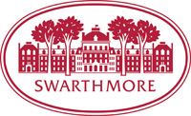

Department of Chemistry and Biochemistry

COLLOQUIUM SERIES, Spring 2015

February 5 John Wolfe, University of Michigan

"New Palladium-Catalyzed Reactions for the
Stereoselective Synthesis of Heterocycles"

February 19 Gregory Petsko, Weill Cornell Medical College

"Targeting Protein Trafficking: A New Approach
To the Treatment of Alzheimer’s Disease"

March 5 K. Jebrell Glover, Lehigh University

"Caveolin: A Tale of Two Prolines"

Postponed until Spring 2016

