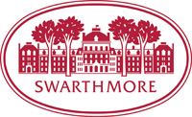

Department of Chemistry and Biochemistry

COLLOQUIUM SERIES, Spring 2014

February 6 Mary Watson, University of Delaware

“Transition Metal Catalysis of Nontraditional Electrophiles"

February 27 Jeanne E. Pemberton, University of Arizona

"Eco-Friendly Bio-synthesized and Bio-inspired Surfactants:
How Sweet It Is!!"

April 3 Michael Shatruk, Florida State University

"Controlling Spins with Pressure and Light: Itinerant Magnets,
Spin-Crossover Complexes, and Organic Hypervalent Dimers"

