A Proposal for an Internal Carbon Charge at Swarthmore College
Revised, January 2016

Background
This proposal grew out of discussions held over the summer of 2015 by members of the Swarthmore community, listed below, all of whom endorse its recommendations. The proposal was revised after discussion with senior staff and community members, and a separate discussion with the Sustainability Committee. All participants in these discussions are listed at the end of the proposal. The report was presented to the Board of Managers Social Responsibility Committee in December.

There is broad consensus that a well-designed national carbon charge could “efficiently reduce the emissions that cause climate change, encourage innovation in cleaner technologies, and cut other pollutants.” Some 40 countries have taken steps in that direction. European fossil fuel companies such as BP, Shell, Statoil, and Total have called for a global carbon charge as a way of responding to climate change while reducing market uncertainty around carbon. Political will to implement such a charge is still lacking in the United States, despite some bipartisan support for measures to price carbon emissions, such as the proposal by Congressman Chris Van Hollen ’82. A number of major corporations—including Microsoft, Disney, and Google—have already implemented internal carbon charges, partly to prepare for the national charge many analysts believe is coming.

Given this context, we propose that Swarthmore adopt an internal carbon charge as Yale, Princeton, and a few other universities are doing. More specifically, we propose a three-part carbon charge plan:

1) A shadow price on carbon, currently set to $40/MT eCO2, to be applied to all new construction projects;
2) A carbon charge of $40/MT eCO2, applied to college-wide emissions on an annual basis, with revenues to be earmarked for energy conservation and efficiency as well as renewable energy projects, funded through a 1% levy on all departmental budgets; and
3) An increase in metering, feedback, and messaging focused on encouraging communal behavior change. Enhancing both individual and collective responsibility, this proposal recognizes and affirms our duty to future generations: our obligation to pay some resources forward.

Why a Carbon Charge at Swarthmore?
- To shift the College’s energy investment more rapidly toward energy efficiency and renewable energy by raising funds to help cover initial costs, enabling future savings and improving our preparation for climate change and extreme weather.

Applying a shadow carbon price to construction projects and implementing a carbon charge on present consumption are two steps that can help the College prepare more effectively for a carbon-constrained future. In particular, by raising funds that can improve infrastructure and increase energy efficiency and use of renewables, this design models for others an urgently-needed global transition in energy investment while helping the College manage rising energy costs and extreme weather events that have required extraordinary responses, such as renting emergency generators twice in the past two years.

- To engender a sense of collective responsibility and agency for carbon emissions through our community so that individuals and groups learn more about leading on climate change mitigation.

At present, Facilities is almost solely responsible for overseeing the College’s carbon emissions, which leaves the great intellectual work of the day outside the realm of our academic work. Community members are unaware of their daily energy usage and ignorant about how the community as a whole uses energy. In order to engage our students in the challenge of building a more resilient world, we all need to grapple with the complex technical, social, and economic details of our relationship to energy.

- To facilitate student, faculty and staff learning about the benefits, liabilities, and obstacles associated with a national carbon charge by grappling with the complexities of an internal carbon charge.

Stanford University economist Frank Wolak argues that universities and foundations can contribute meaningfully to climate change mitigation by implementing carbon charges. Wolak notes that the “scientific, economic and political challenges” of designing such an internal charge fall within the responsibilities and capabilities of educational institutions and enable student participation in “creative career-enhancing ways.” Wolak also highlights the leadership role of universities in designing and implementing a carbon charge, eventually producing a model scalable to a national level.

- This climate change proposal would enable Swarthmore to be among the first in higher education in the country to provide leadership on climate change preparedness.

In April 2015, a Yale University Task Force recommended creating a revenue-neutral carbon charge at Yale. As described below, we propose a more ambitious model at Swarthmore: one in which revenues raised by the charge are invested in energy efficiency and renewables similar to Microsoft’s approach (Light, 41-50).

Context for a Carbon Charge:
Swarthmore’s Climate Commitment and Carbon Action Plan

In 2010, then-President Rebecca Chopp signed the American College & University Presidents' Climate Commitment, joining the leaders of institutions of higher education across the country in accelerating educational and operational efforts to address climate change. In 2012, Swarthmore completed a Greenhouse Gas Inventory (GHG) of carbon emissions produced in the period 2005-2010; annual data on energy consumption for more recent years is available from Facilities management.

Understanding the sources of carbon emissions is a first step toward reducing our carbon usage. Scope 1 and 2 emissions are those most easily controlled by the College because of the direct relationship between these emissions and the physical plant. Scope 1 emissions result from the direct burning of fossil fuels for heating; Scope 2 emissions refer to the carbon involved in the production of electricity purchased. Scope 3 emissions are the most difficult to assess because they potentially include all upstream carbon emissions involved in the production of items supporting College operations. We do not yet measure most of our Scope 3 emissions, which include a wide array of items such as food, paper, packaging, computers and other technology. We do measure air travel, commuting, and study abroad, but not yet with an eye to conservation.

Figure 1, from the Carbon Action Plan of 2012 with data from 2010, visually represents our varied contributions to carbon emissions:

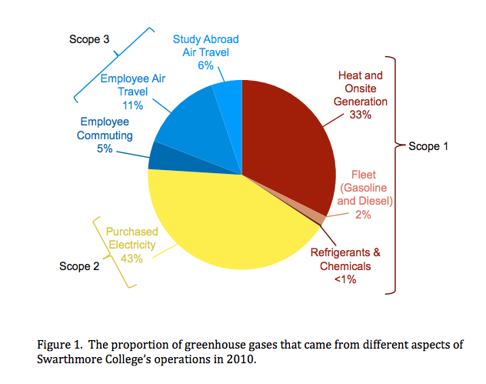
As Figure 1 shows, 78% of the College’s counted carbon emissions came from Scope 1 and Scope 2 categories in 2010. (The majority of employee air travel in Scope 3 is conducted by Admissions and Development officers rather than by faculty travel to conferences and/or research.) This proportion has remained fairly constant: in 2014, 79% of the College’s counted carbon emissions came from Scope 1 & 2. Table 1 provides further detail on gross and net emissions. Net emissions subtract carbon-offset purchases from gross emissions. Carbon offsets are expenditures on activities to reduce carbon dioxide or greenhouse gases elsewhere to compensate for emissions at Swarthmore. Swarthmore purchases Renewable Energy Credits (RECs) which support wind energy in the western United States. These offset purchases amount to about 45 percent of gross emissions.

 | Emissions in MT eCO  (metric ton CO2 equivalent) | % of gross emissions
Scope 1 | 7,547.0 | 41.5
Scope 2 | 6,817.0 | 37.5
Scope 3 | 3,809.0 | 21.0
Gross emissions | 18,173.0 | 100
Offsets | -8,228.0 | 45.3
Net emissions | 9,296.0 [9,945] | 51.1[54.7]

Table 1. Carbon emissions by source for 2014.
Adapted from Swarthmore College Energy Use Status Report For 2014

Table 1 and Figure 1 indicate the predominance of carbon emissions from heating and electricity in Swarthmore College’s greenhouse gas emissions. Figure 2 tracks carbon emissions over time. After a significant reduction since 2005, carbon reduction has hit a plateau in the last few years, suggesting the necessity of new efforts to improve energy efficiency and increase use of renewables.

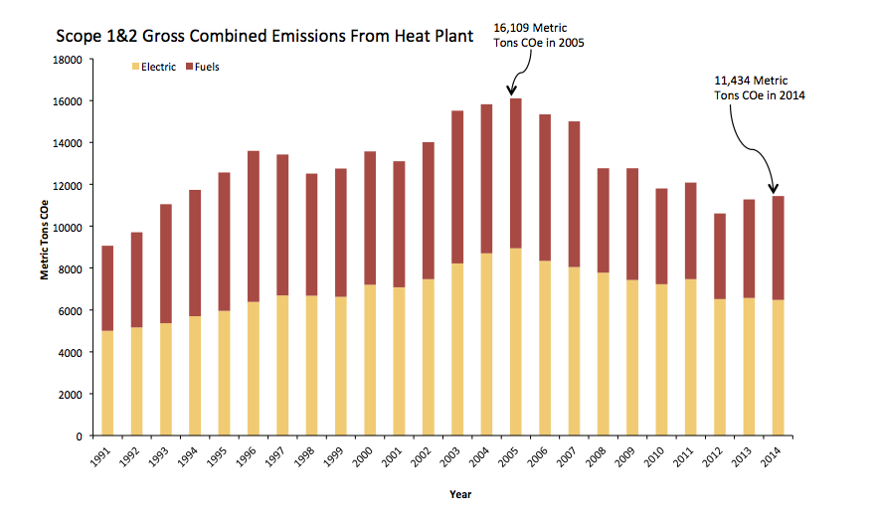
Figure 2. Scope 1 and 2 Combined Emissions.

Models for voluntary carbon charges

A recent white paper from Vassar College (Hall et al 2015) suggests that a voluntary carbon charge at a small liberal arts college should assess any plan in terms of three criteria: 1) effectiveness in raising capital in order to increase climate change preparedness and resilience (our first goal), 2) capacity for inspiring personal behavior change (our second goal), and 3) administrative feasibility. Table 2 summarizes several alternative strategies, drawing on Vassar’s white paper to fit the Swarthmore context.

 | Offset purchases | Individual charges | Redistributive model | Shadow pricing | Fund model
Effect | College level | College level policy affecting individuals | Department level | College level | College level
Raise capital | n/a | Low | n/a | n/a | High
Change behavior | Low | High | Mediumf | Medium | Low
Implementation feasibility | High | Low | Low | High | High

Table 2. Features of various carbon pricing plans at Swarthmore College.

Offset purchases are easy to administer: this strategy helps Swarthmore stay on track for the American University and College Presidents’ Climate Commitment (“Carbon Commitment”), but they neither raise capital to help improve energy efficiency nor encourage behavior change. Individual charges for electricity and heating would create strong incentives for behavior change, but these are not feasible without significant investment of both time and money (in metering and infrastructure design). A redistributive model, in which departments that conserve more energy have more to spend on other priorities, has the potential to create behavior change but would also require significant investment in metering, policy and infrastructure design. The two most feasible options which also have the capacity for changing behavior and/or raising capital are shadow carbon pricing and the development of a fund model carbon charge.

Proposal: A three-part Carbon Charge
We propose launching the Swarthmore College Carbon Charge Plan with three interconnected plans: 1) a shadow price on carbon, currently set to $40/MT eCO2, to be applied to all new construction projects; 2) a carbon charge of $40/MT eCO2, applied to college-wide emissions on an annual basis, to be set aside in a fund earmarked for energy conservation as well as energy efficiency and renewable energy projects; and 3) an increase in metering, feedback, and messaging focused on encouraging communal behavior change. By working on all three fronts simultaneously, we greatly increase our ability to educate our students and the community as a whole as we also take effective steps towards reducing carbon emissions and preparing for a carbon-constrained future.

- A shadow price for carbon emissions. Currently, in analyzing the economics of a planned construction project, the College projects the energy costs associated with the building to help determine whether greater investments in energy-saving technologies would be prudent. It does not, however, include a "shadow" price for the greenhouse gas emissions that the building is likely to produce. If it were to do so, the College might find that greater initial investments in emission-reducing technologies are justified. Such shadow pricing requires selection of a carbon price. The Yale University Task Force recommends a $40 per ton carbon price. This is close to the EPA figure for the social cost of carbon and large enough to be significant, but not too onerous to implement initially.

We propose:
- An initial shadow price of $40 per metric ton carbon dioxide equivalent (MT eCO2) for 2014, to be included in the pricing of all new construction projects.
- This price should rise as global emissions continue to climb, in order to reflect the increasing social cost of carbon and in accordance with the best climate science research and mitigation strategies available.
- This shadow price should be regularly revisited and revised by a combination of senior staff and the Board of Managers, the Sustainability Committee, and perhaps the Vice President of Finance and the Vice President of Facilities and Grounds in conversation with the Property and Finance Committees of the Board.

This shadow price encourages the College to plan for resilience in the face of climate change. Stu Hain reports, for instance, that such a shadow price might have led the College to invest in groundwater source heating (institutional-scale geothermal) for the recent Danawell construction.

2. An immediate, significant internal charge on annual Scope 1 and Scope 2 carbon emissions, applied at the College level. Revenues from the charge will go into a fund earmarked for investments in energy conservation, energy efficiency, and renewable generation. A committee composed of senior staff (notably, Greg Brown and Stu Hain) and members drawn from or appointed by the Sustainability Committee should be charged with deciding how these funds should be disbursed; along with investing in high-efficiency infrastructure, strategies for engendering a sense of collective agency and responsibility for carbon emissions should be a high priority.

We propose:
- A $40 carbon charge, applied to 2014 emissions of 9,296 (or 9,945) metric tons of carbon dioxide equivalent (MTCO2e), producing revenues of roughly $400,000.
- The charge would rise in tandem with the shadow price.
- A 1% charge would be levied on all departmental budgets. The total operating budget (which excludes compensation) for the college is $43 million. A 1% charge on each budget would raise $400,000, roughly the amount projected for our initial carbon charge of $40/ per metric ton CO2e. The argument for this initial step is its simplicity: everyone contributes very slightly to the challenge of beginning to account for the social costs of our fossil fuel use, increasing our energy efficiency and reducing our per capita carbon consumption. The limitation of this proposal is that there is little intrinsic connection to actual carbon emissions at a disaggregated level. But this could be a first step toward a more sophisticated and nuanced plan.

Several variants to this funding approach can be envisaged. The carbon charge could be phased in, for example beginning with a 0.5% charge in 2016/17, with a goal to increase to 1% the next fiscal year. Departments wishing to promote faster carbon reductions could contribute more than 1%. Departments could also propose measurable strategies for reducing their local carbon emissions and request support from the carbon charge fund to carry out those plans. The funding mechanisms for the carbon charge will be refined over time to more closely align with the consumption of energy.

Such a carbon charge is an excellent mechanism for moving forward on last year’s call for “big, concrete proposals” for sustainability, most of which remain unfunded. By creating revenues to fund spending on energy efficiency and renewables, this design ensures that the College will continue to advance toward its commitment to carbon neutrality while also eventually reaping the savings associated with conservation. Like the shadow carbon price, the carbon charge should rise over time, though we hope the higher charge figure will be applied to falling emissions, limiting its financial impact.

3. Increased metering, feedback, and messaging focused on encouraging communal behavior change.

We propose:
- The Sustainability Committee, in coordination with Aurora Winslade, the new Director of Sustainability, along with Melissa Tier, Sustainability Coordinator, and the Green Advisors, be charged with developing or facilitating at least one initiative per year, using a combination of metering, user fees, feedback, and messaging to encourage behavior change among students, faculty, staff—or all three.
- These campaigns could involve either price incentives or nudging (sometimes called “non-market mechanisms” or “choice architecture”) or both.
- Reports on these campaigns should be publicized on the College home page as well as on the Sustainability website.
- When possible and appropriate, coursework in Environmental Studies may also engage these issues, as is the case presently with ENVS 005 (Fall 2015) and may also be the case with the Introduction to Environmental Studies (ENVS 001) or the Environmental Studies capstone (ENVS 090).

Example 1: Shane Loeffler (a Green Advisor involved with Garnet Go Green) received support from the Green Initiatives Fund to install efficient showerheads in the athletic facilities. Savings may be invested in more efficient showerheads in dorms. This proposal might be extended with a campaign to invite students to shorten their showers, since, for instance, more natural gas goes into heating hot water for Willets than goes into heating the whole building in the dead of winter. Research coming out of ETH Zurich, an engineering, science, technology, mathematics and management university, found inexpensive energy meters on showers led to 22% conservation through real-time feedback. Meters currently on the market require hand-held showerheads, but it would be worth exploring ways to provide real-time feedback on energy usage in our showers. The Sustainability Committee, composed of students, faculty, and staff, seems the ideal group to facilitate, foster, and oversee such projects. Some portion of the carbon fund revenues (from #2 above) could extend SusCom’s ability to facilitate these projects.

Example 2: Motivated by the recognition that the College needs to increase its commitment to renewable energy, discussed on page 4 of this proposal, a group of students from ENVS 005 conducted a feasibility study for a substantive solar array on campus. As they interviewed campus stakeholders and solar companies operating in the region, the students engaged questions of finance (cost-benefit analysis of owning panels versus a power purchasing arrangement), engineering (structural supports, angles and positioning, etc.), project management, writing and presentation skills; they are also began to raise campus awareness about the benefits and limitations of solar power. Subsequent ENVS coursework might focus on social psychology affecting campus behavior, sustainability communication initiatives, or other similar strategies.

Example 3: Workshops for interested faculty could also encourage incorporation of sustainability issues in existing courses, such as addressing issues of health and environmental change in a health economics course and seminar. Workshops and summer grants supported by Mellon funding successfully increased Environmental Studies offerings over the past three years; a similar effort could expand student engagement with and agency around carbon emissions and climate change.

This tripartite proposal encompasses carbon pricing, a carbon fund, and increased messaging, metering and curricular development; it addresses all four of our opening objectives: (1) To shift the College’s energy investment more rapidly toward energy efficiency and renewable energy, (2) To engender a sense of collective responsibility and agency for carbon emissions through our community, (3) To facilitate student, faculty and staff learning about the benefits, liabilities, and obstacles associated with a national carbon charge by grappling with the complexities of an internal carbon charge, and (4) To provide leadership on climate change preparedness within the higher education community.

A list of community members involved in drafting these proposals can be found below. We are open to feedback and suggestions for extending and improving this proposal.

Members of the 2015 Summer Carbon Tax Discussion Group
Betsy Bolton, Professor of English Literature and Coordinator, Environmental Studies Program
John Caskey, Professor of Economics
Stephen Golub, Professor of Economics
Ayse Kaya, Assistant Professor of Political Science
Ellen Magenheim, Professor of Economics
Leonard Nakamura ’69, Vice President, Federal Reserve Bank of Philadelphia
Jennifer Peck, Assistant Professor of Economics
Lee Smithey, Professor of Sociology and Coordinator, Peace Studies Program
Melissa Tier, Sustainability Coordinator
Tao Wang, Assistant Professor of Economics

Present at September 16 2015 discussion of the proposal
Valerie Smith, President
Stephen Golub, Professor of Economics
Betsy Bolton, Professor of English Literature and Coordinator, Environmental Studies Program

Present at the October 9 2015 discussion of the proposal
Greg Brown, Vice President of Finance
Stu Hain, Vice President for Facilities and Capital Projects
Tom Stephenson, Provost
David Singleton, Board of Managers, Property and Finance Committees
Carr Everbach, Professor of Engineering
Leonard Nakamura ’69, Vice President, Federal Reserve Bank of Philadelphia
Stephen Golub, Professor of Economics
Betsy Bolton, Professor of English Literature and Coordinator, Environmental Studies Program

Members of the Sustainability Committee present on October 21 2015
Eric Wagner, Athletics & Physical Education - Co-Chair
Ralph Thayer, Director of Maintenance - Co-Chair
Melissa Tier, Sustainability Coordinator
Maurice Eldridge, Vice President for College and Community Relations and Executive Assistant to the President
Carr Everbach, Department of Engineering
Giovanna Di Chiro, Environmental Studies Program
Tao Wang, Department of Economics
Sibelan Forrester, Department of Modern Languages & Literatures
Deb Kardon-Brown, Assistant Director for Student Programs, Lang Center
Sheila Magee, Facilities
Mark Davis, ITS
Nathaniel Graf, '16
Rebecca Griest, '16

Present at the December 4, 2015 meeting
with the Social Responsibility Committee of the Board
Bennett Lorber, Chair
David Singleton, Vice Chair
Ben Berger, Professor Political Science, Acting Director of the Lang Center
Becca Berstein
Betsy Bolton, Professor of English Literature and Coordinator, Environmental Studies Program
Greg Brown, Vice President, Finance
Rhonda Cohen
Janet Smith Dickerson
Elizabeth Economy
Maurice Eldridge, Vice President for College and Community Relations and Executive Assistant to the President
Janet Erlick
​David Gelber
Stephen Golub, Professor of Economics
Nathaniel Graf '16
Stu Hain, Vice President for Facilities and Capital Projects
James C. Hormel
Leonard Nakamura ’69, Vice President, Federal Reserve Bank of Philadelphia
Salem D. Shuchman
Val Smith, President
Lee Smithey, Professor of Sociology and Coordinator, Peace Studies Program
Tom Spock, Chairman of the Board
Tom Stephenson, Provost
Elizabeth Svenson, HHMI Program Administrative Coordinator
Ralph Thayer, Director of Maintenance
Debbie Thompson, Data Coordinator
Melissa Tier, Sustainability Coordinator
Eric Wagner, Athletics & Physical Education

Aurora Winslade, Director of Sustainability, by phone

References
Borenstein, Severin (2015). “What’s a University to do about Climate Change?”, https://energyathaas.wordpress.com/2014/12/07/whats-a-university-to-do-about-climate-change/.
Hall, Alistair, et al. (2015). “Internal Carbon Accounting at a Small Liberal Arts College”. Vassar College. http://sustainability.vassar.edu/docs/9-15InternalCarbonAccountingataSLAC.pdf
Light, Sarah (2015). “The New Insider Trading: Environmental Markets within the Firm”, Stanford Environmental Law Journal, 34:1, 41-50.
Marron, Donald, Eric Toder and Lydia Austin (2015). “Taxing Carbon: What, Why, and How”, Tax Policy Center, Urban Institute and Brookings Institution.
Tiefenbeck, Verena, et al. “Helped, not Pushed: How Real-Time Information Fosters Resource Conservation” Department of Management, Technology, and Economics, ETH Zurich,
Weinbergstrasse 56, 8037 Zurich, Switzerland
Wolak, Frank (2014). “Universities Can Do Better Than Symbolism: A Revenue-Neutral Carbon Tax”, SIEPR Policy Brief, Stanford University. http://web.stanford.edu/group/fwolak/cgi-bin/sites/default/files/policy_brief_price_carbon_oct_2014.pdf
Yale Presidential Carbon Charge Tax Force (2015). “Report to the President and Provost of Yale University: Findings and Recommendations on a Carbon-Charge Program at Yale”.

http://www.nytimes.com/2015/06/07/opinion/the-case-for-a-carbon-tax.html?_r=0. See also Marron et al (2015).
https://vanhollen.house.gov/climate
For a discussion of Microsoft’s program, see Light (2014).
Wolak (2014). See also Borenstein (2014).
That Commitment has recently been rebranded as a “Carbon Commitment,” to be joined by a “Resilience Commitment;” the two together will be considered a “Climate Commitment.” Swarthmore needs to decide how it will respond to this rebranding—will it add a Resilience Commitment?—by January 2016.
Personal communication, Ralph Thayer. October 23, 2015.
Verena Tiefenbeck, Lorenz Goette, Kathrin Degen, Vojkan Tasic, Elgar Fleisch, Rafael Lalive, Thorsten Staake, “Helped, not Pushed: How Real-Time Information Fosters Resource Conservation”
The views expressed here are personal and not those of the Federal Reserve Bank of Philadelphia.

