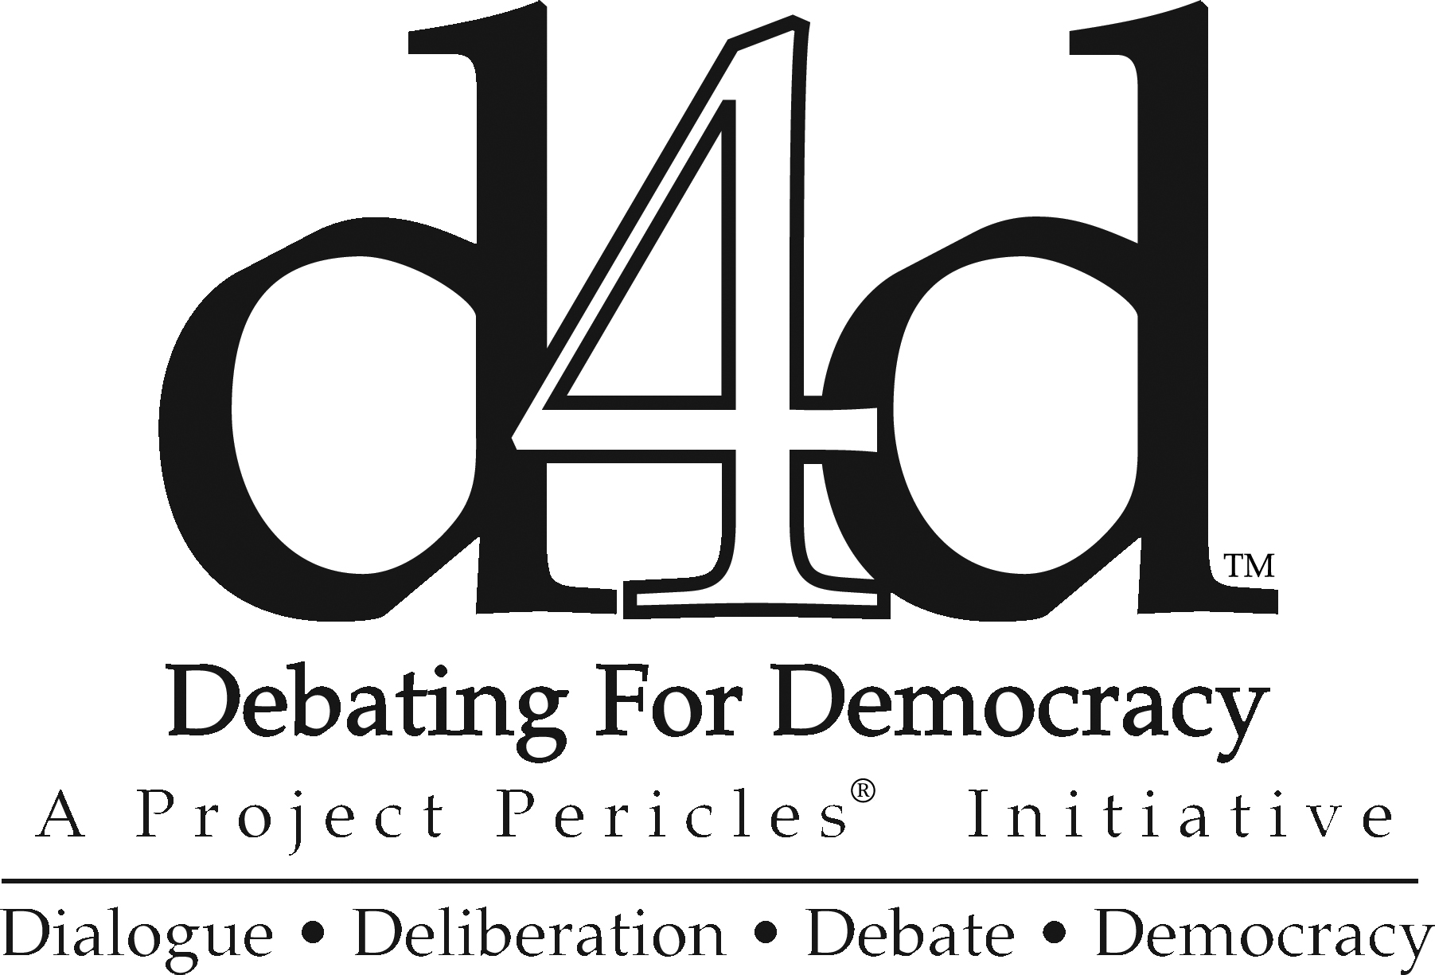**Debating for Democracy (D4D)**™

Debating for Democracy (D4D)™ is a distinctive campus-based program that represents the mission of Project Pericles in action. D4D promotes civic engagement and effective advocacy skills among a wide range of students. Through **D4D on the Road**™ workshops hosted on Periclean campuses, the **D4D National Conference** in New York City, the **D4D Letters to an Elected Official Competition**, and co-curricular programs on each campus, students acquire the tools and tactics they need to advance their issues and to get their messages across to elected officials, fellow students, community groups, and the media.

Student participants **have done important work including:**

* A Bates College student testified before the Maine Legislature about the need to provide aid for asylum-seekers (the Bates team wrote about this topic as part of the D4D Letters to an Elected Official competition). The Bates team is creating a public service announcement to give Mainers an introduction to the stories of asylum-seekers
* Carleton College students ran youth empowerment workshops for local high school students who went on to develop an active school reform campaign of their own
* Students have developed campaigns in support of the DREAM ACT, mountaintop-removal coal mining, Net Neutrality, and the Violence Against Women Act (VAWA), among others
* Many groups of students met with their elected officials and congressional staff members in their home states and in Washington, D.C. to discuss their issues.

The **D4D on the Road**™ workshops hosted at Periclean colleges and universities provide training in leadership development, media strategy, coalition building, and messaging. In addition to their own students, faculty, staff, and alumni, hosting Periclean campuses around the country welcome students from local colleges and universities as well as community leaders. Using our carefully designed model, advocacy experts empower participants to advance their particular issue or cause. They learn advocacy skills that can be applied to a variety of issues and situations, including stakeholder identification, pending legislation analysis, and strategic planning. Participants identify new strategies for making change, practice developing and delivering an effective advocacy message, and build relationships to support and sustain their work. Through these day-long workshops participants learn to work within the democratic processes to improve the condition of society. Utilizing a series of dynamic exercises, participants learn strategies for developing effective messages, critically analyzing the opposition’s messages, and the importance of thoroughly understanding their target audiences.

Since 2008, Project Pericles has trained more than 3,300 participants at Periclean colleges and universities across the United States. All of the Periclean campus have participated in D4D on the Road.

Project Pericles appreciates the generous support of The Spencer Foundation, the Eugene M. Lang Foundation and our Periclean colleges and universities for supporting the 2015-2016 D4D on the Road workshops. Previous funders have included the Henry Luce Foundation.

At the **D4D** **National Conference**, **s**tudent leaders from Periclean campuses across the country are joined by college presidents, faculty, members of the media, and foundation, government, and community leaders to participate in a series of panels and workshops with leading experts on topics including: civic engagement, education, the environment, journalism, social entrepreneurship, social justice, and public policy. The National Conference features a Legislative Hearing in which teams of students present in front of a panel of government officials. Teams compete for $5,000 in prize money that they use to develop advocacy and educational campaigns around critical issues. Project Pericles designed the conference to provide students with concrete steps they can take to move their issues forward. Student are encouraged and expected to return to their campuses to advance civic and political engagement among their classmates. The first D4D National Conference in 2008 was funded by the Christian A. Johnson Endeavour Foundation.

The 2017 D4D National Conference will take place March 30-31, 2017 at The New School.

The 2015 D4D National Conference was dedicated to our founder Eugene M. Lang, and hosted by Eugene Lang College The New School for Liberal Arts in New York City. Prior to the conference, all student attendees, in teams, wrote Letters to an Elected Official, on pressing policy issues that they care deeply about. At the sixth national conference, we heard from many young men and women who eloquently described their struggles for social justice. Student activists shared their hopes and aspirations for LGBTQ rights, immigration reform, and environmental justice. The conference provided student delegates an opportunity to discuss their issues with fellow students from other Periclean campuses from around the country, to exchange insights, and to gain strength from solidarity with fellow activists and student leaders.

The 2015 D4D National Conference featured an interactive messaging workshop and a poster session where students shared their projects with fellow students and attendees. Students presented on topics including decriminalizing non-violent crimes, policing in New York, using technology for promoting civic engagement, and voter registration.

We concluded with visits to five local non-profit organizations: College and Community Fellowship, Community Voices Heard, Friends of the High Line, Harlem Grown, and Museum at Eldridge Street/A Landmark Synagogue Story.

Conference presenters have included:

* Phil Aroneanu, US Managing Director and Co-Founder, 350.org
* Emily Badger, Staff Writer, The Washington Post
* Carol Browner, former EPA Administrator
* Jeffrey Clements, Author of *Corporations Are Not People*
* Ami Dar, Founder and Executive Director, Idealist.org
* Thomas J. Downey, former U.S. Congressman (D-NY)
* Rajeev K. Goyal, author of *The Springs of Namje: A Ten-Year Journey from the Villages of Nepal to the Halls of Congress*
* Jacob S. Hacker, author of *Winner-Take-All Politics: How Washington Made the Rich Richer--and Turned Its Back on the Middle Class*
* Nancy Kassebaum Baker, former U.S. Senator (R-KS)
* Bob Kerrey, former U.S. Senator (D-NE) and former Governor of Nebraska
* Arthur Levine, President, Woodrow Wilson Foundation
* Michael S. McPherson, President, Spencer Foundation
* Constance Berry Newman, former U.S. Assistant Secretary of State for African Affairs
* Pedro Noguera, Professor of Teaching and Learning, New York University
* Kurt L. Schmoke, former Mayor of Baltimore, MD
* Ben Smith, Editor-in-Chief, BuzzFeed
* Harris L. Wofford, former U.S. Senator (D-PA)

**D4D Letters to an Elected Official Competition:**

The D4D Letter to an Elected Official Competition engages students around public policy issues, the political process, and with their elected officials. Since 2008, hundreds of teams from all Periclean colleges and universities have participated in this competition. Every year, a panel of judges with significant legislative experience select the five winning letters written by teams of students from Periclean campuses. Project Pericles awards prizes to the winning student teams to support their efforts to move their issue forward locally and nationally. In addition to the letter to an elected official, this year we asked students to share a project proposal about how they would use their award.

The letters proposed innovative solutions on a wide variety of issues ranging from implementing food waste management systems at the national level, to advocating for financial literacy services for struggling families, to supporting redistricting to ensure equal access to a quality education in the state of Pennsylvania. These letters were sent to elected officials throughout the United States.

An elected official who served as one of the external evaluators wrote, “let all these students know what wonderful and impressive work they did,” adding that “if [she] had received any of the letters from a constituent, [she] would have been blown away.” Another outside evaluator commented that the letters were, “so well written and inspiring.”

We look forward to working with the five winning teams of the 2016 D4D Letters to an Elected Official competition throughout the 2016-2017 academic year:

**Hayden Moyer ‘**17 and **Walter Stover** ‘17 (**Allegheny College**) wrote to Senator Robert Casey (D-PA) about online privacy and adapting Europe’s Right to be Forgotten in the United States. They will develop a website “promoting digital privacy rights and serving as a database” for cases supporting their endeavor.

**Tran Nguyen ‘**17 and **Megan Yocum** ‘17 (**Berea College**) sent State Senator Jared Carpenter (R-KY) a letter discussing the expansion of Kentucky’s 2013 Religious Freedom Restoration Act. The pair plans to create a public service announcement and present it to elected officials during lobbying meetings.

**Sarah Goldman** ‘17 and **Jenni Rogan** ’19 (**Carleton College**) penned a letter to Senator Amy Klobuchar (D-MN) regarding the 2014 Farm Bill Crop Insurance and Subsidies Policy. The students will create a mentorship program for students to work with farmers in their state and participate in a training program during the summer of 2017.

**Katie Dobbins** ‘17, **Emma Gaither** ‘18, **Casey Hawkins** ‘18, and **Tejas Soman** ‘18 (**Hendrix College**) wrote to State Senator Joyce Elliott (D-AR) about restricting local media sources from publishing the names of juveniles charged as adults for crimes. The team will partner with student organizations in Arkansas to publicize their issue and organize a concert to raise awareness. The students also plan to hold a panel discussion and a letter writing campaign to petition elected officials to address the matter.

**Amina Farias** ‘18 and **Eleanor Neal** ‘18 (**Pitzer College**) wrote to Representative Judy Chu (D-CA) on the issue of Medicaid-funded mental health treatment and recovery support programs. To “prevent recidivism while promoting community reintegration”, working with a community partner, they will create and distribute a resource guide to support women with mental illness and substance abuse problems as they pursue self-sufficiency and stability.

**Periclean Colleges and Universities**

Allegheny College • Bates College • Berea College • Bethune-Cookman University  
Carleton College • Chatham University • Dillard University • Drew University  
Elon University • The Evergreen State College • Goucher College • Hampshire College

Hendrix College • Macalester College • Morehouse College • New England College  
The New School • Occidental College • Pace University • Pitzer College  
Rensselaer Polytechnic Institute • Rhodes College • St. Mary's College of Maryland  
Skidmore College • Spelman College • Swarthmore College • Ursinus College  
Wagner College • Widener University • The College of Wooster

**PROJECT PERICLES, 551 FIFTH AVENUE, SUITE 1910, NEW YORK, NY 10176**

**T: 212.986.4496 F: 212.986.1662** [www.projectpericles.org](http://www.projectpericles.org)