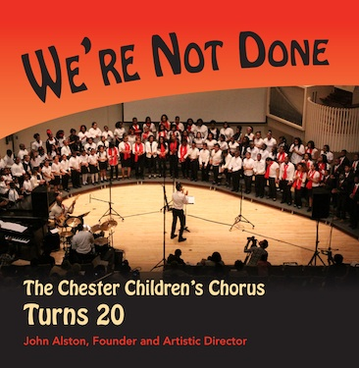
It’s finally here! You’ve been asking for a new CD and we are happy to announce the release of We’re Not Done. The Chester Children’s Chorus Turns 20. The album features 11 original songs written by founder and artistic director John Alston, recorded in session on May 18, 2013 and live at our Spring 2014 concerts.
20th Anniversary CD
featuring original music and gospel tunes
Goes on sale at our Holiday Concerts, December 12 & 13th
Or use the coupon below to order by mail

The album will be sold at our Holiday Concerts, Friday, December 12th & Saturday, December 13th at Lang Concert Hall, Swarthmore College. The cost of each CD is $15.00.
OR
You may order via mail for $17.00 each using the form below or download a CD order form at www.chesterchildrenschorus.org. For more information contact Elisa DeNofio at: 610-957-6049 or edenofi1@swarthmore.edu.
All proceeds will help support the Chorus’ year-round program.
The MAIL ORDER price of $17.00 per copy includes postage & handling. Please mail the form below with your check or money order to:
Chester Children’s Chorus
Swarthmore College
500 College Avenue
Swarthmore, PA 19081

Number of copies____________x $17 per copy = Order total_____________
Name__________________________________________________________________
Address________________________________________
City and state___________________________ Zip_________________
Daytime phone number _______________________________________ (required)
Email_______________________________________________________________________________

