Swarthmore College Biology Department

T-Shirt Order Form

APRIL 15th DEADLINE

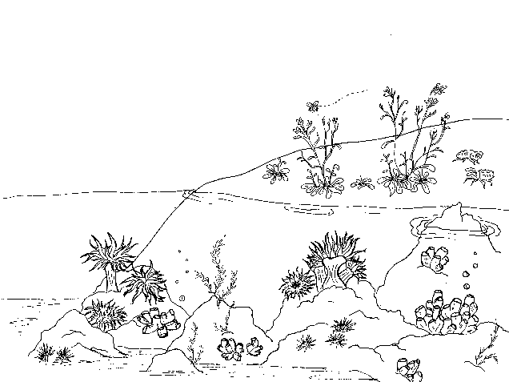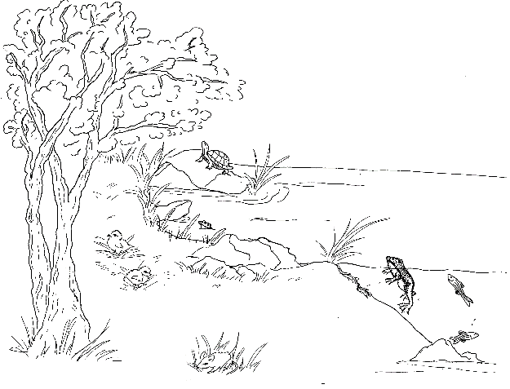

Swarthmore College Biology

Get a blue department t-shirt!

Name (First and Last):________________________________

Email:_____________________________________________

Staff, Faculty, or Student:_____________________________

Quantity and Sizing:

|  |  |  |
| --- | --- | --- |
| ___S | ___XL | ___3XL |
| ___M | ___XXL | ___4XL |
| ___L |  |  |

Total Cost:

Quantity x $11.76= ______________

Or use the link to order and pay online: ($11.76/shirt)

https://www.customink.com/g/kmw0-00ag-wz0e.

**Office Hours for Cash and Change forms**

M: 4:15-5pm

T: 3:30-5pm

W:  10:30am-11:30am

F: 10-11am, 2-4pm

S/S: 3pm-5pm

**\*The t-shirt project is the responsibility of the Swarthmore Biology Club; the cost is not being funded or supplemented by the Biology Department and the order process is entirely student- run. We will NOT order a shirt without first receiving payment. All questions, comments, and concerns about ordering and payment should be directed to sschick1@swarthmore.edu.**